Heedfulness, Mindfulness, Monitoring Awareness

Purpose:
In this learning experience, students will cultivate attention. Attention incorporates three concepts: 1. “heedfulness” of things that could be dangerous or harmful; 2. “mindfulness” of what we are trying to do or accomplish without distraction and without forgetting what we are doing and 3. “monitoring awareness” of what is going on in our mind, our bodies, and around us. These aspects of attention not only allow us to maintain our focus and learn better, they also help us catch emotional impulses before they create problems for ourselves and others.
Learning Objectives:  Students will be able to:  • Engage in the practices of heedfulness,  mindfulness, and monitoring awareness  • Describe the experience of paying  attention to things on the inside (our  body, sensations, and mental  experiences)  • Describe strategies for catching impulses  before they cause us problems | Primary Core Component  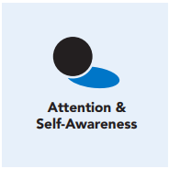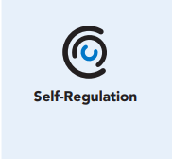
Length  45 Minutes | Materials Required  • Writing utensils and paper  • A cup filled with water

Check-In (10 min)
Slide 2: Check-In  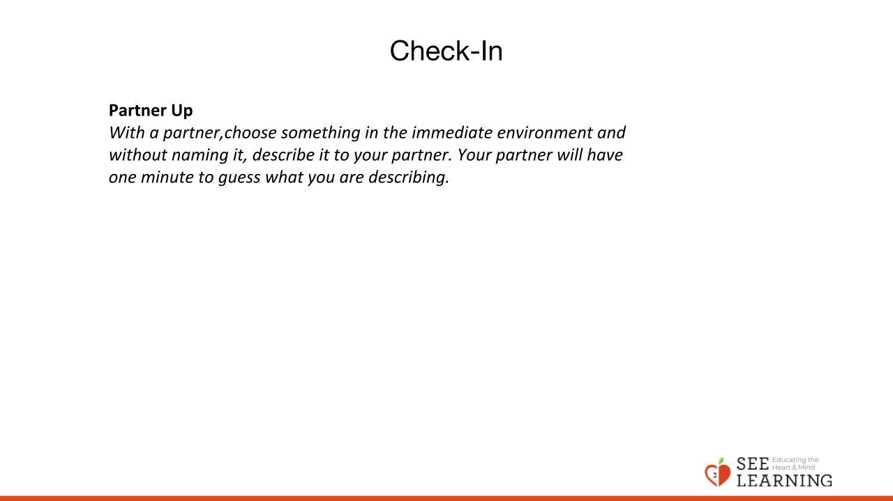 | Instructions and Guided Language  With a partner, choose something in the  immediate environment and without naming  it, describe it to your partner. Your partner  will have one minute to guess what you are  Describing.  Settling Activity (3 minutes)  [PAUSE]s can be up to 10 seconds each  • “Let’s take a moment to get comfortable  in an alert position. What does your body  need right now? [PAUSE]  • For you it may be settling into your chair,  leaning against a wall, or sitting or lying on  the floor. Please take a moment to make  yourself comfortable. Feel free to move if  you need to. [PAUSE]  • Now I invite you to think of a resource.  A resource is something that makes you  feel better, safer, happier, or stronger.  • Your resource can be a person, a place,  a thing, something about yourself, or  a memory. It can be real or imaginary.  Notice the details of this resource and any  sensations that come with it. [PAUSE]  • When you think about this resource, what  do you notice happening inside your body?  [LONGER PAUSE]  • Next, if you like, I invite you to ground.  Bring your attention to your body and what  it is in contact with. Perhaps you feel the  chair against your back, your hand on your leg. Possibly you feel the coolness of the  table, the softness of your shirt, maybe the  air going in and out of your nostrils. What  sensations do you notice on the inside?  [PAUSE]  • If you notice a pleasant or neutral sensation,  just pay attention to that and observe it.  See if it changes or stays the same. [PAUSE]  • If you become aware of an unpleasant  sensation, you can always shift your  attention to another place that feels better  and let your attention rest there. Or you can  also re-focus on your resource. [PAUSE]  • If you get distracted, remember that you  are human and it’s okay to get distracted.  Just acknowledge you’re distracted and  try to bring your attention back to your  resource or a pleasant or neutral sensation  in your body. [LONGER PAUSE]  • As we do this, we’re learning more about  our bodies and how to calm them and make  them feel better.  • Now we’ll conclude the practice. If you  closed your eyes, I now invite you to open  them. Thank you for settling in with me.”

Presentation/Discussion- What is attention and what is it for? (10 min)
Slide 4: Presentation/Discussion  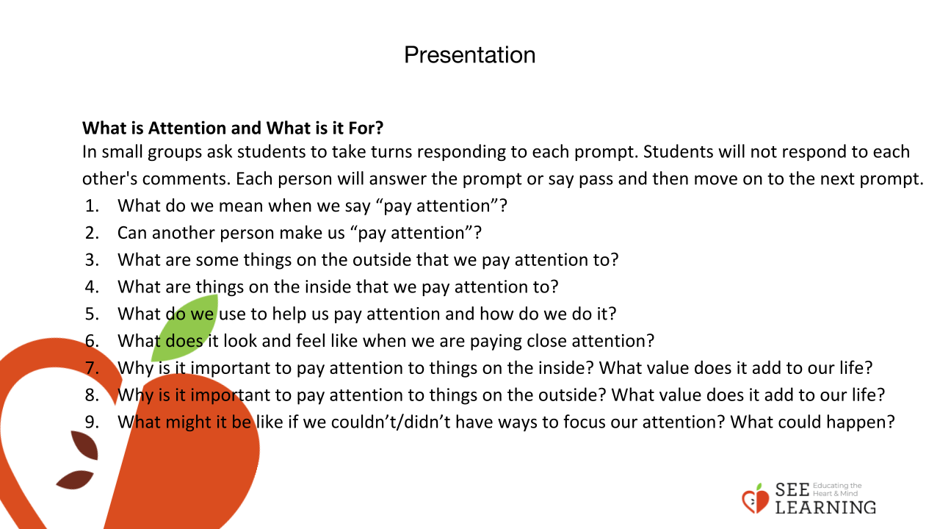 | Instructions and Guided Language  What is attention and what is it for?  In small groups ask students to take turns responding to each prompt. Students will not respond to each other’s comments. Each person will answer the prompt or say pass and then move on to the next prompt.  • What do we mean when we say “pay attention”?  • Can another person make us “pay attention”?  • What are some things on the outside that we pay attention to?  • What are things on the inside that we pay attention to?  • What do we use to help us pay attention and how do we do it?  • What does it look and feel like when we are paying close attention?  • Why is it important to pay attention to things on the inside? What value does it add to our life?  • Why is it important to pay attention to things on the outside? What value does it add to our life?  • What might it be like if we couldn’t/didn’t have ways to focus our attention? What could happen?  Guiding Language  “In our previous lessons, we’ve been noticing how we can pay attention to outside things by using our senses.  Similarly, we can pay attention with our mind to what’s going on inside us, our sensations, thoughts, and feelings.  This skill of attention supports our ability to learn and can be strengthened through practice.  What are some things on the inside that we have already been placing our attention on? (tracking sensations) What else might we notice if we pay attention to what is going on on the inside? (a piece of music stuck in one’s head; daydreaming, imagining, worrying)  We’re going to explore this concept of attention more deeply today.”

Insight Activity - Introduce new vocabulary by telling a story (10 min)
Slide 4-7: Insight Activity  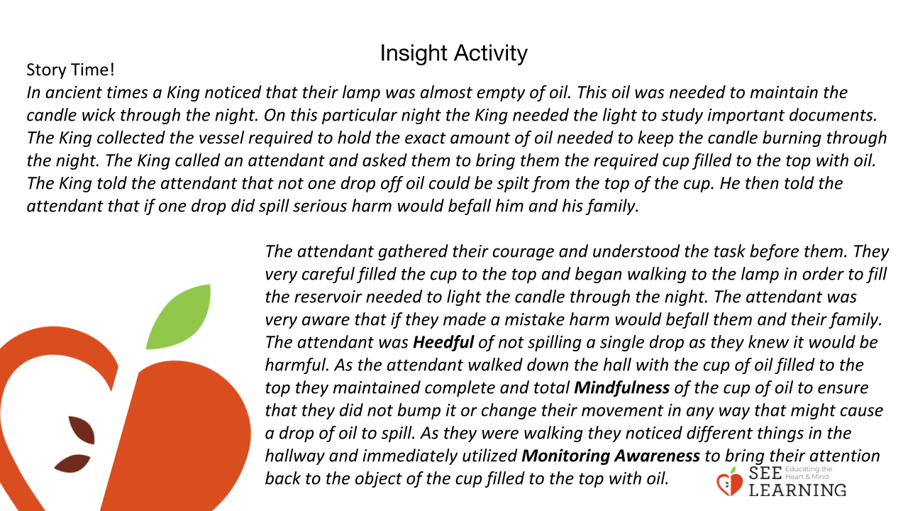  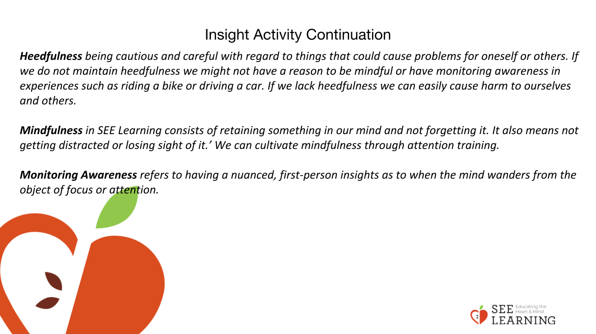  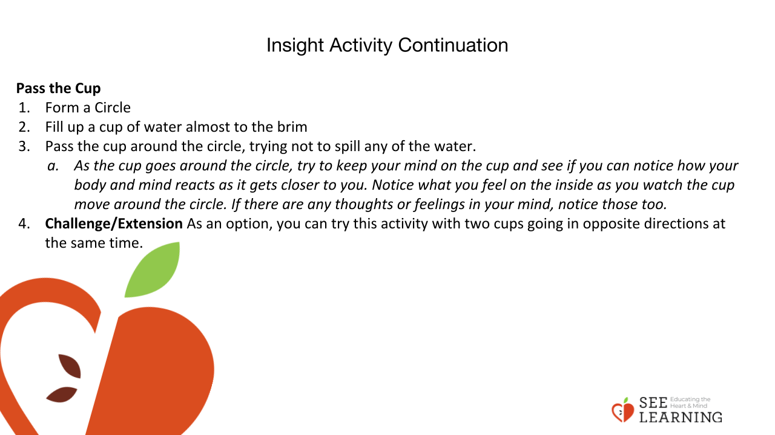  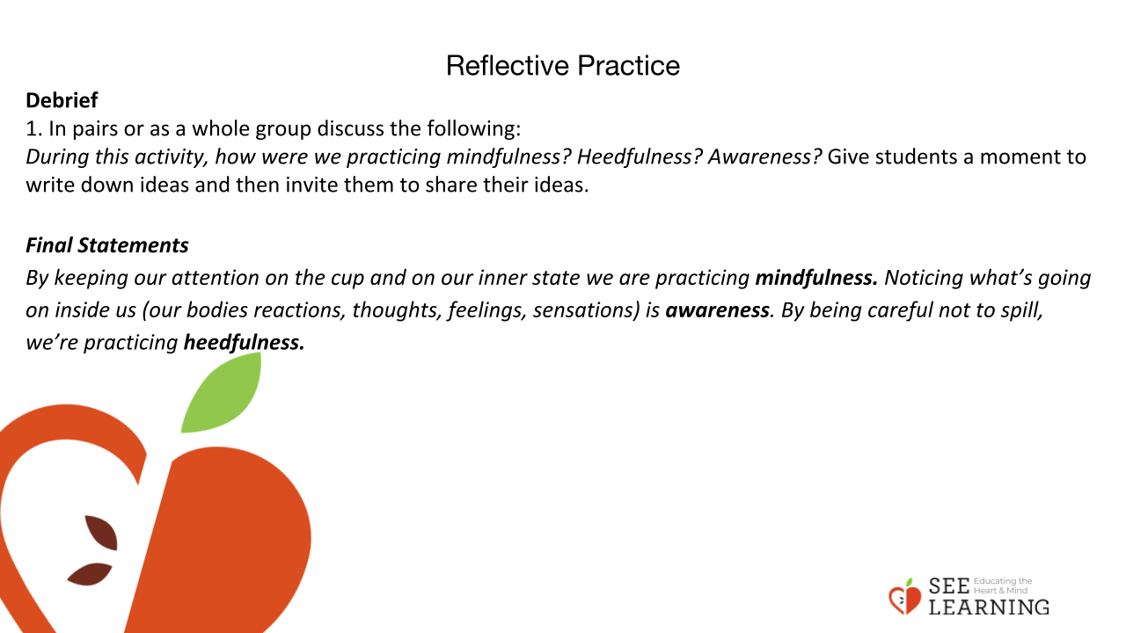 | Instructions and Guiding Language  “In ancient times, a King noticed that their lamp was almost empty of oil. This oil was needed to maintain the candle wick through the night.  On this particular night the King needed the light to study important documents.  The King collected the vessel required to hold the exact amount of oil needed to keep the candle burning through the night. The King called an attendant and asked them to bring them the required cup filled to the top with oil. The King told the attendant that not one drop of oil could be spilt from the top of the cup. He then told the attendant that if one drop did spill, serious harm would befall him and his family.  The attendant gathered their courage and understood the task before them. They very carefully filled the cup to the brim and began walking to the lamp in order to fill the reservoir needed to light the candle through the night.  The attendant was very aware that if they made a mistake harm would befall them and their family. The attendant was Heedful of not spilling a single drop as they knew it would be harmful.  As the attendant walked down the hall with the cup of oil filled to the top they maintained complete and total Mindfulness of the cup of oil to ensure that they did not bump it or change their movement in any way that might cause a drop of oil to spill.  As they were walking, they noticed different things in the hallway and immediately utilized Monitoring Awareness to bring their attention back to the object of the cup filled to the top with oil.  In this story, we can see that Heedfulness helped the attendant recognize what was at stake to ensure that no harm occurred to them or others. The attendant was also mindful of the task and the object of focus. The attendant also used monitoring awareness to bring their attention back to the object of the cup filled with oil.  Heedfulness being cautious and careful with regard to things that could cause problems for oneself or others. If we do not maintain heedfulness we might not have a reason to be mindful or have monitoring awareness in experiences such as riding a bike or driving a car. If we lack heedfulness we can easily cause harm to ourselves and others.  Mindfulness in SEE Learning consists of retaining something in our mind and not forgetting it. It also means not getting distracted or losing sight of it. We can cultivate mindfulness through attention training. Monitoring  Awareness refers to having the ability to notice as to when the mind wanders from the object of focus or attention, allowing us to bring it back to our intended point of focus.”  Pass the Cup  • Form a circle  • Fill up a cup of water almost to the brim  • Pass the cup around the circle, trying not to spill any of the water.  • “As the cup goes around the circle, try to keep your mind on the cup and see if you can notice how your body and mind reacts as it gets closer to you. Notice what you feel on the inside as you watch the cup move around the circle. If there are any thoughts or feelings in your mind, notice those too.”  • Challenge/Extension As an option, you can try this activity with two cups going in opposite directions at the same time.  Debrief In pairs or as a whole group discuss the following: “During this activity, how were we practicing mindfulness? Heedfulness? Awareness?” Give students a moment to write down ideas and then invite them to share their ideas. “By keeping our attention on the cup and on our inner state, we are practicing mindfulness. Noticing what’s going on inside us (our bodies reactions, thoughts, feelings, sensations) is awareness. By being careful not to spill, we’re practicing heedfulness.”

Reflective Practice (10 mins)
Slide 5: Reflective Practice  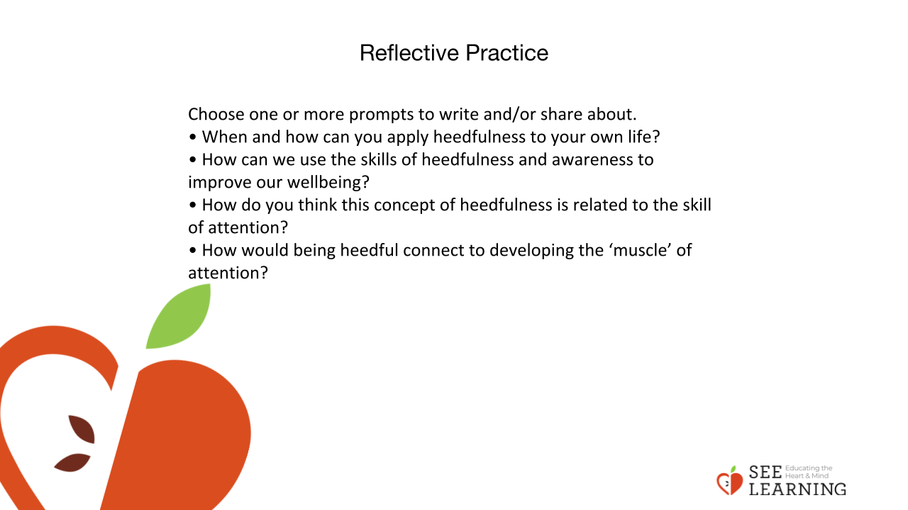 | Instructions and Guided Language  Writing Prompt/Verbal Share “Choose one or more prompts to write and/or share about.  • When and how can you apply heedfulness to your own life?  • How can we use the skills of heedfulness and awareness to improve our wellbeing?  • How do you think this concept of heedfulness is related to the skill of attention?  • How would being heedful connect to developing the ‘muscle’ of attention?”

