Exploring Attention
Purpose:
In this learning experience, students will be introduced to the concept of attention by using the visual metaphor of a flashlight. After discussing attention and its benefits, students play a game called “I notice, I wonder.” During this, they pass around a novel object while sharing what they notice about it, and then things they wonder about it. This activity highlights how paying close attention reveals details that could make even a simple object interesting, and also that each of us may experience the same object in different ways. The learning experience concludes with a reflective practice for using a resource to strengthen attention.

Learning Objectives:  Students will be able to:  • Explore the skill of “attention” by studying  related vocabulary and the benefits that  come from developing attention  • Explore the strengthening of attention  as a skill  • Learn that people often perceive things  differently, even when looking at the  same object or situation | Primary Core Component  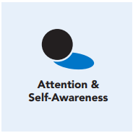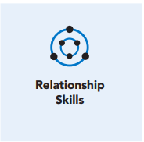
Length  45 Minutes | Materials Required  • Several small objects of curiosity,  preferably ones that students are unlikely  to have encountered or paid close  attention to before. (Examples: seedpod,  tool, seashell, interesting textile,  wooden mask, honeycomb, bone, piece  of unusual fruit, photographs,art, etc.)  • A bag (Optional: if you want to do a  version where students don’t see the  object)

Check-In (10 min)
Slide 2: Check-In   | Sample Script  [PAUSE]s can be up to 5-7 seconds each  Standardized Resourcing, Grounding  & Tracking Practice  Note: Resourcing, Grounding, Tracking and  Shift and Stay were introduced in Chapter 2. If  you have not already introduced these skills,  please do so first. Otherwise, this settling  practice will not be familiar to students.  • “Let’s take a moment to get comfortable  in an alert position. What does your body  need right now? [PAUSE]  • For you, it may be settling into your chair,  leaning against a wall, or sitting or lying on  the floor. Please take a moment to make  yourself comfortable. Feel free to move if  you need to. [PAUSE]  • Now I invite you to think of a resource,  something that makes you feel better,  safer, happier, or stronger. A person, a  place, a thing, something about yourself,  or a memory. It can be real or imaginary.  Notice the details of this resource and any  sensations that come with it. [PAUSE]  • When you think about this resource, what  do you notice happening inside your body?  [LONGER PAUSE]  • Next, if you like, I invite you to ground.  Bring your attention to your body and  what it is in contact with. Perhaps you feel  the chair against your back, your hand onyour leg. Possibly you feel the coolness of  the table, the softness of your shirt, maybe  the air going in and out of your nostrils.  What sensations do you notice on the  inside? [PAUSE]  • If you notice a pleasant or neutral sensation,  just pay attention to that and observe it.  See if it changes or stays the same. [PAUSE]  • If you become aware of an unpleasant  sensation, you can always shift your  attention to another place that feels better  and let your attention rest there. Or you can  also re-focus on your resource. [PAUSE]  • If you get distracted, remember that you  are human and it’s okay to get distracted.  Just acknowledge you’re distracted and  try to bring your attention back to your  resource or a pleasant or neutral sensation  in your body. [LONGER PAUSE]  • As we do this, we’re learning more about  our bodies and how to calm them and make  them feel better.  • Now we’ll conclude the practice. If you  closed your eyes, I invite you to open them.  Thank you for settling in with me.”

Presentation - Exploring Attention (10 mins)
Slide : Reflective Practice  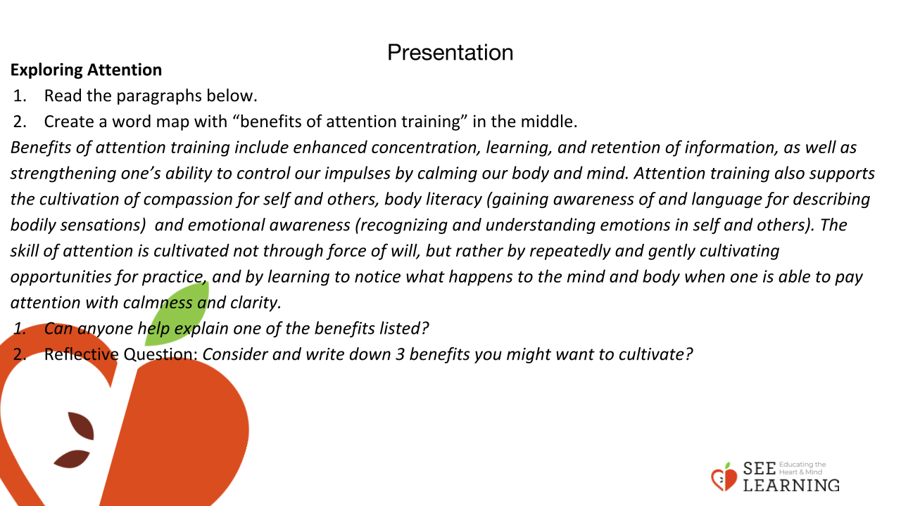 | Instructions and Guided Language  • The teacher or a student volunteer can  verbally read the paragraphs below.  • The teacher or a student volunteer can create  a word map with “benefits of attention  training” in the middle.  “Benefits of attention training include  enhanced concentration, learning, and  retention of information, as well as  strengthening one’s ability to control our  impulses by calming our body and mind.  Attention training also supports the  cultivation of compassion for self and others,  body literacy (gaining awareness of and  language for describing bodily sensations)  and emotional awareness (recognizing and  understanding emotions in self and others).  The skill of attention is cultivated not  through force of will, but rather by  repeatedly and gently cultivating  opportunities for practice, and by learning  to notice what happens to the mind and  body when one is able to pay attention  with calmness and clarity. Another benefit of  attention cultivation is ethical awareness—  awareness of what contributes to our and  others’ flourishing.  Can anyone help explain one of the  benefits listed?”  Reflective Question: “Consider and write  down 3 benefits you might want to cultivate.”

Insight Activity - I notice, I wonder (15 mins)
Slide 4: Insight Activity - I notice, I wonder  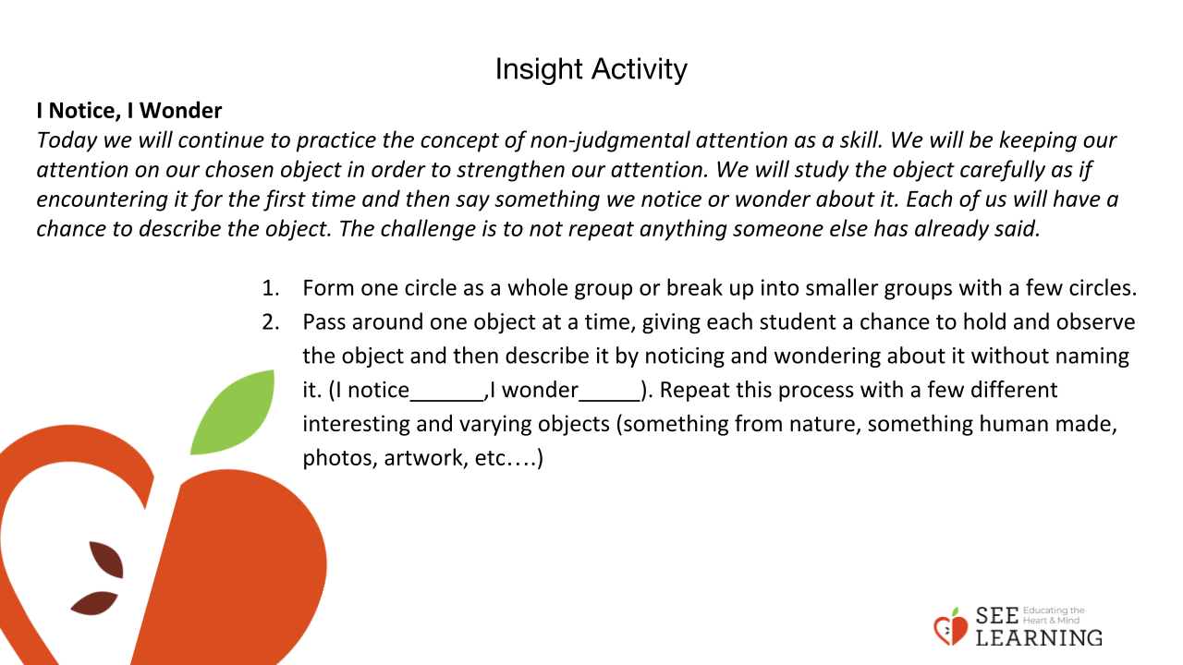 | Instructions and Guided Language  “Today we will continue to practice the  concept of non-judgmental attention as  a skill.  We will be keeping our attention on  our chosen object in order to strengthen  our attention.  We will study the object carefully as if  encountering it for the first time and then say  something we notice or wonder about it.  Each of us will have a chance to describe  the object. The challenge is to not repeat  anything someone else has already said.”  • Form one circle as a whole group or break up  into smaller groups with a few circles.  • Pass around one object at a time, giving  each student a chance to hold and observe  the object and then describe it by noticing  and wondering about it without naming it.  (I notice______,I wonder_____).  Repeat this process with a few different  interesting and varying objects (something  from nature, something human made, photos,  artwork, etc....)

Reflective Practice (10 mins)
Slide 5: Reflective Practice  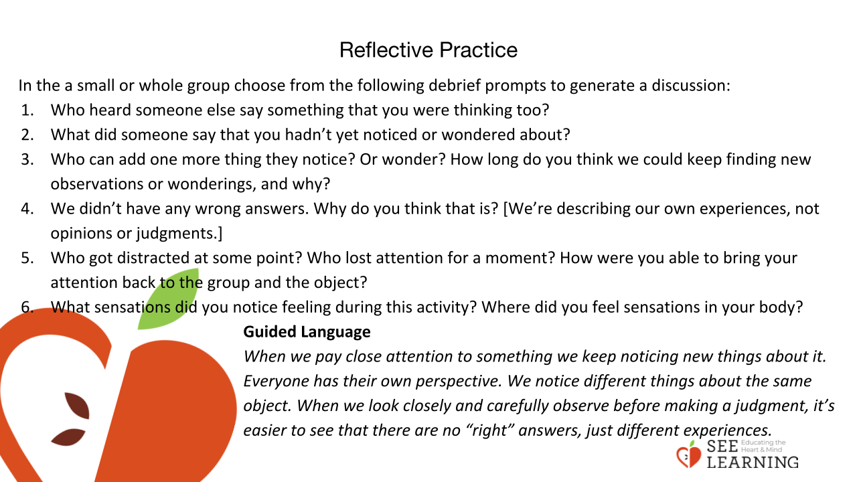 | Instructions and Guided Language  In the circle or in pairs, ask students to debrief  choosing from the following questions:  • Who heard someone else say something that  you were thinking too?  • What did someone say that you hadn’t yet  noticed or wondered about?  • Who can add one more thing they notice?  Or wonder?  How long do you think we could keep finding  new observations or wonderings, and why?  • We didn’t have any wrong answers.  Why do you think that is? [We’re describing  our own experiences, not opinions or  judgments.]  • Who got distracted at some point?  Who lost attention for a moment?  How were you able to bring your attention  back to the group and the object?  • What sensations did you notice feeling  during this activity?  Where did you feel sensations in your body?  Guided Language  “When we pay close attention to something,  we keep noticing new things about it.  Everyone has their own perspective.  We notice different things about the same  object.  When we look closely and carefully, observe  before making a judgment.  It’s easier to see that there are no “right”  answers, just different experiences.”

