Exploring the Mind

Purpose:
In this learning experience, students will engage in a vocabulary mixer through the structure
of a jigsaw activity. Students will illustrate and describe a concept and share their findings
with the rest of the class. Students will engage in a focusing practice and describe the
benefits this practice can have on the mind and body.
Learning Objectives:  Students will be able to:  - Explore what is meant by “mind” and  - the ways we can study the mind  - Learn that people can calm and stabilize  - their mind by using strategies that help  - them to relax and settle  - Explore the similarities people share,  - with regard to our minds and mental  - experiences | Primary Core Component  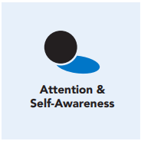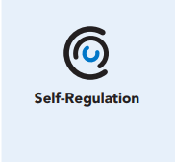
Length  45 Minutes | Materials Required  - Vocabulary Mixer  - Writing utensils and paper  - Markers

Check-In (5 min)
Slide 2: Check-In  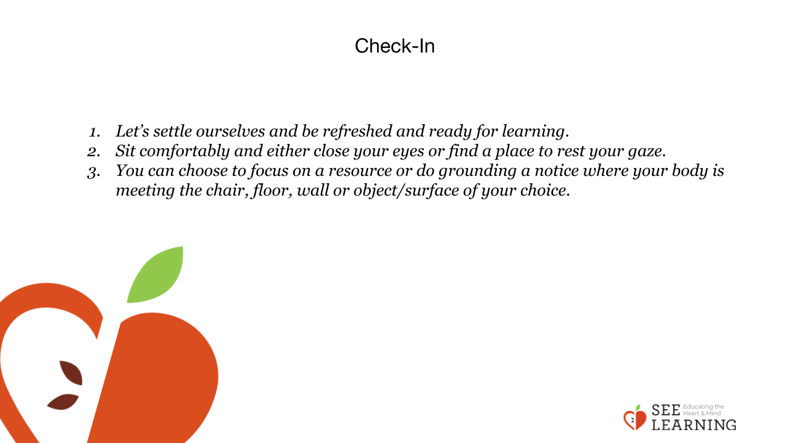 | Instructions and Guiding Language  Settling Activity  Guiding Language  [PAUSE]s can be up to 10 seconds each  • “Let’s settle ourselves and be refreshed  and ready for learning.  • Sit comfortably and either close your eyes  or find a place to rest your gaze. [PAUSE]  • You can choose to focus on a resource or  do grounding.  • If you do grounding, notice where your  body is meeting the chair, floor, wall or  object/surface of your choice.

Presentation - The Mind Jar (15 min)
Slide 3: Presentation - The Mind Jar  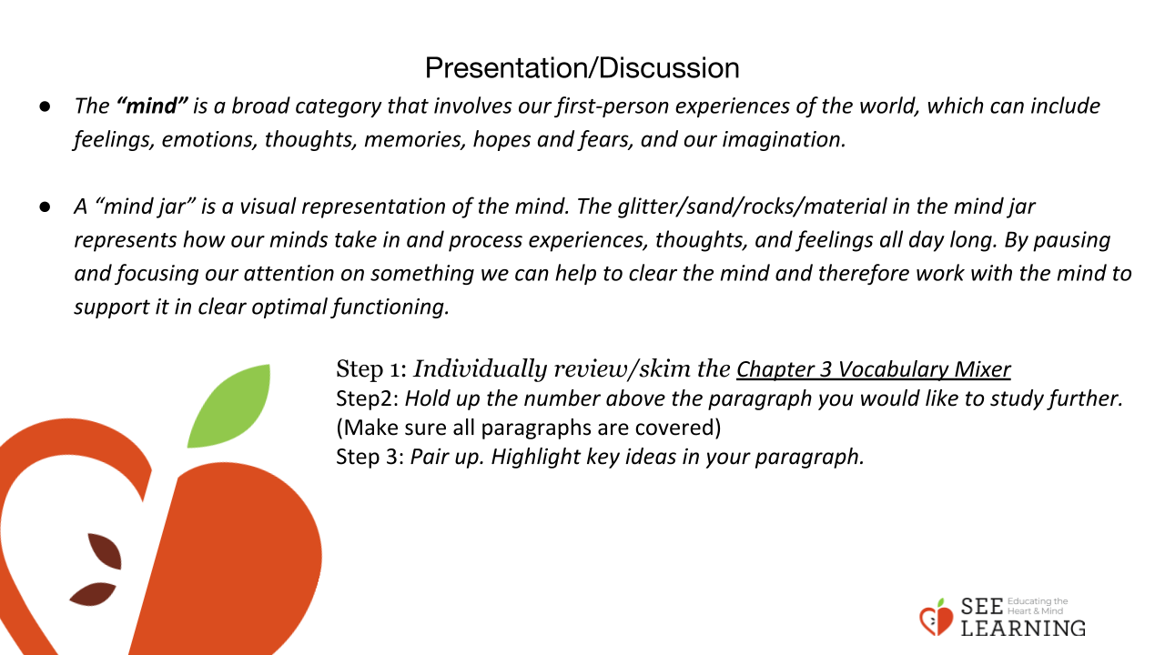 | Instructions and Guiding Language  “The “mind” is a broad category that  involves our first-person experiences of the  world, which can include feelings, emotions,  thoughts, memories, hopes and fears, and  our imagination.  A “mind jar” is a visual representation of  the mind.”  Show the mind jar.  “The glitter/sand/rocks/material in the mind  jar represents how our minds take in and  process experiences, thoughts, and feelings  all day long.  When we don’t pause to check in with  and clear the mind our thinking can  become cloudy.  By considering the metaphor of the mind jar  we can learn that our mind can be relatively  clear or cloudy, making it easier or harder  to discern what is happening within us and  around us; that the way we perceive things is  affected by the state of our own mind.  By pausing and focusing our attention on  something, we can help to clear the mind and  therefore work with the mind to support it in  clear optimal functioning.  Another way we can work with our mind and  support a healthy mind is by understanding it.  There are a few methods we can use to study  the mind and we will explore those today.  When we have a better understanding of how  the mind works, we can use this knowledge  to increase our focusing skills and create  productive neural pathways in the brain.  This will also help us evaluate what thoughts,  emotions and feelings are beneficial, and  what are harmful, for our and others’  wellbeing. Thus, helping us cultivate  Ethical discernment.”

Insight Activity - The Mind Jar (15 min)
Slide 4: Insight Activity - The Mind Jar  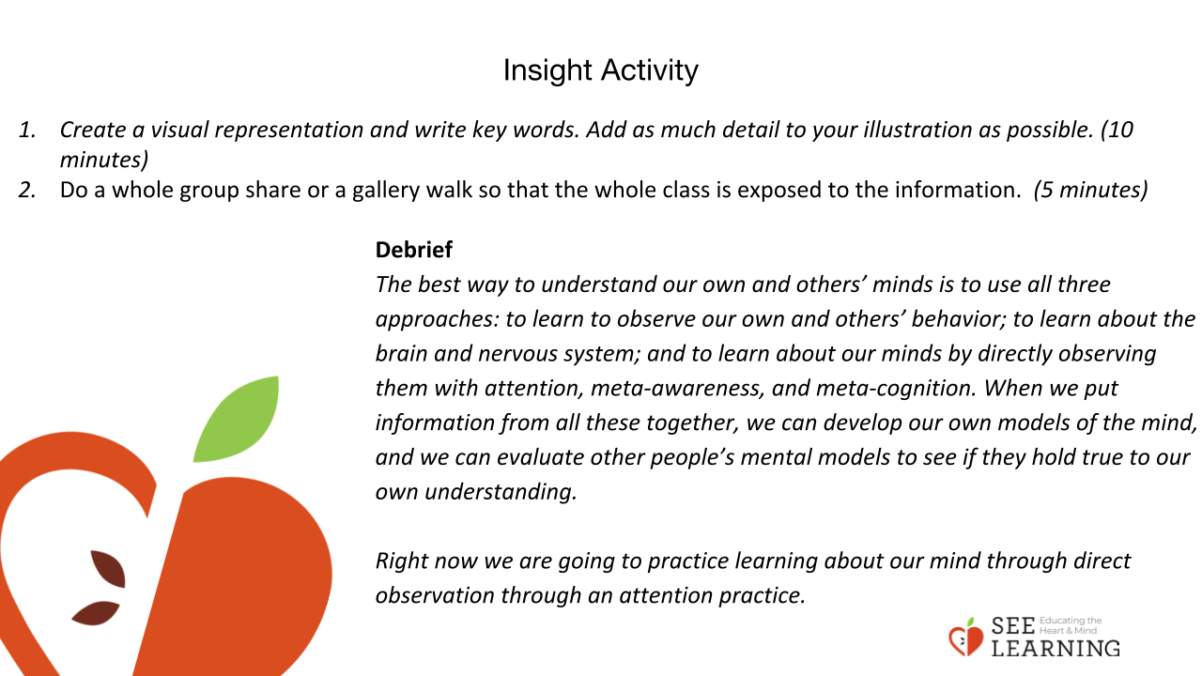 | Instructions and Guiding Language  “Step 1:  Individually review/skim the Chapter 3  Vocabulary Mixer  Step 2:  Hold up the number above the paragraph  you would like to study further. (Make sure all  paragraphs are covered)  Step 3:  • Pair up.  • Highlight key ideas in your paragraph.  • Create a visual representation and write  key words.  • Add as much detail to your illustration  as possible.  Step 4:  Do a whole group share or a gallery walk  so that the whole class is exposed to the  Information.”  Debrief  “The best way to understand our own and  others’ minds is to use all three approaches:  1. to learn to observe our own and  others’ behavior;  2. To learn about the brain and nervous system; and  3. To learn about our minds by directly observing them with attention, meta-awareness, and meta-cognition.  When we put information from all these together, we can develop our own models of the mind, and we can evaluate other people’s mental models to see if they hold true to our own understanding.  Right now we are going to practice learning about our mind through direct observation through an attention practice.”

Reflective Practice - Settling the Mind (10 mins)
Slide 5: Reflective Practice  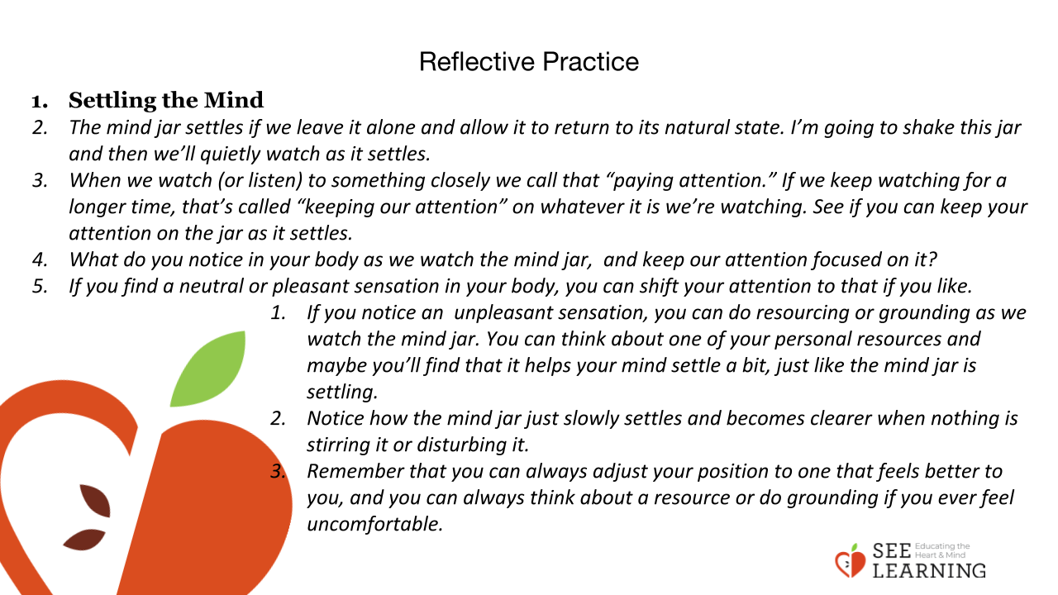 | Instructions and Guided Language  • “I’m going to talk you through a reflective  practice, and then those who wish to can  share out at the end. Remember that you  can always adjust your position to one that  is better for you, and you can always think  about a resource or do grounding, instead  of focusing on the mind jar, if you ever feel  uncomfortable.  • For the next few moments we will focus on  the “Mind Jar”  • The Mind Jar settles if we leave it alone  and allow it to return to its natural state.  I’m going to shake this jar and then we’ll  quietly watch as it settles.  • When we watch (or listen) to something  closely we call that “paying attention.”  • If we keep watching for a longer time,  that’s called “keeping our attention” on  whatever it is we’re watching.  • See if you can keep your attention on the  jar as it settles. [PAUSE]  • What do you notice in your body as  you watch the mind jar, and keep your  attention focused on it? [PAUSE]  • If you find a neutral or pleasant sensation  in your body, you can shift your attention  to that if you like. [PAUSE]  • If you notice an unpleasant sensation, you  can do resourcing or grounding as we  watch the mind jar. You can think about  one of your personal resources and maybe  you’ll find that it helps your mind settle a  bit, just like the mind jar is settling. [PAUSE]  • Notice how the mind jar slowly settles and  becomes clearer when nothing is stirring it  or disturbing it. [PAUSE]  • Remember that you can always adjust  your position to one that feels better to  you, and you can always think about a  resource or do grounding if you ever feel  uncomfortable. [PAUSE]  Journal Entry/Writing Prompt  • “Write down how that experience was for  you. Was it challenging or Easy?  • Consider and record current sensations,  thoughts and feelings.  • Consider the idea of ‘cloudy mind’ and  ‘clear mind’ in general, or something  connected to yourself.”

Debrief (3 mins)
Slide 6: Debrief  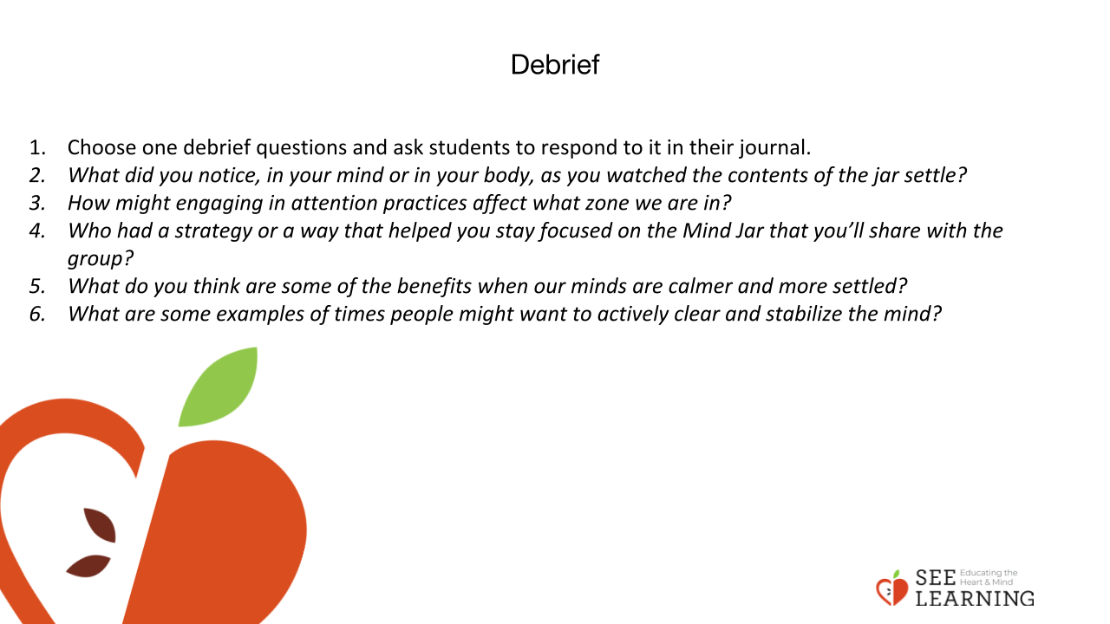 | Instructions and Guided Language  Whole Group or Pairs:  • “What did you notice, in your mind or in  your body, as you watched the contents  of the jar settle?  • How might engaging in attention practices  affect what zone we are in?  • Who had a strategy or a way that helped  you stay focused on the Mind Jar that  you’ll share with the group?  • What do you think are some of the  benefits when our minds are calmer and  more settled?  • What are some examples of times people  might want to actively clear and stabilize  the mind?”

