How Compassion and Stress Affect the Body

Purpose:
In this learning experience, students will read, annotate, and discuss the Stress Contagion Article to develop a deeper understanding of shared impacts of our nervous systems, our levels of awareness, and our personal locus of control over sensations, thoughts and feelings. Students will also envision through reflection how society would be changed if others understood stress contagion.
Learning Objectives:  Students will be able to:  - Examine their understanding of interdependence  - Define the concept of stress contagion  - Describe examples of mirror neurons in action | Primary Core Component  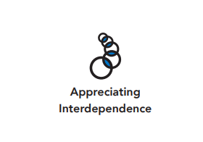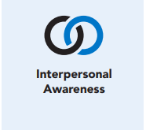
Length  45 Minutes | Materials Required  - Help Now! Strategy images in Chapter 2, Learning Experience 4  - “Stress Contagion Article” (1 copy per student)  - 4As Note Catcher (1 copy per student)  - Writing utensils and paper

Check-In (9 min)
Slide 2: Check-In  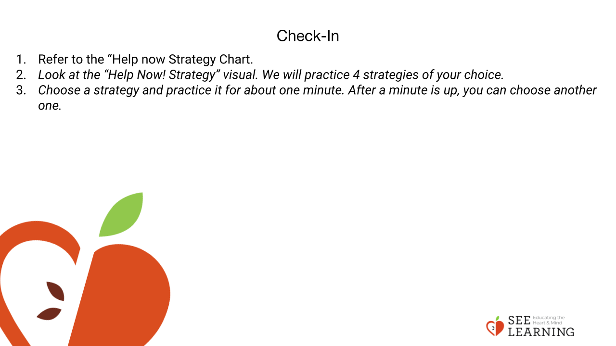 | Instructions and Guiding Language  [PAUSE]s can be up to 10 seconds each.  Instructions and Guiding Language  • Refer to the Help Now! Strategy Chart.  • “Look at the “Help Now! Strategy” pictures. We will practice 4 strategies of your choice.  • Choose a strategy and practice it for about one minute. After a minute is up, you can choose another one.”  • Repeat this process until students have practiced 4 strategies of their choice.

Presentation/Discussion - (10 min)
Instructions and Guiding Language
“Different parts of the nervous system relate to stress and well-being. Some allow us to feel sensations. Those sensations are connected to our body’s ability to get ready for action (sympathetic activation) or to get ready for relaxation, digestion and sleep (parasympathetic activation).

Stress is universal. We all get stuck in our high zones or low zones at some point. What activates us differs from person to person. We can’t access this information directly through thought or emotion, but can through being attentive to the sensations of our body.

Humans and animals get stuck in the high zone or low zone and naturally want relief. We want to find a way to feel better. But sometimes we make choices that are less productive or less healthy than others. We might shout at someone, or criticize someone. We might engage in risky behavior or consume a substance or take an action that makes us feel better temporarily, but that isn’t good for us in the long run.

Some stress responses are healthier, or more appropriate in certain circumstances than others. Some behaviors continue the cycle of stress; others bring us back into our resilient zone. By learning about our nervous system, we gain awareness about ourselves and others. We can work to make intentional choices for ourselves, and can hold compassion for others.”

Insight Activity (15 mins)
Activity Overview
Students will read, annotate, and discuss the “Stress Contagion Article” to develop a deeper understanding of shared impacts of our nervous systems, our levels of awareness, and our personal locus of control over sensations, thoughts and feelings.

Slide 3-4: Insight Activity  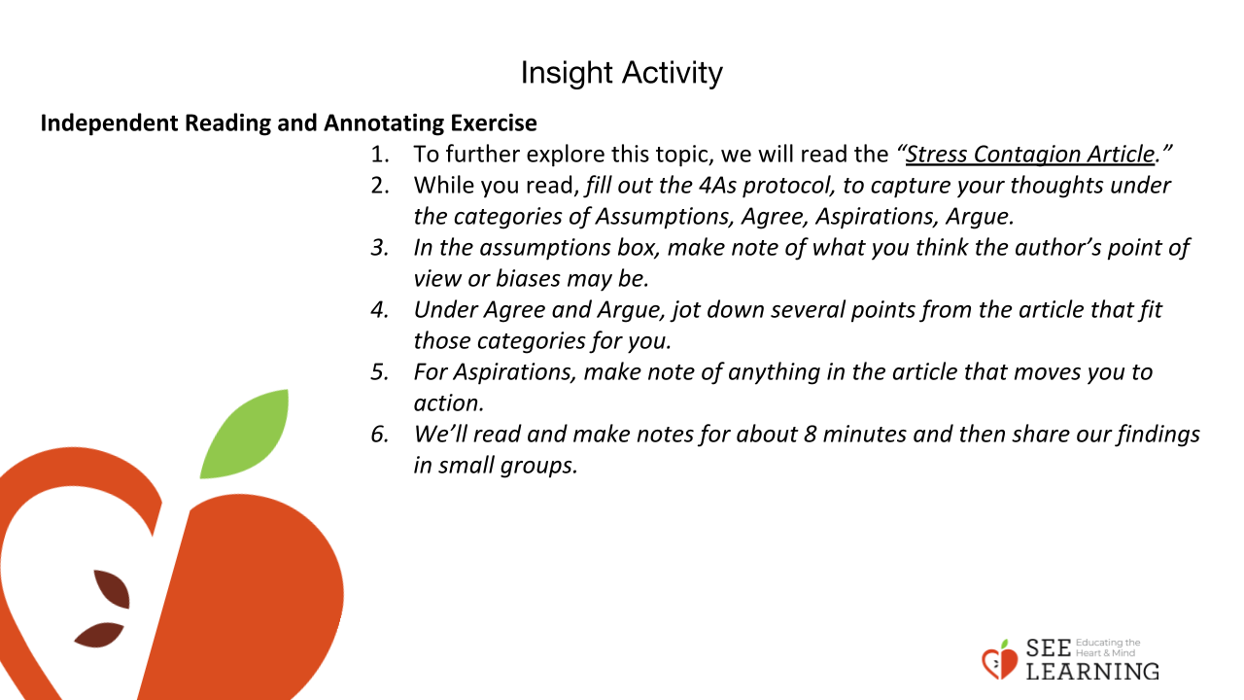  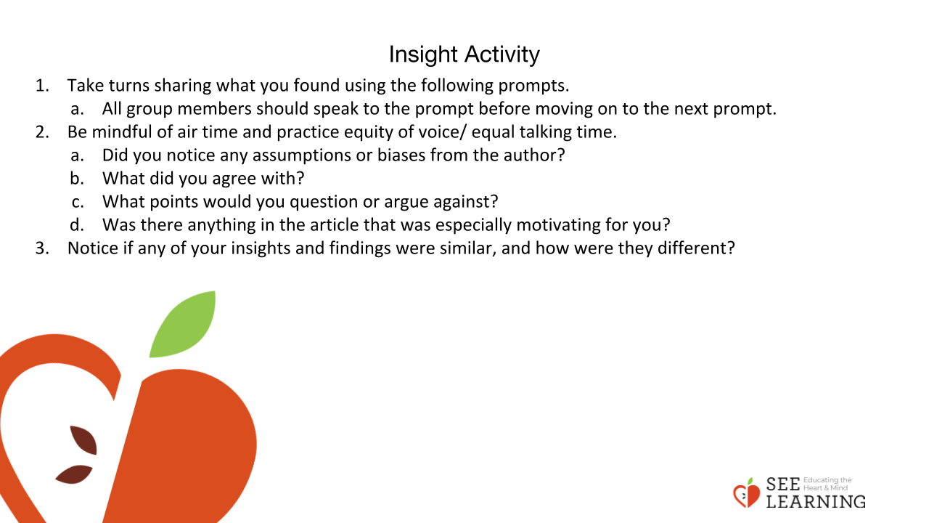 | Instructions and Guiding Language  Review  “The state of our nervous system directly affects our stress levels and well-being.  We can identify sensations and name our own inner state by using the “Resilient Zone” graphic. We can use strategies to stabilize the nervous system and return to and/or maintain an inner state of resilience and well-being.”  Introduce New Information  • “Our nervous system isn’t just an individual matter.  • Scientists have long noticed that we have “emotion contagion.” Emotion contagion describes the way in which we pick up on each others’ emotions because we resonate with each other, even on an unconscious level.  • When someone is outside of their resilient zone, the people around that person will be affected. If someone is solidly in their resilient zone, feeling a lot of safety and well-being, we feel that too and experience our own increased sense of calm and well-being from being connected to them.  • Our individual nervous system picks up on and responds to the state of other people’s nervous systems. The state of our nervous system impacts those around us and vice versa.”  Independent Reading and Annotating Exercise  • To further explore this topic, we will read the “Stress Contagion Article.”  • While you read, fill out the 4As protocol, to capture your thoughts under the categories of Assumptions, Agree, Aspirations, Argue.  • In the assumptions box, make note of what you think the author’s point of view or biases may be.  • Under Agree and Argue, write down several points from the article that fit those categories for you.  • For Aspirations, make note of anything in the article that moves you to action.  • We’ll read and make notes for about 8 minutes and then share our findings in small groups.”  Small Group Work  • “Take turns sharing what you found using the following prompts. All group members should speak to the prompt before moving on to the next prompt.  • Be mindful of air time and practice equity of voice/equal talking time. - Did you notice any assumptions or biases from the author? - What did you agree with? - What points would you question or argue against? - Was there anything in the article that was especially motivating for you?  • Notice if any of your insights and findings were similar, and how were they different?”
Reflective Practice (10 mins)
Slide 5: Reflective Practice  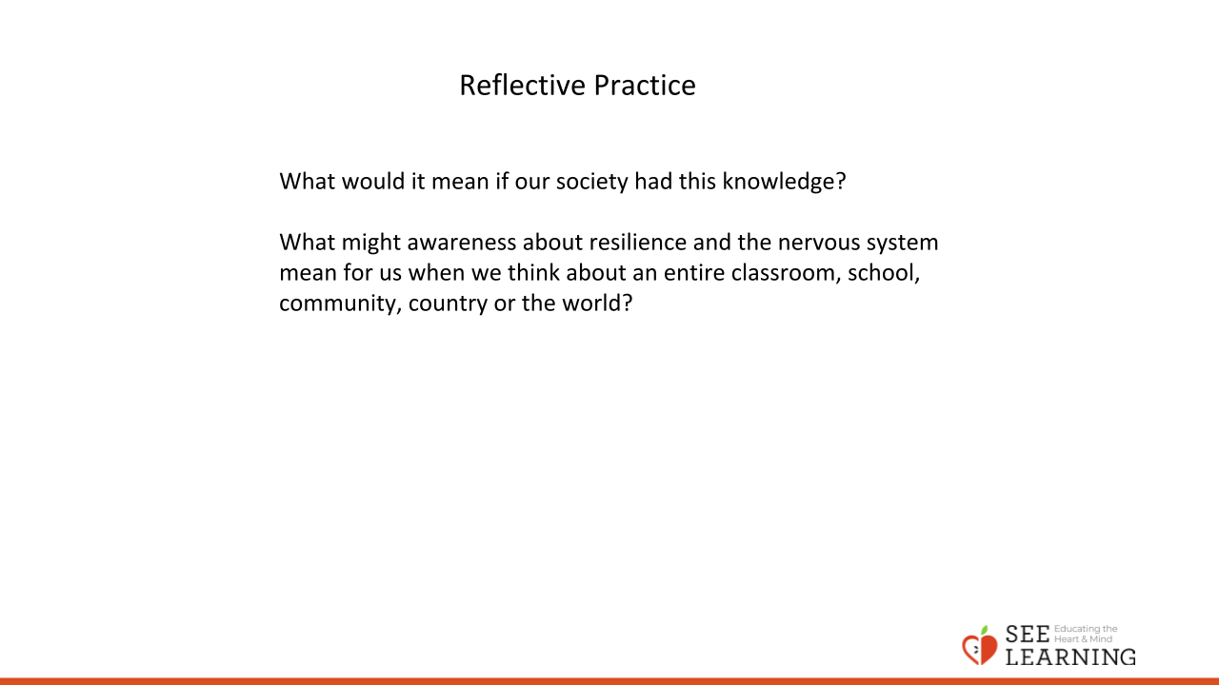 | Instructions and Guiding Language  Instructions  Read the script below and ask students to relax, reflect and listen mindfully.  Resilience for All Reflective Practice Script (6 min)  “Adjust your posture to one that is most comfortable and take a moment to ground — becoming aware of the way your body is supported — or to resource — bringing something to mind that makes you feel better, safer or stronger.  Now, spend a moment to become aware of your natural wish for well-being and to be free of distress and unwanted hardship. Remember that everyone goes through difficult times, but things are always in a constant process of change.  Consider if you are pushing yourself too hard, or having unrealistic expectations for yourself. For example, expectations that you might not have for a good friend. What kind and wise thing might you say to help such a friend if they were in your situation right now?  Take a moment to send yourself that message, and positive, healing thoughts and energy in any way that feels best for you.  Notice what you feel on the inside as you do this. [PAUSE] Now, bring to mind a person to whom you’d like to send resilience and strength.  Picture them sitting or standing before you, if this is helpful.  Take a moment to recognize them as a human being, just like yourself, who wants happiness and doesn’t want distress or unwanted hardship.  Take a moment to recognize whatever hardships they are going through, have been through, or will go through in the future.  Recognize that despite these hardships, they are resilient, because they have made it through thus far, and they’ve kept on going.  Now, send them resilience, strength, support, and compassion in whatever way feels best to you.  If you like, you can picture something that represents this, like sending them a warm, healing light that emanates from your heart and gradually fills their entire body with wellbeing.  If you like, you can also imagine saying to them, “I wish you happiness and freedom from all suffering.”  Notice what you feel on the inside. [PAUSE]  Now let’s take a moment to imagine what society would be like if everything supported the resilience of every person.  You can imagine small changes if you like. Or you can imagine larger, fundamental changes.  Picture in your mind the way people would treat each other, the way they would feel supported, the way they would feel safe to express themselves and their creativity. Take a moment to imagine what this would be like. [PAUSE]  Notice what you feel on the inside. [PAUSE]  Let’s conclude by taking a moment to recognize that we all have the potential to cultivate resilience in ourselves and others.  In small and large ways, we have the ability to bring about a change for good in this world. If you’d like to, bring to mind a sense of that ability and commitment to help make the world a safer, happier, and better place. [PAUSE] Thank you.”  Written or Verbal Reflection  • Answer one or more of the prompts below.  • “What would it mean if our society had this knowledge? • What might awareness about resilience and the nervous system mean for us when we think about an entire classroom, school, community, country or the world?”

