The Practice of Grounding

Purpose:
In this learning experience students will explore a variety of ways to practice grounding. Students will gain insights into what grounding is and how to do it. Students will illustrate the process and benefits of grounding through a collaborative art project.
Learning Objectives:  Students will be able to:  - Practice a variety of grounding strategies and observe how our bodies feel when we move them in certain ways  - Describe that grounding practices are a strategy that can be used to remain and/ or return to the resilient zone/OK zone and bring balance and well-being back to the body and mind.  - Identify that the body and nervous system respond to physical touch, and that they can use this to regulate the nervous system. | Primary Core Component  
Length  45 Minutes | Materials Required  - Chart paper or board space and markers  - Printouts of grounding stations (optional)

Check-In (5 min)
Slide 2: Check-In  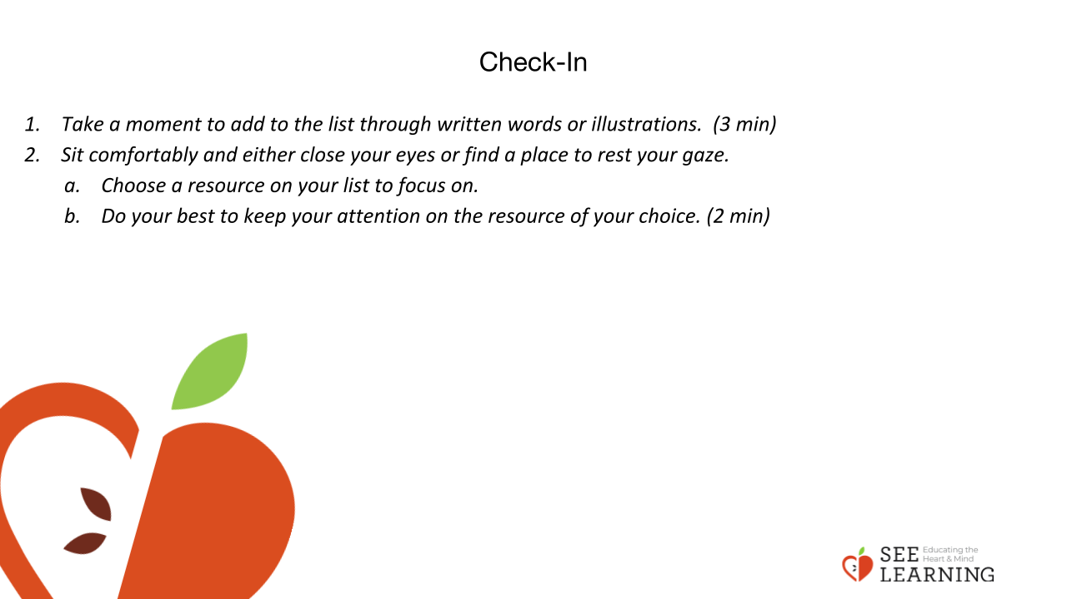 | Instructions and Guiding Language  [PAUSE]s can be up to 10 seconds each.  Guiding Language  “As we settle ourselves today, take out your Personal Resourcing list.  Take a moment to add to the list through written words or illustrations. (3 min)  Sit comfortably and either close your eyes or find a place to rest your gaze.  Choose a resource on your list to focus on. Do your best to keep your attention on the resource of your choice. (2 min)

Presentation/Discussion (10 min)
Instructions and Guiding Language
“The human nervous system responds to the physical contact of our bodies with objects and surfaces.

When we touch certain objects or surfaces, our body can respond by relaxing or regulating itself. This is called grounding.

Then when we pay attention to that response by attending to pleasant or neutral sensations in the body (through tracking), we can allow that response to deepen and spread throughout the body.

Each person has particular grounding techniques that will work best for them.

Practicing grounding can make it easier and more effective over time.

Grounding can help the body feel better, safer, more secure, and more stable. In that sense it is similar to resourcing, except instead of thinking of a resource, grounding involves using physical contact and your sense of touch to achieve a comfortable state.

Sometimes touching a surface or changing the way we are sitting or standing can help our bodies feel better.

Researchers have learned that the human nervous system responds to the physical contact of our bodies with objects and surfaces.

Paying attention to pleasant or neutral sensations in the body when grounding can lead to feeling more relaxed and regulated.

Every person has particular grounding techniques that will work best for them. Like all of our other strategies, grounding is a practice and becomes more effective, over time.

We’re going to be trying out different grounding postures today, like standing, sitting, pushing down on a desk, leaning against the wall, pushing against the wall.

We’ll be pausing briefly during each posture to track our sensations, as we’ve done before, to help us be very intentional.”

Insight Activity (15 min)
Activity Overview
This activity can be led by the teacher, students, or through stations. Students will practice the skill of grounding by trying out different stances and noticing which ones bring about the greatest sense of well-being in their bodies. The students or teacher will read through and practice a variety of grounding postures. The practices will include standing, sitting, pushing down on their desk, leaning on and pushing against the wall and holding an object
Slide 3-5: Insight Activity  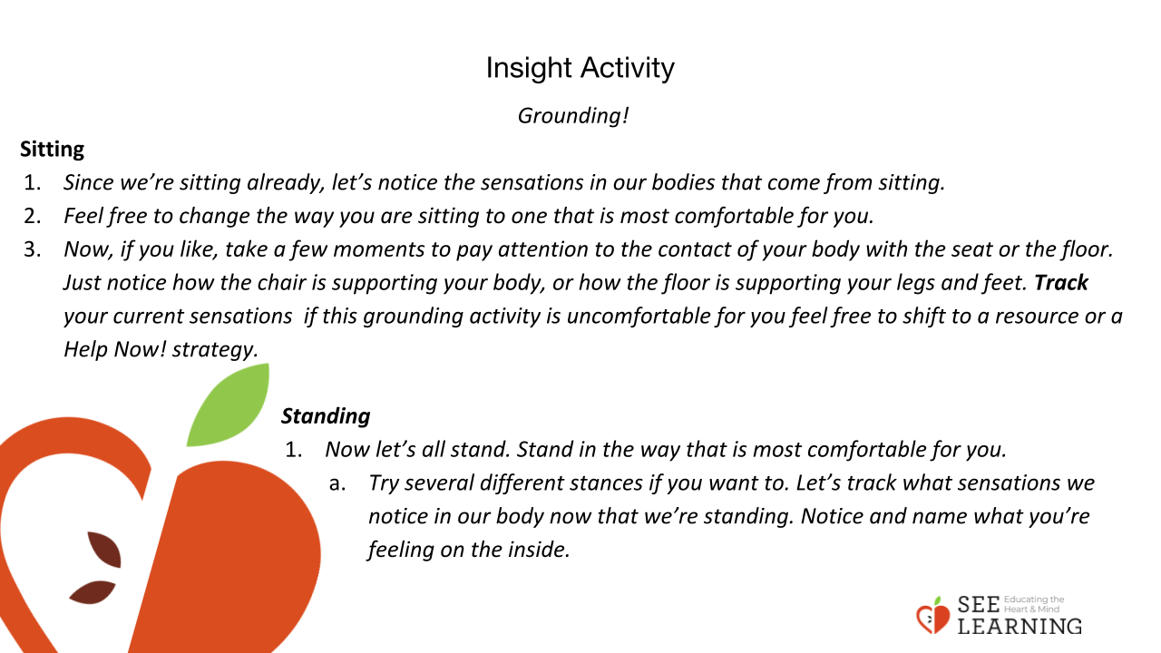  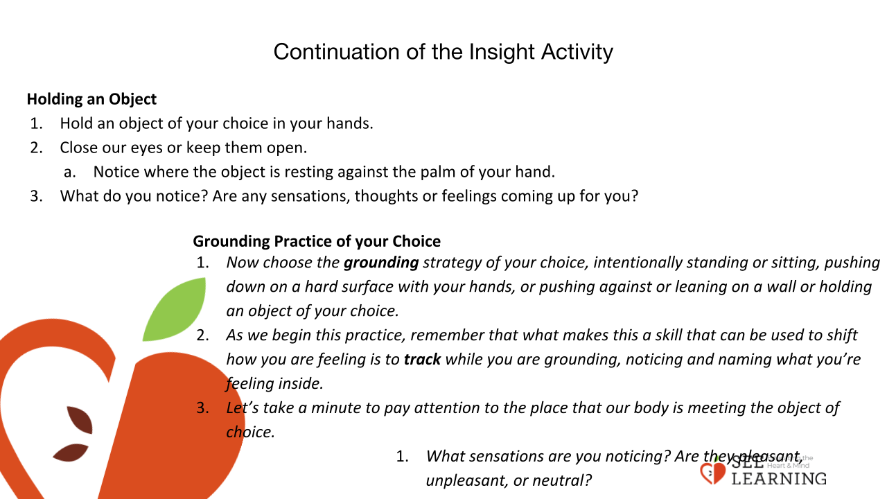  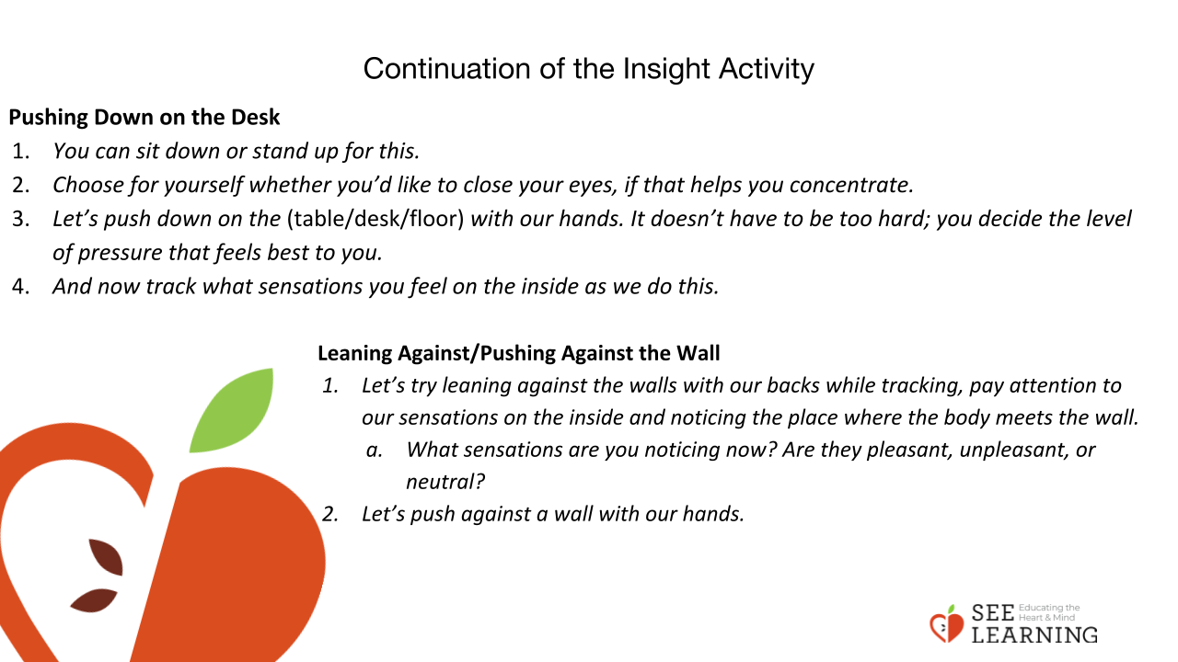 | Instructions and Guiding Language  “When we focus on what our body is in contact with, and how our body feels supported we are practicing grounding. Let’s experiment with the idea of seeing if we feel differently depending on what our body is doing.  We’ll be moving around today, but it’ll be kind of a quiet time because we’ll all be trying to tune in and notice our internal sensations.”  Sitting  “Since we’re sitting already, let’s notice the sensations in our bodies that come from sitting. Feel free to change the way you are sitting to one that is most comfortable for you. [PAUSE]  Now, if you like, take a few moments to pay attention to the contact of your body with the seat or the floor.  Just notice how the chair is supporting your body, or how the floor is supporting your legs and feet. Track your current sensations. If this grounding activity is uncomfortable for you, feel free to shift to a resource or a Help Now! Strategy.” [PAUSE]  Standing  “Now let’s all stand. Stand in the way that is most comfortable for you.  Try several different stances if you want to. Each time, see how your body responds by noticing what happens on the inside. [PAUSE]  Let’s track what sensations we notice in our body now that we’re standing. Notice and name what you’re feeling on the inside.” [PAUSE]  Pushing Down on the Desk  “Let’s try something different. You can sit down or stand up for this. Choose for yourself whether you’d like to close your eyes, if that helps you concentrate. Let’s push down on the (table/desk/floor) with our hands. It doesn’t have to be too hard; you decide the level of pressure that feels best to you. [PAUSE] And now track what sensations you feel on the inside as we do this.” [PAUSE]  Leaning Against/Pushing Against the Wall  “Let’s try leaning against the walls with our backs. And let’s track while we do this, paying attention to our sensations on the inside and noticing the place where the body meets the wall. [PAUSE]  What sensations are you noticing now? Are they pleasant, unpleasant, or neutral? (Invite students to share.) Let’s push against a wall with our hands. While we’re doing that, let’s do tracking.  Let’s notice what sensations are in our body when we push against a wall, and where in our body we feel those sensations.” [PAUSE]  Holding an Object  “Hold an object of your choice in your hands. Close our eyes or keep them open. Feel the weight of the object in your hand. Notice where the object is resting against the palm of your hand. What do you notice? Are any sensations, thoughts or feelings coming up for you?”  Grounding Practice of your Choice  “Now choose the grounding strategy of your choice, intentionally standing or sitting, pushing down on a hard surface with your hands, or pushing against or leaning on a wall, or holding an object of your choice.  As we begin this practice, remember that what makes this a skill that can be used to shift how you are feeling is to track while you are grounding, noticing and naming what you’re feeling inside.  Let’s take a minute to pay attention to the place that our body is meeting the object of choice. What sensations are you noticing?  Are they pleasant, unpleasant, or neutral? (Invite students to share.)  There are no right or wrong answers to these reflection questions. Whatever is true for you, is your right answer.”  Debrief  “Because our nervous system is constantly monitoring the posture of our bodies and the contact of our bodies with objects, including whatever is currently supporting us — such as the floor, a chair or couch, a bed, the ground — simply changing our stance can help the nervous system regulate itself better. Tracking sensations supports a deepening of the experience and the building of body literacy.  We use grounding to help our bodies feel more safe, strong, secure, or happy.  This works because our nervous system always pays attention to the position of our bodies and what we’re in contact with. The body senses our position in space, and in relation to other objects.  The body responds and it senses whether we are feeling better or worse, depending upon our position and what we’re touching.”

Reflective Practice (10 mins)
Slide 5: Reflective Practice  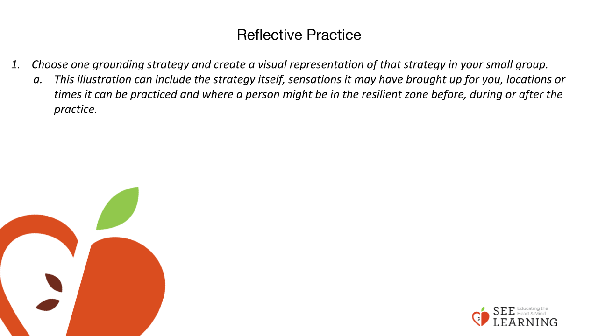 | Instructions and Guiding Language  “Choose one grounding strategy and create a visual representation of that strategy in your small group.  This illustration can include the strategy itself, sensations it may have brought up for you, locations or times it can be practiced and where a person might be in the resilient zone before, during or after the practice. Think of this as a teaching tool that we’ll be able to use to reflect back on today’s learning.  Do a mini gallery walk. Talk to at least one person in the room, pointing out something you especially enjoy or value on one of the posters.”  Teaching Tips As your students grow more familiar with grounding, keep this activity fresh by adding other postures including sitting with one’s back against the wall or lying down if your space permits.  Arm positions, such as folding one’s arms, can also be used. Remember to encourage students to use tracking to notice and name the sensations in their bodies. This will help individuals see which postures are most helpful to them.  Suggest to students who are of shorter stature to try a position where their feet are touching the floor or ground. If their feet do not touch the ground, stack books or something that can help them sense their feet against a surface.  Some students who have experienced traumatic events, may have sensations of floating or spinning at times. Giving a choice to put something heavy (like a book or their backpack) on their lap, if sitting, can help some of those students experience being grounded for the first time.

