Resourcing to Address Thinking Traps

Purpose:
In this learning experience, students will describe and apply self-regulation strategies including resourcing, grounding, shift and stay, and noticing sensations by completing a graphic organizer while visiting information stations. Students will practice resourcing by creating a written or illustrated list of people, places and/or experiences they appreciate. Finally students will reflect on possible misconceptions around applying self-regulation strategies.
Learning Objectives:  Students will be able to:  - Apply regulation strategies including resourcing, tracking, and shift and stay to increase awareness and steady the mind-body  - Practice resourcing by creating a written and/or illustrated list of appreciations and reflections that promote self-compassion | Primary Core Component  
Length  45 Minutes | Materials Required  - Self-Regulation Skills Gallery Walk (one per class)  - Self-Regulation Terms handout (one per student)  - Paper and drawing materials

Check-In (10 min)
Slide 2 and 3: Check-In  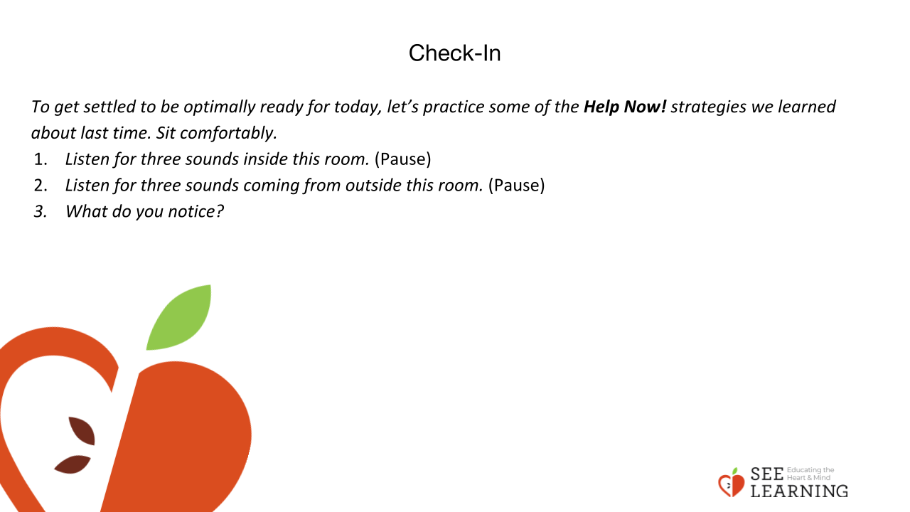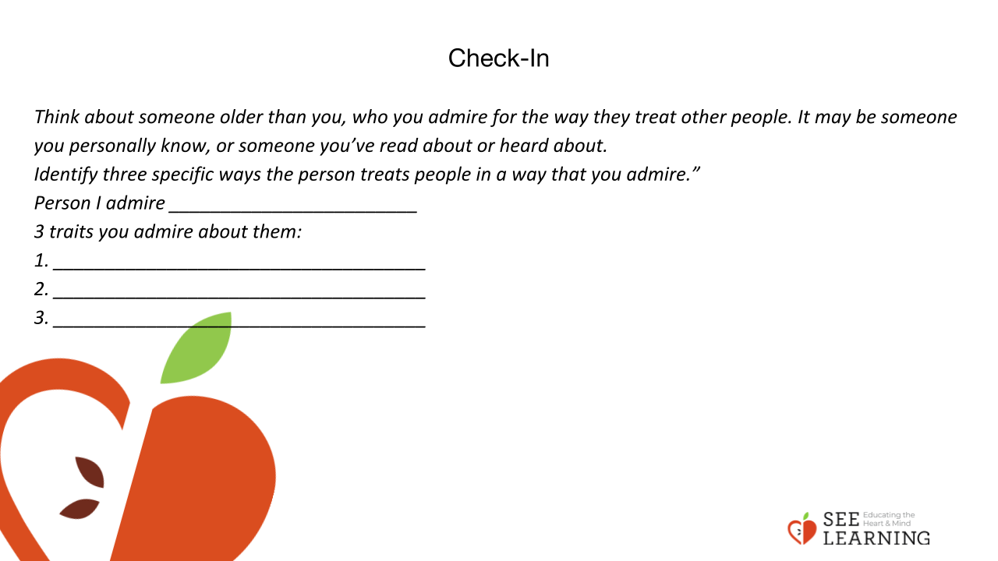 | Instructions and Guiding Language  Settling Activity (5 minutes)  [PAUSE]s can be up to 10 seconds each.  “To get settled to be optimally ready for today, let’s practice some of the Help Now! Strategies we learned about last time. Sit comfortably. If paying attention to specific sounds is unpleasant, you can always shift to a sense that is more pleasant for you.  • Listen for three sounds inside this room. [PAUSE]  • Listen for three sounds coming from outside this room. [PAUSE]  • What do you notice on the inside? Do you notice any pleasant or neutral sensations? If you notice an unpleasant sensation, remember that you can shift your attention to a part of your body that feels better. [PAUSE]  • Look around the room for something that catches your attention; an object, a color, the light, a person. ([PAUSE]  • What do you notice on the inside? [PAUSE]  • What else do you notice on the inside? Do the sensations you notice change or stay the same? [PAUSE]  • When you’re ready, shift your attention from this internal awareness back to our group.”  Check-in (5 minutes)  “Think about someone older than you, who you admire for the way they treat other people. It may be someone you personally know, or someone you’ve read about or heard about.  Identify three specific ways the person treats people in a way that you admire.”  Person I admire ________________________  3 traits you admire about them:  1. ____________________________________  2. ____________________________________  3. ____________________________________  “Share your ideas with a partner. As you are describing this person, notice any sensations or feelings that you might be experiencing.”

Insight Activity and Presentation - Self-Regulation Skills Gallery Walk (20 min)
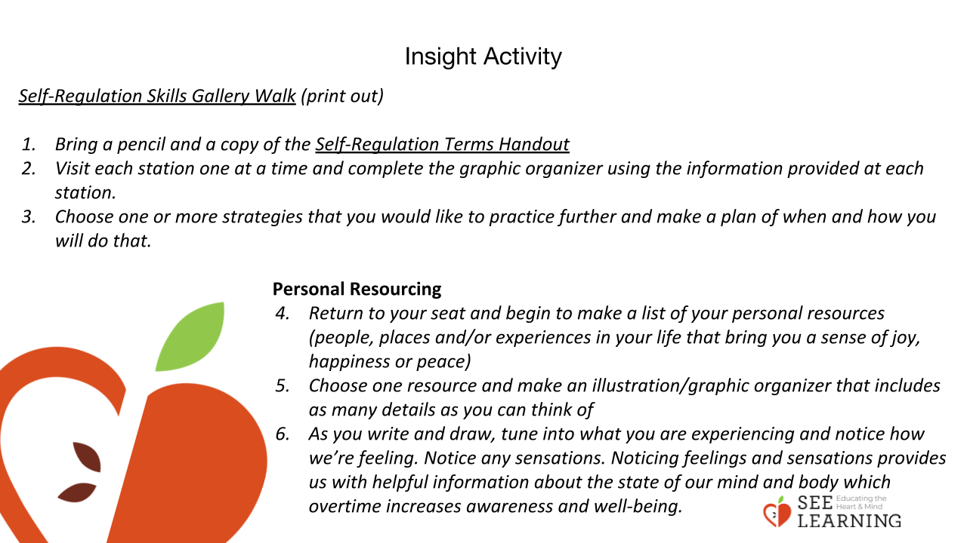 | Instructions and Guiding Language  Cut out and place the Self-Regulation Skills Gallery Walk Station descriptions at different places in the classroom for students to visit.  1. “Bring a pencil and a copy of the Self-Regulation Terms Handout  2. Visit each station one at a time and complete the graphic organizer using the information provided at each station.  3. Choose one or more strategies that you would like to practice further and make a plan of when and how you will do that.  Personal Resourcing  4. Return to your seat and begin to make a list of your personal resources (people, places and/or experiences in your life that make you feel better, happier or safer)  5. Choose one resource and make an illustration including as many details as you can  6. As you write and draw, tune in and notice how you’re feeling. Notice any sensations. Noticing feelings and sensations provides us with helpful information about the state of our mind and body which over time can increase awareness and well-being.”
Reflective Practice (10 min)
Slide 5: Reflective Practice  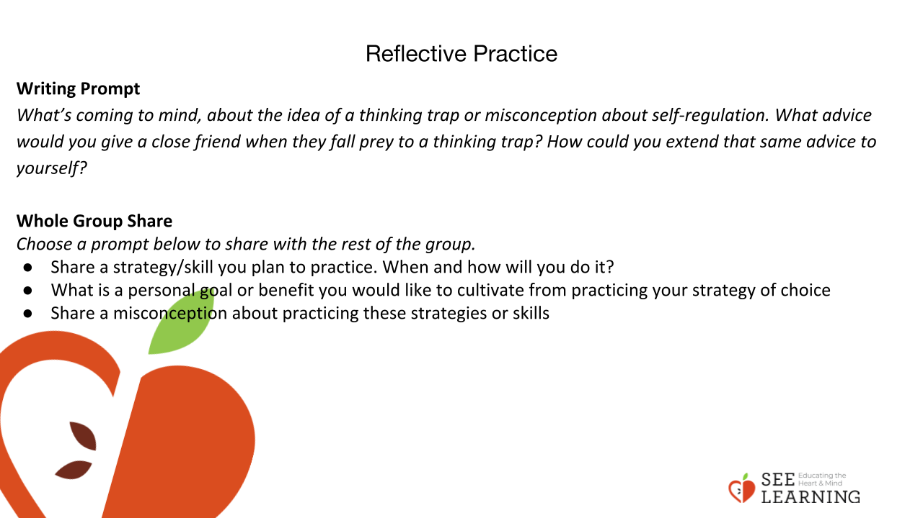 | Instructions and Guiding Language  Explain  “There can be thinking traps that are misconceptions, which can prevent us from seeing the benefit of practicing self-regulation skills and strategies. When this happens, we have to analyze the value closely and see what it involves.  Misconceptions around practicing selfregulation could include the idea that it s a weakness, that it won’t actually work, or that you don’t have time for it.  Let’s think about that for a bit.”  Writing Prompt  “What’s coming to mind for you about the idea of a thinking trap or a misconception about self-regulation?  What advice would you give a close friend when they fall prey to a thinking trap?  How could you extend that same advice to yourself?”  Whole Group Share “Choose a prompt below to share with the rest of the group.  • Share a strategy/skill you plan to practice. When and how will you do it?  • What is a personal goal or benefit you would like to cultivate from practicing your strategy of choice?  • Share a misconception about practicing these strategies or skills.”

