Exploring Sensations and Help Now! Strategies

Purpose:
In this learning experience, students will explore sensations and their relationship to our nervous system. Students will build an expanded vocabulary with which to describe these nuanced understandings. Students will learn Help Now! Strategies that draw on the classroom environment. Help Now! Strategies (developed by Elaine Miller-Karas and the Trauma Resource Institute and used by permission in SEE Learning) are readily accessible tools to help students return themselves to a regulated body state when they get stuck in a dysregulated state such as being overly agitated or filled with heightened excitement. These strategies provide a platform for learning about the concept of sensations and to build a regular practice of attending to them.
Learning Objectives:  Students will be able to:  - Demonstrate the ability to practice self-awareness by noticing sensations, thoughts, and feelings that accompany their experience of practicing each Help Now! Strategy  - Describe how intentionally recognizing inner sensations, emotional and mental states supports the function of the nervous system in keeping the body balanced and calm. | Primary Core Component  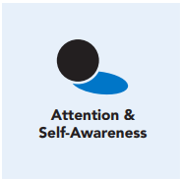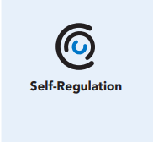
Length  45 Minutes | Materials Required  - Class agreements written on poster and markers  - Chart paper or board space and markers to record student brainstorm responses  - A handout for each student with the Help Now! Strategies  - Optional: a copy of the Help Now! Strategies to post on the walls handout, one per student

Check-In (5 min)
Slide 2: Check-In  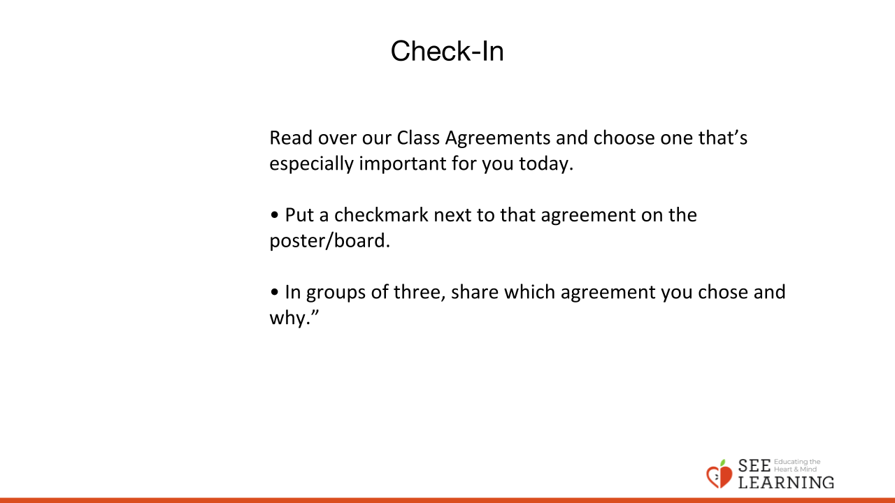 | Instructions and Guiding Language  [PAUSE]s can be up to 10 seconds each.  • “Read over our Class Agreements and choose one that’s especially important for you today.  • Put a checkmark next to that agreement on the poster/board.  • In groups of three, share which agreement you chose and why.”  Debrief (5 minutes)  “Let’s take a look at the messages we’ve given one another about what’s most important for us to pay attention to during our time together today. [PAUSE] All of our agreements are valuable, yet we know that we all have different things going on in our lives on any given day. [PAUSE]  What are a couple of messages you’re getting from the checkmarks we all placed by agreements today?”  Settling Activity (3 minutes)  • “We’ll all settle in and be as quiet as possible for one full minute. I’ll time it and then get your attention so we can share what we noticed.  • You can: - Tune into your hearing, one of your five senses. Pay careful attention to whatever sounds you may hear. See if you can identify three sounds inside the room. (PAUSE 30 seconds) - Now see if you can identify any sounds outside the room. (PAUSE 30 seconds)  • Pair up and answer the following questions: - What sounds did you notice? - Were you able to identify where they were coming from? - What was making the sound? Or - Tune in to your vision, your sense of sight. Identify three or more colors or items inside the room. (PAUSE 30 seconds)  • Pair up and answer the following questions: - What did you notice? - As you noticed the colors and items in the room, where you in the high, low, or okay zone?”

Presentation/Discussion - The Nervous System and Sensations (5 min)
Slide 3: Presentation/Discussion  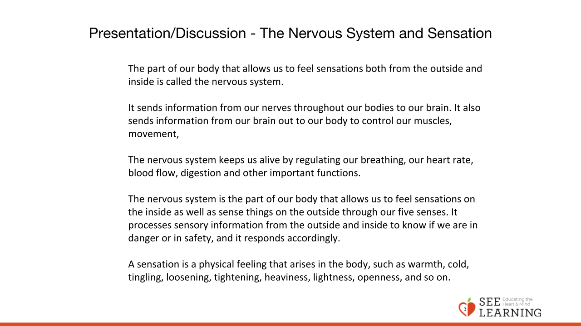 | Instructions and Guided Language  Display an image of the nervous system.  “The part of our body that allows us to feel sensations both from the outside and inside is called the nervous system.  It sends information from our nerves throughout our bodies to our brain. It also sends information from our brain out to our body to control our muscles, movement,  The nervous system keeps us alive by regulating our breathing, our heart rate, blood flow, digestion and other important functions.  The nervous system is the part of our body that allows us to feel sensations on the inside as well as sense things on the outside through our five senses. It processes sensory information from the outside and inside to know if we are in danger or in safety, and it responds accordingly.  A sensation is a physical feeling that arises in the body, such as warmth, cold, tingling, loosening, tightening, heaviness, lightness, openness, and so on.  Physical sensation words are different from general feeling words like good, bad, stressed, relieved, et cetera. They are also different from emotion words like happy, sad, afraid, and excited. Just as we can sense things on the outside with our five senses, we can pay attention to sensations inside our bodies as well. Sensations can be pleasant, unpleasant, or neutral.  For example, an external sensation could be feeling the warmth of the sun on our face when outdoors. An internal sensation could be the warm rush of blood to our cheeks when we are feeling embarrassed.  We are capable of increasing our ability to recognize sensations, which in turn gives us critical information about how our nervous system is operating.  Recognizing and identifying sensations as they occur is a practice we can use to support optimal functioning of our nervous system which can assist the body in self-regulating.  Help Now! Strategies are not complicated to learn, and can be used anytime and anywhere to help our bodies become calmer and feel safer. One of those strategies is noticing sensations. When we practice this and other strategies we have agency over our responses, and can regulate ourselves.  Help Now! Strategies were developed to give adults and young people small, doable actions that, when practiced and practiced, can be useful in times of stress or distress, for calming ourselves and regaining our ability to pause, think, and choose how to act.  Help Now! Strategies involve doing a simple physical or mental task that redirects our attention, thereby giving our autonomic nervous system a chance to “reset.”  Research shows that when the nervous system is dysregulated, directing attention to other sensations by doing activities like the Help Now! Strategies can have a regulating effect on the body, sometimes within seconds.  Help Now! Strategies also tend to work best when coupled with tracking (paying attention to sensations inside our body).”

Insight Activity (15 mins)
Slide 4: Insight Activity  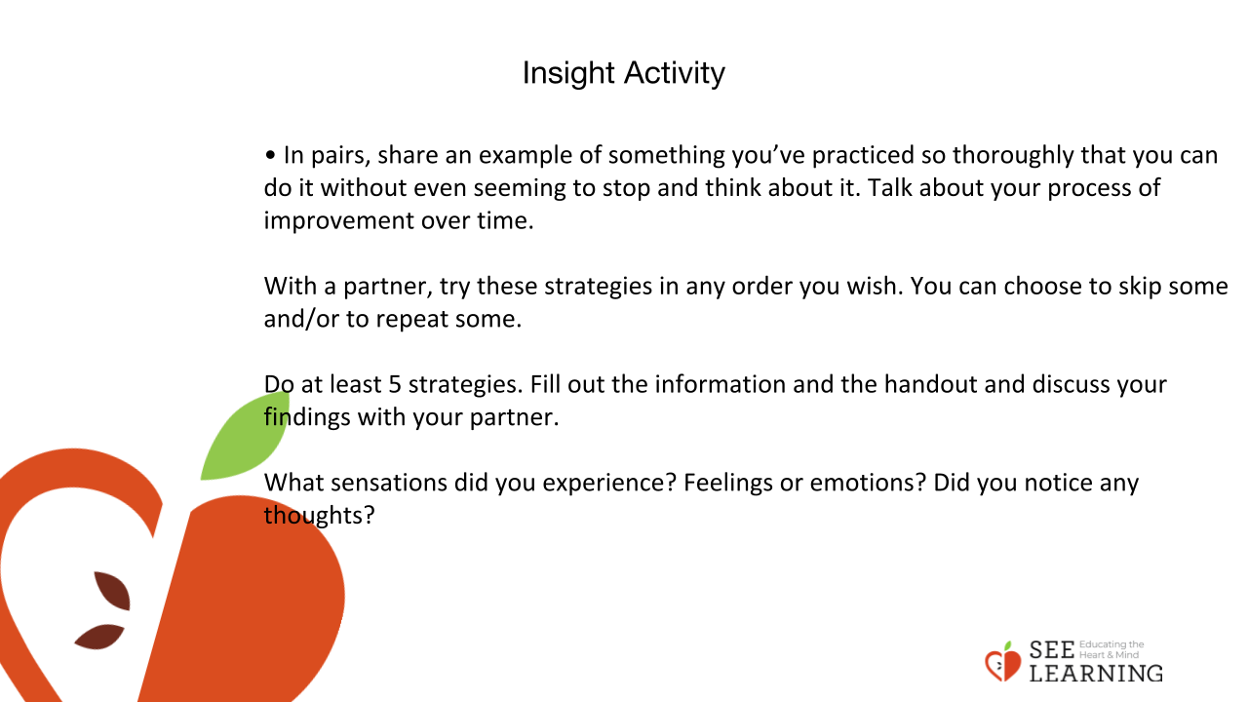 | Instructions and Guided Language  Help Now Strategies  • “Think of one or two skills you have, maybe in sports, or related to music or school, any situation where you’ve practiced something so many times that it’s just second nature now, you don’t really even have to consciously think about how to do it.  • In pairs, share an example of something you’ve practiced so thoroughly that you can do it without even seeming to stop and think about it. Talk about your process of improvement over time.  • The strategies that we are learning about also need to be practiced again and again. For these strategies to be readily available to us in challenging times, we have to practice them many, many times when we are already in our Resilient Zone. This helps build the ‘muscle memory’ needed for the skill to be readily available when we need it. • Introduce and explain the Help Now! Strategies hand out. Come up with one example together as class.  • With a partner, try these strategies in any order you wish. You can choose to skip some and/or to repeat some. Do at least 5 strategies. Fill out the information and the handout and discuss your findings with your partner. What sensations did you experience? Feelings or emotions? Did you notice any thoughts?

Reflective Practice (10 mins)
Slide 5: Reflective Practice  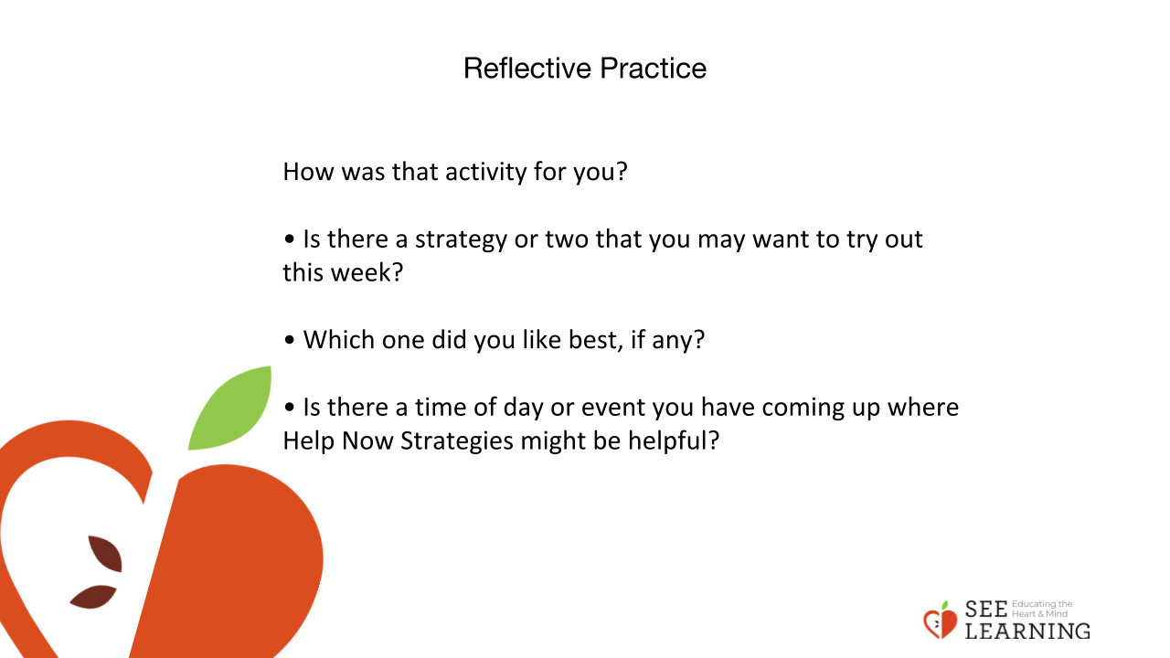 | Instructions and Guided Language  Applying the Practices  • “How was that activity for you?  • Is there a strategy or two that you may want to try out this week?  • Which one did you like best, if any?  • Is there a time of day or event you have coming up where Help Now Strategies might be helpful?  Rainstorm  If possible, have the group make a circle around the perimeter of the room so that everyone can see you and one another. Or direct them to go ‘up and down each row’ if they are seated in desks.  • “We’re going to create a rainstorm together. Has anyone done this before? • I’ll start a motion, and you’ll all join in with the same motion, one at a time, in the order we’ve just established.  • Continue until the last participant is doing the same motion the leader is. The leader will switch to the next action and continue it while other participants pick it up in order around the group again. We will repeat until the game is done, and the storm has ended!”  Leader Actions:  • Rub palms together slowly  • Rub palms together quickly (produces more noise)  • Slow snapping of fingers  • Faster snapping of fingers (produces more noise)  • Slapping thighs with hands  • Faster snapping of fingers (produces more noise)  • Slow snapping of fingers  • Rub palms together quickly (produces more noise)  • Rub palms together slowly  • Stop (and the noise of the ‘storm’ will die down as each participant finishes in turn)  “So! There were some sensations!  Touch, sound, movement through space, seeing each other...what a wealth of sensory information we just gave ourselves, reminding us of the importance of having fun together! What do you notice on the inside? [PAUSE for brief sharing. Note that some students may not have enjoyed rubbing their palms together or snapping their fingers. Validate that they are paying attention to their nervous systems and building body literacy by noticing what it finds pleasant, neutral, and unpleasant.]

