Exploring Sensations and Help Now! Strategies

Purpose:
In this learning experience, students will explore sensations and their relationship to our nervous system. Students will build an expanded vocabulary with which to describe these nuanced understandings. Students will learn Help Now! Strategies that draw on the classroom environment. Help Now! Strategies (developed by Elaine Miller-Karas and the Trauma Resource Institute and used by permission in SEE Learning) are readily accessible tools to help students return themselves to a regulated body state when they get stuck in a dysregulated state such as being overly agitated or filled with heightened excitement. These strategies provide a platform for learning about the concept of sensations and to build a regular practice of attending to them.
Learning Objectives:  Students will be able to:  - Apply the resilient zone (which also may be called the okay zone or zone of well-being), the low zone and the high zone to a fictional character.  - Identify how the resilient zone graphic can frame their understanding of resiliency by understanding triggers that can bump us out of our “OK Zone” and practices that help support resiliency and the ability to return to our “Resilient Zone” | Primary Core Component  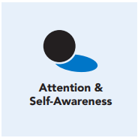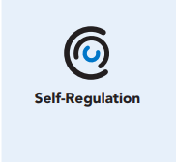
Length  45 Minutes | Materials Required  - Blank Zones graphic  - Resilient Zone Partner Brainstorm Note catcher (one per pair)  - Clarifications and Champions handout, one per student

Check-In (5 min)
Slide 2: Check-In  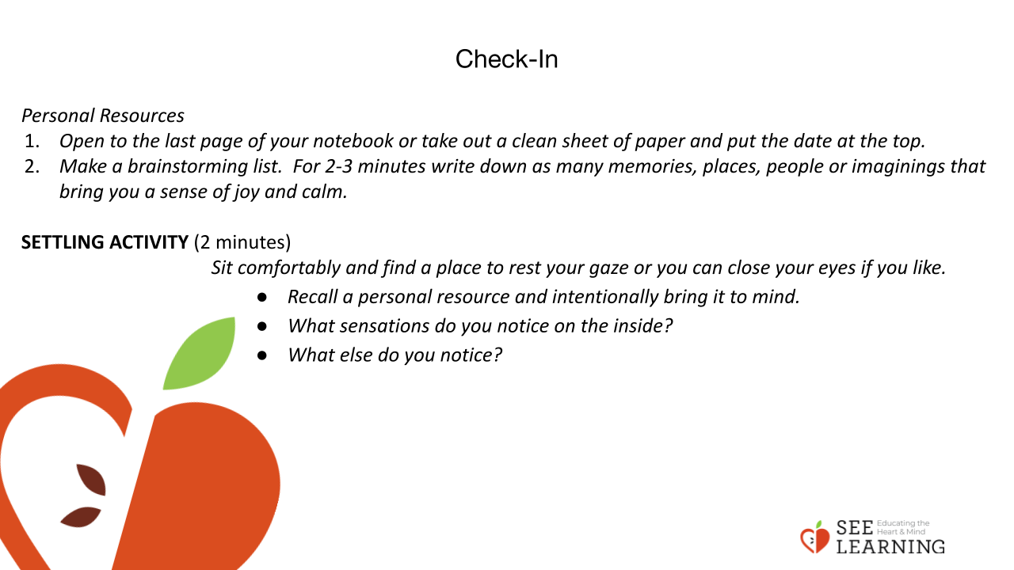 | Instructions and Guiding Language  “Open to the last page of your notebook or take out a clean sheet of paper and put the date at the top.  Make a brainstorming list. For 2-3 minutes, write down as many memories, places, people or imaginings as you can that bring you a sense of joy and calm. This will be a quick exercise to capture as long of a list as you can of examples to use later. (2-3 minutes)  We just made a list of personal resources. Personal Resources are internal, external, or imagined things that can help us feel better, safer or more resilient when we think of them. They are unique to each person and change with time and experiences.  There is value to noticing positive moments in our daily lives. A consistent positive aspect of our life can act kind of like an anchor, that when we think of it — this person, place, object, memory or idea — we feel better, safer, stronger, or more resilient.  When we intentionally bring these aspects to mind and notice the sensations, we are practicing resourcing in an embodied way. It is important to feel the full sensory experience of the resource.”  Settling Activity (2 minutes)  Guiding Language  “Let’s settle ourselves and be refreshed and ready for learning. Sit comfortably and find a place to rest your gaze or you can close your eyes if you like.  • Recall a personal resource and intentionally bring it to mind, recalling the details. [PAUSE]  • What sensations do you notice on the inside? [PAUSE]  • Can you draw your attention to the pleasant or neutral sensations connected to your resource?  • As you notice pleasant or neutral sensations, what else do you notice? [PAUSE] See if the sensations change or if they stay the same. [PAUSE]  • If at any time the sensations become too unpleasant, you can shift your attention back to the classroom away from the internal awareness. [PAUSE]  • When you’re ready, shift your attention from this internal awareness back to our group.”

Presentation/Discussion - Further Exploration of Resiliency (5 min)
Instructions and Guiding Language
• “What other strategies or practices have we tried out/talked about that might help us build resilience? Last week we practiced noticing sensations/building body literacy and just now, we practiced using personal resourcing.
• We can apply both of these practices proactively to help us build resilience and as an in-the-moment practice for when we get bumped out of the resilient zone.
• Can anyone remind us what resilience means? What does it mean to be resilient? Being resilient means being able to respond in a productive way to challenges, stress, threats, and unexpected surprises.
• Difficulties happen to all of us, in large and small ways. Resilience is something that we have and also something we can develop. By learning to notice what is happening inside us, we can learn strategies that bring us back to our resilient zone when we have been pushed out of it.
• The Resilient Zone graphic gives us a visual to help describe when our mind and body are in a state of well-being. When we are in our resilient zone, we can handle the stresses of daily life and can act and react in healthy ways. We can experience a whole range of emotions and thoughts in our resilient zone — some positive and some negative. When we are in the resilient zone we feel relatively in control.
• What can bump us out of our resilient zone? Stress can bump us out of our resilient zone and into our high or low zone.
• How might a person feel when stuck in the high zone? In the high zone, we may feel anxious, agitated, nervous, angry, or stressed out. Our body is dysregulated, making it hard for us to concentrate, learn new information, or make responsible decisions.
• What about the low zone? When we are stuck in the low zone, we may feel tired, lacking in energy, unexcited about things we normally like, unmotivated, or deflated. It becomes difficult for us to learn new things, solve problems, seek the company of others, or make our best choices.
• Anyone can get bumped into the low or high zone. It can become problematic for us if we get stuck in the low or high zones. The skills can help us develop greater ability to get unstuck.
• Fortunately we all have the ability to recognize when we are bumped into our high and low zones, and we can use skills to get back into the resilient zone. We can use these same skills to stay in our resilient zone, and even to widen our resilient zone, making it less likely for us to be bumped out.”

Insight Activity (15 min)
Activity Overview
Students will build their understanding of the three zones (high, resilient, low) through creating scenarios. The scenarios will include the identification of a trigger that bumps a character out of the “OK Zone” and a strategy or practice that can be used to support a person in returning to the “Resilient Zone” after being bumped out.

Slide 3: Insight Activity  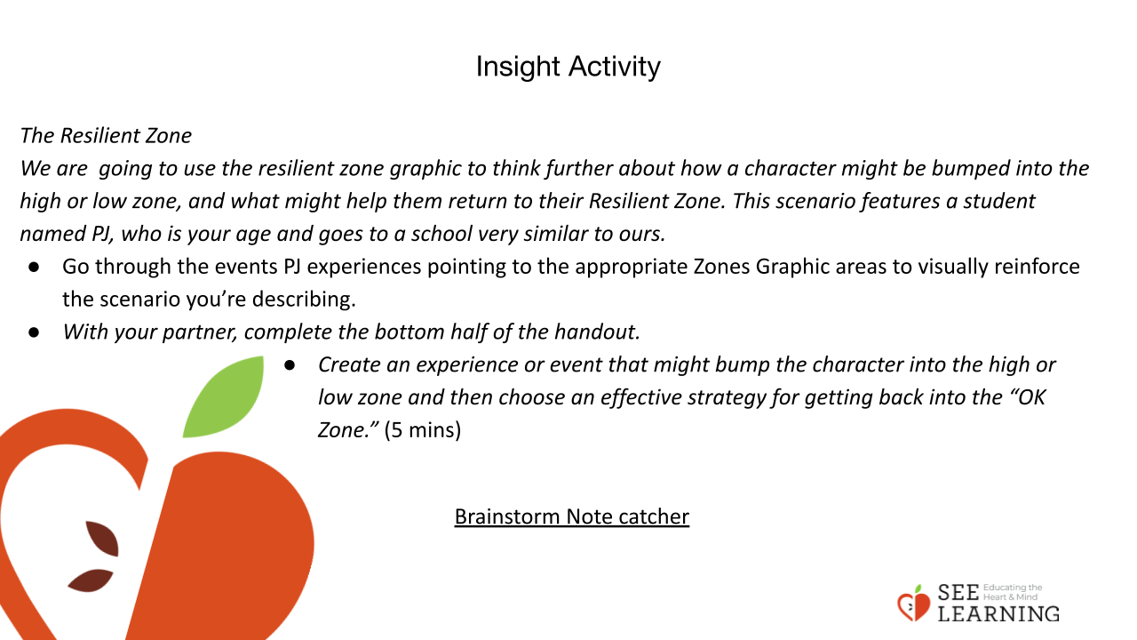 | Instructions and Guiding Language  • “We are going to use the resilient zone graphic to think further about how a character might be bumped into the high or low zone, and what might help them return to their Resilient Zone. This scenario features a student named PJ, who is your age and goes to a school very similar to ours.  • When we are in our resilient zone and experience difficulties, we can often deal with the challenges without being bumped out of our resilient zone. We are not super stressed-out or troubled because our body and mind feel safe enough, and we can readily see ways to respond to the challenging situation. Other times, the experience in the moment can bounce us into our high or low zone, and we can get stuck there.  Display and describe the Brainstorm Note catcher. Go through the events PJ experiences pointing to the appropriate Zones Graphic areas to visually reinforce the scenario you’re describing.  • With your partner, complete the bottom half of the handout. Create an experience or event that might bump the character into the high or low zone and then choose an effective strategy for getting back into the “OK Zone.” (5 mins)  • Pair up with another pair, making a group of four. Take turns sharing the scenarios you’ve written, including the trigger or stressful event, an example of being bumped into either the high or low zone, and your ideas for the strategy that might be helpful in that situation, and why.  Habits grow stronger over time. Abilities develop over time. We can practice different strategies to enhance our resilience and see which ones, if any, feel most effective in supporting our resilience.”

Reflective Practice (15 mins)
Activity Overview
Students will continue working in their same groups of four to gain clarity on the LE’s concepts and vocabulary.

Slide 4: Reflective Practice  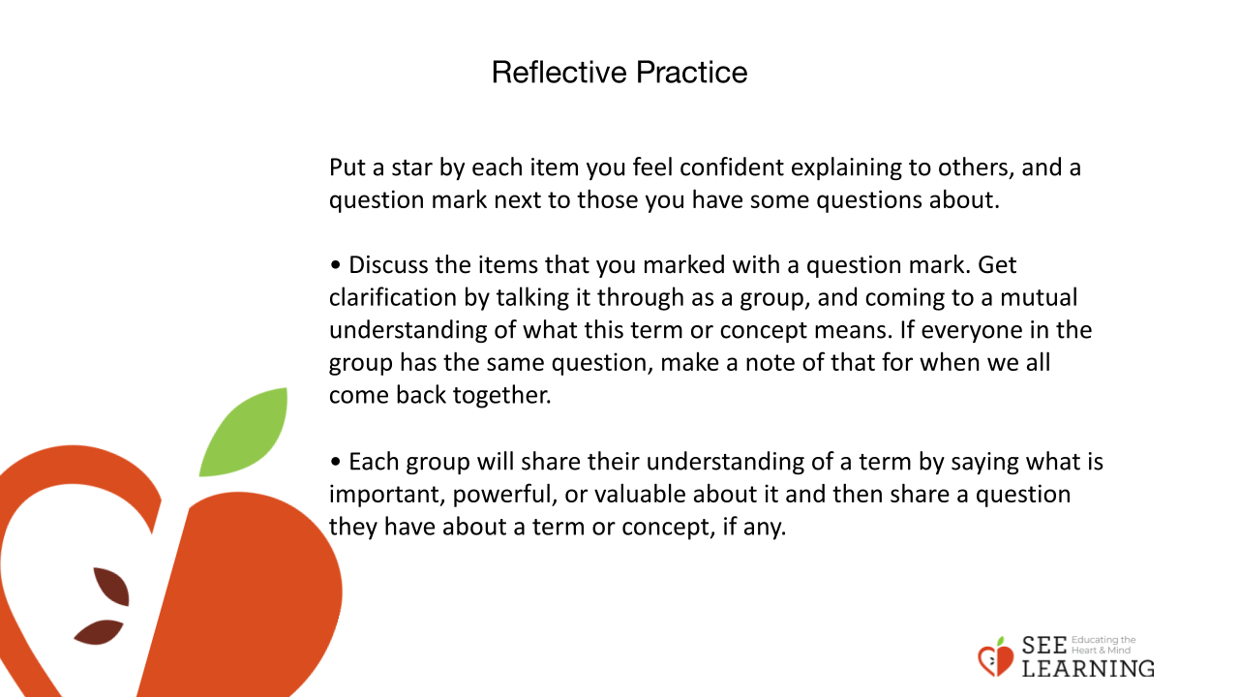 | Instructions and Guiding Language  Introduce the “Clarifications and Champions Handout.”  • “Silently read the list of terms and concepts on this handout. Some of them are from our lesson today and others you may not be familiar with.  • Put a star by each item you feel confident explaining to others, and a question mark next to those you have some questions about.  • Discuss the items that you marked with a question mark. Get clarification by talking it through as a group, and coming to a mutual understanding of what this term or concept means. If everyone in the group has the same question, make a note of that for when we all come back together.  • Each group will share their understanding of a term by saying what is important, powerful, or valuable about it and then share a question they have about a term or concept, if any.”  “The strategies we are learning will not stop us from having uncertainty in our lives, or from experiencing unfairness, unpleasantness, or even hurtful or destructive situations.  What these and other intentional strategies can become, when practiced and practiced over time, is an effective tool for regaining our own power in a stressful moment, so we are able to return to our personal resilience zone. From there, we can make more clearheaded decisions about what to say or do.

