The Neuroscience of Resilience

Purpose:
In this learning experience, students will examine how all people have nervous systems that will react to stressful situations. Students will identify that our brains are wired for self-preservation to protect when in danger. However, at times an automatic response occurs, based upon past experiences. This response may be harmful and not be helpful or appropriate to particular situations. Through activities, students will recognize that as we develop our body awareness and strategies for shifting from one mental, sensory, or emotional state to another, we grow increasingly more skillful at being able to rewire our nervous system. The new skills can change the automatic responses, and with greater conscious awareness, stay within our Resilient Zone.
Learning Objectives:  Students will be able to:  - Describe the concept of the Resilient Zone by applying the graphic to the creation of a relatable fictional character  - Describe cause and effect of events, feelings or thoughts that could take a person out of their Resilient Zone  - Describe ways to stay within the Resilient Zone | Primary Core Component  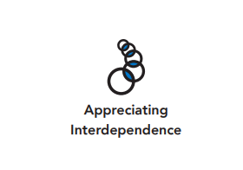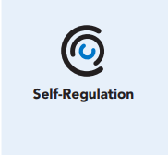
Length  45 Minutes | Materials Required  - Soft instrumental background music  - Resilient Zone visual  - Notebook or folder  - Colored pencils, crayons, pens, regular pencils, markers  - Emotions Word Bank handout

Check-In (5 min)
Slide 2: Check-In  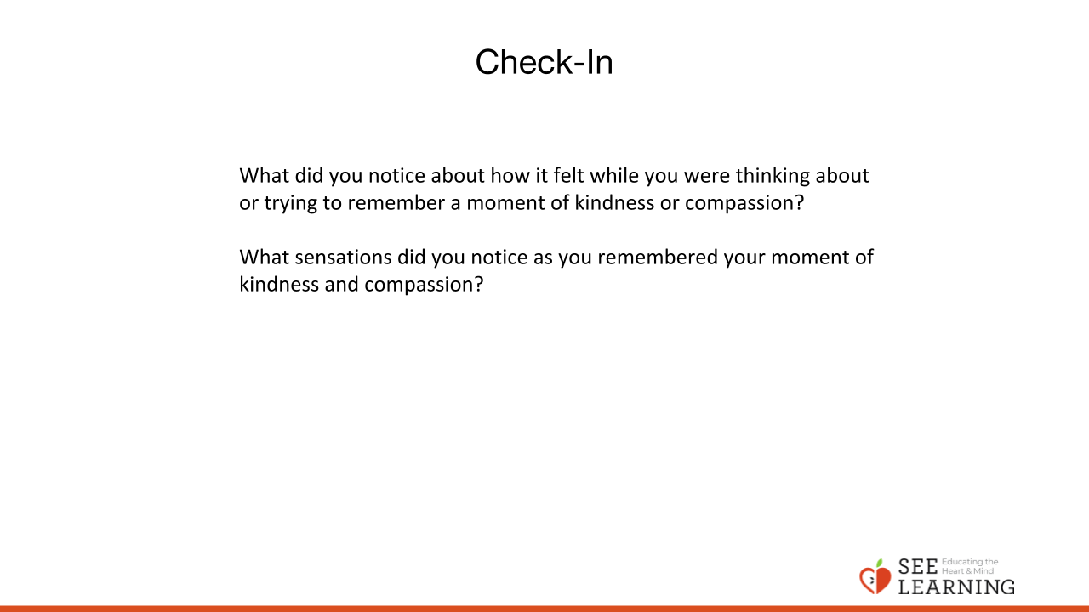 | Instructions and Guiding Language  [PAUSE]s can be up to 10 seconds each.  • “We’re going to take a moment to sit quietly together and rest our minds and bodies to help us be ready to focus and connect. [PAUSE]  Maybe you are tired or full of energy; maybe it’s been a challenging day so far, or an exciting one. Either way, it’s helpful to take this moment together. You can close your eyes or keep your eyes open and soften your gaze.  • Let’s each see if we can think of any moments of kindness or compassion in our day so far. Maybe something happened at home or on your way to school or while you’ve been at school today. See what comes up for you, remembering a moment of kindness or compassion that you witnessed or that you felt. It can be a big moment or a small thing. [PAUSE] Picture that moment in your mind and hold onto it. [PAUSE]  Don’t worry if you can’t think of a particular example right now. You can imagine a moment of kindness or compassion. [PAUSE]  • Let’s sit with our moment of kindness or compassion for a little bit. Notice how you’re feeling... notice your sensations, paying attention to pleasant or neutral sensations. (Timed by educator. Start with 15 seconds and lengthen incrementally as you notice most students are becoming comfortable with the existing amount of time.)  • We have time to hear from a few people — what thoughts came to mind for you? (2-4 volunteers)  • What did you notice about how it felt while you were thinking about or trying to remember a moment of kindness or compassion? (1-3 volunteers)  • What sensations did you notice as you remembered your moment of kindness and compassion?  • If the feelings and sensations that came up for you were pleasant ones, you can place yourself back into them later today. Just thinking about the good feelings and noticing the sensations that are pleasant or neutral can help you feel better at a completely different time.

Presentation/Discussion - (5 min)
Slide 3: Presentation/Discussion  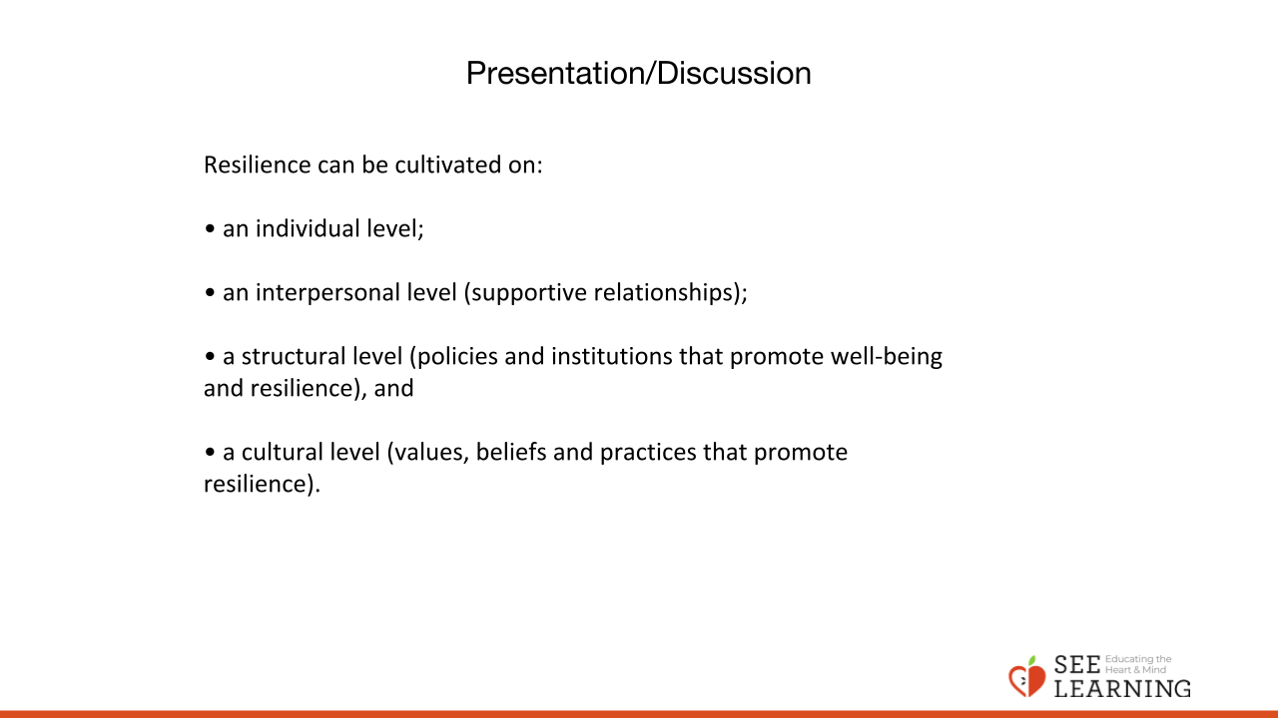 | Instructions and Guided Language  “Being resilient can mean being able to respond in a productive way to challenges, stress, threats and unexpected surprises.  The Resilient Zone is a visual tool for understanding the state of our mind and body.  During the day and throughout life, we experience many ups and downs and a wide array of emotions. When we feel generally in control and generally “ourselves,” we say that we are in our “Resilient Zone.”  We are able to respond productively to the stresses and challenges of life. We can make healthy decisions; we can choose how we respond to different stimuli.  We can experience a whole range of emotions in our Resilient Zone, but we still feel relatively in control and we can manage even sadness and anger.  Resilience can be cultivated on:  • an individual level;  • an interpersonal level (supportive relationships);  • a structural level (policies and institutions that promote well-being and resilience), and  • a cultural level (values, beliefs and practices that promote resilience).  The Resilient Zone can also be called the “Zone of Well-Being” or the “OK Zone.”

Insight Activity (20 min)
Slide 4: Insight Activity  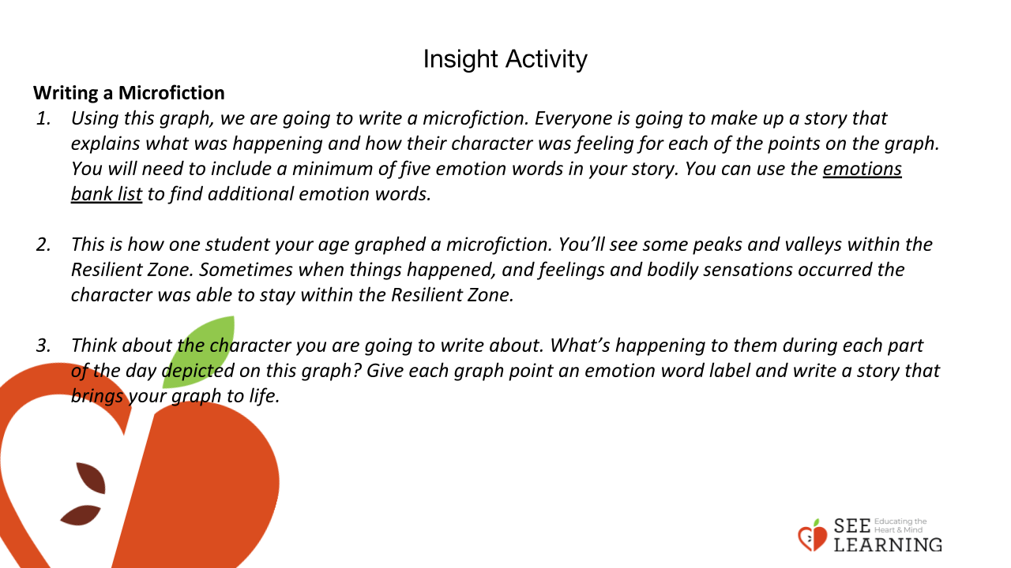  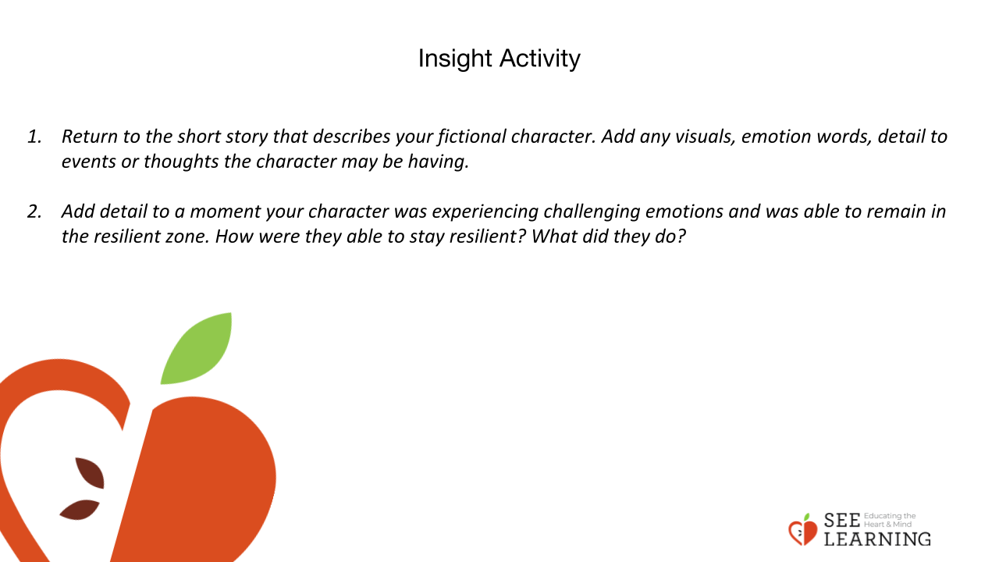 | Instructions and Guiding Language  “Let’s look at this Resilient Zone graphic.  • Take a few moments to see what you notice about it. (Ask a few volunteers to share by pointing out the important elements of the graphic.)  • Can someone describe the different parts of this graphic?  • What do you think the high, low, and okay zone mean?  • In the High Zone, our feelings are very escalated and we have big reactions that we may feel unable to control, in that moment.  • In the Low Zone our energy is very low, feelings like wishing to withdraw, get away, and/or turning inward may occur.”  Writing a Microfiction  • “Using this graph, we are going to write a microfiction.  • Everyone is going to make up a story that explains what was happening and how their character was feeling for each of the points on the graph.  • You will have 5 minutes to write and you will need to include a minimum of five emotion words and 2 sensory words in your story.  • You can use the emotions bank list and the sensory word list to find additional emotion words.  • (Show the provided example.) This is how one student your age graphed a microfiction. You’ll see some peaks and valleys within the Resilient Zone. Sometimes when things happened, and feelings and bodily sensations occurred, the character was able to stay within the Resilient Zone.  • Do you notice some places where their reactions took them into the High or Low Zone? What types of emotions or sensations may they have been experiencing?  • Think about the character you are going to write about. What’s happening to them during the part of the day depicted on this graph? Give each graph point an emotion word label and write a story that brings your graph to life. We’ll have five minutes of private writing time now, and then we’ll get into small groups and share the graphs and stories. Is there a sensation that accompanies the emotion label?”  Small Group Share  In groups of 2 or 3, students will share the written story they made up to match the graph.

Reflective Practice - Reflect, Write, and Share (15 mins)
Slide 5: Reflective Practice - Reflect, Write, and Share  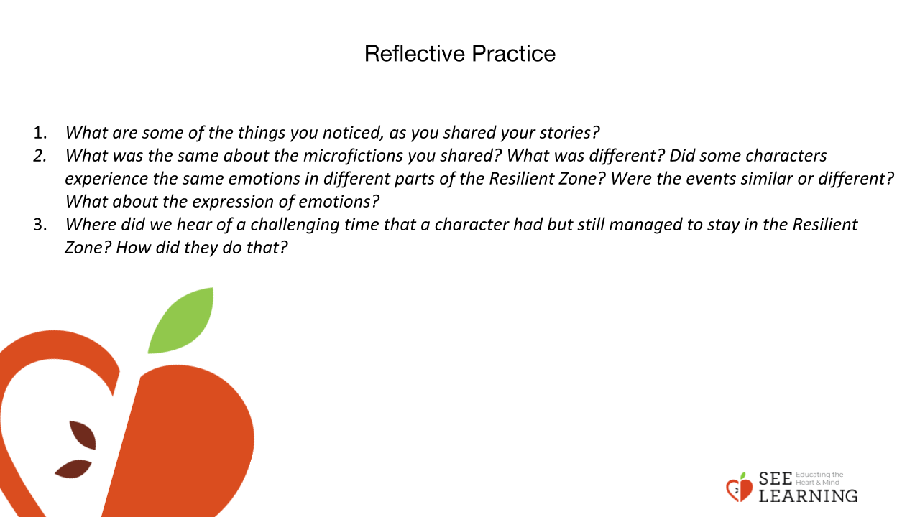 | Instructions and Guiding Language  • “What are some of the things you noticed, as you shared your stories? (Students respond.)  • What was the same about the microfictions you shared? What was different? Did some characters experience the same emotions in different parts of the Resilient Zone? Did some characters report the same sensations? Were the events similar or different? What about the expression of emotions?  • Where did we hear of a challenging time that a character had but still managed to stay in the Resilient Zone? How did they do that?” (Students respond.)  “People can have a wide variety of responses to the same event.  What fills one person with huge energy might make another person want to just go to sleep. As we’ve seen through our stories, many different life events can have a similar effect.  We heard so many different ideas of what could be happening to your story’s character using that same ‘ups and downs of the day’ graph! What we know for sure is that the ups and downs are part of our common humanity.  We all DO have reactions to things; we all have nervous systems that will react in various situations. People can build the skills and practices that help us have the internal power to notice, name, pause, and to make a choice in how we react to stressful events.  Our bodies absolutely will react. We’re all human. We’re all in this together. We can build the skills needed to return ourselves to our Resilient Zone, even in very challenging situations.”

