The Science of Stress and Resilience

Purpose:
In this learning experience, students will engage in an independent reading and a small
group activity. Students will develop a basic understanding of the complex structure of
the brain, the science of stress, and gain insight into the practices that support resilience.
Students will begin to reflect on their level of awareness around body literacy or noticing
and responding to sensations in the body.
Learning Objectives:  Students will be able to:  - Develop a basic understanding of the  neuroscience of stress and resilience  - Describe rudimentary brain structure  and understand that the brain is  malleable (it changes)  - Engage in practices that support  resilience by exploring their current  level of body literacy (noticing  physical sensations) | Primary Core Component  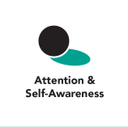
Length  45 Minutes | Materials Required  - Our Brain Structure reading handout  - Chart paper/large paper or board  - Writing utensils and paper

Check-In (5 min)
Slide 2: Check-In  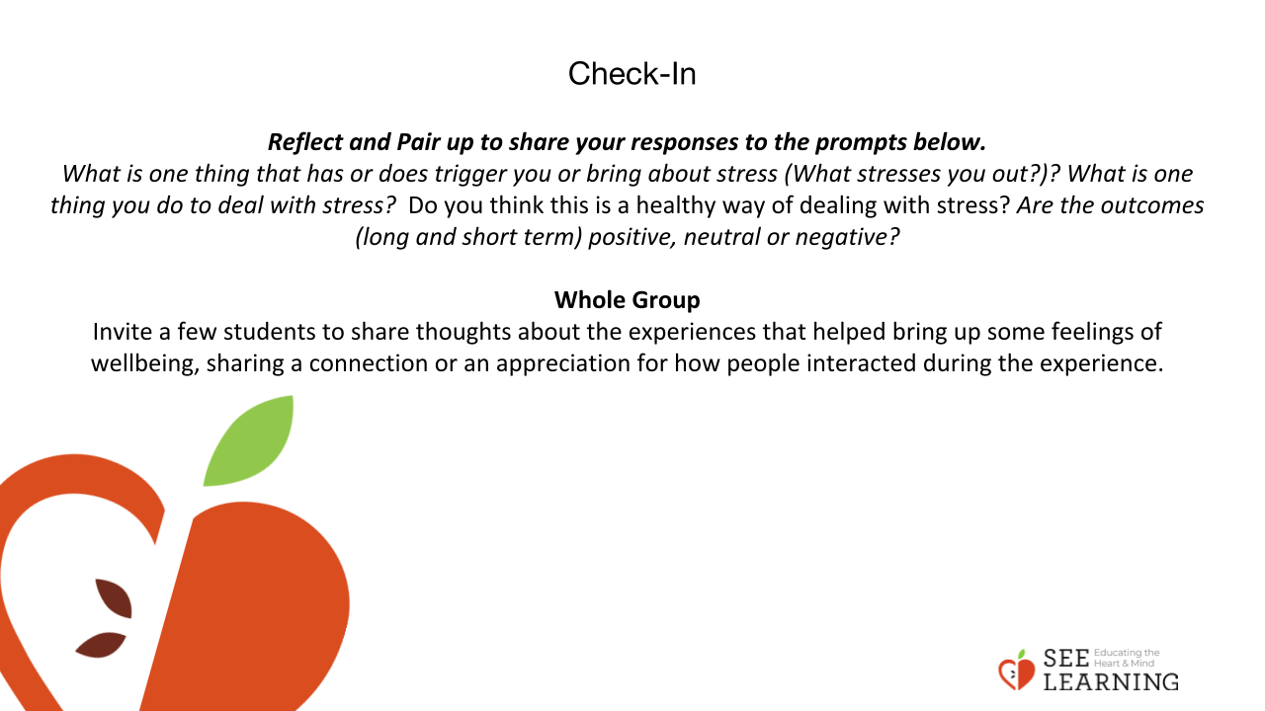 | Instructions and Guiding Language  We’re going to take a moment to sit quietly together and rest our minds and bodies to help us be ready to focus and connect. [Pause.] Maybe you are tired or full of energy; maybe it’s been a challenging day so far, or an exciting one. Either way, it’s helpful to take this moment together.  You can close your eyes or keep your eyes open, softening your gaze.  Let’s each see if we can think of any moments of kindness or compassion in our day so far. Maybe something happened at home or on your way to school or while you’ve been at school today. See what comes up for you, remembering a moment of kindness or compassion that you witnessed, or that you felt. It can be a big moment or a small thing. [Pause.] Picture that moment vividly in your mind. [Pause.] Don’t worry if you can’t think of a particular example right now. You can imagine a moment of kindness or compassion. [Pause.]  Let’s sit with our moment of kindness or compassion for a little bit. Notice how you’re feeling...notice your sensations, paying attention to pleasant or neutral sensations.  Timed by educator. Start with 15 seconds and lengthen incrementally as you notice most students are becoming comfortable with the existing amount of time.)  We have time to hear from a few people—what thoughts came to mind for you? (2-4 volunteers.)  What did you notice about how it felt, while you were thinking about, or trying to remember a moment of kindness or compassion? (1-3 volunteers.)  What sensations did you notice as you remembered your moment of kindness and compassion?  If the feelings and sensations that came up for you were pleasant ones, you can remind yourself to go back into them later today. Just thinking about the good feelings and paying attention to pleasant or neutral sensations you were experiencing can help you feel better at a completely different time.  Check in (2 min)  Reflect and Pair up to share your responses to the prompts below.  What is one thing that you do to deal with stress? Do you think this is a healthy way of dealing with stress? Are the outcomes (long and short term) positive, neutral or negative?  Whole Group  Invite a few students to share thoughts about the experiences that helped bring up some feelings of wellbeing, sharing a connection or an appreciation for how people interacted during the experience.

Presentation/Discussion - ( 7 min)
Teaching Tips:
Understanding that resilience is a skill that can be built and reinforced is encouraging to adults and young people alike. Knowing some scientific information about anxiety and ways to explain resilience can help students be more confident in their own opportunities to impact the way they feel, think and act. (And if older students are sharing their learning with younger children, they may appreciate this video: resilience)There are many definitions of resilience. Lead a discussion with the students about the meaning of resilience. You can then have group consensus about what resilience will mean in the context of SEE Learning in the classroom. The video can be helpful in prompting the discussion.
Instructions and Guiding Language
Stress is the physical, mental or emotional strain or tension that comes from being in demanding circumstances. Stress is common to all human beings. In fact, it involves parts of our brain, body and nervous system that we have in common with non-human animals, such as mammals.

Many circumstances, large and small, can lead to feelings of stress. Everyone experiences stress, and not all stress is bad or large-scale. Physically or emotionally exciting events will activate our stress response, whether they are good or bad. It’s important to recognize that we human beings are social beings. We don’t just respond to physical threats, but to emotional threats too. Someone criticizing us, ignoring us, or telling us we look bad can activate our stress system just as much -- or even more -- than seeing a bear in the woods and being afraid.

Chronic stress or intense stress (such as adversity or trauma) around negative events, however, can cause physical, emotional, and relationship problems for ourselves and others, if it is not treated in a healthy way by ourselves and others. In the case of anxiety, there may be a threat that isn’t clearly defined. Because it isn’t clearly defined, our body doesn’t know if the threat has been dealt with or if it’s passed, or whether it’s still there. If we never feel that the threat is gone, we never fully relax. Those chemical processes don’t stop, and they start to damage our bodies and disturb our mental state as well.

Even with adversity and trauma, what is most damaging is the chronic nature of them, rather than the events themselves. This is actually why we can heal: because while we cannot undo the event of the trauma or adversity that is in the past, we can change how we deal with the memories and reminders of that trauma.

Sometimes we respond in ways to relieve stress that work in the short term but can be problematic in the longer term. We might eat or drink substances that make our bodies feel better in the moment but that are unhealthy if overdone. We might engage in activities that are fun but also risky. Those activities make our bodies feel better and more regulated, so they help temporarily, but if they’re very risky, they could also lead to other problems for ourselves and others.

Our bodies and minds are already resilient, and have helped us deal with a multitude of stressors. In addition to the strategies we have already learned and employed up to now, it can be very helpful to learn new strategies, allowing us more options to choose which strategy to use for which occasion. While resilience is inborn, we can also build our skills of resilience, helping us to deal with the challenges of life effectively and helping us to experience greater well-being. We can learn to tune our nervous systems!

Insight Activity - 15-20 mins
Activity Overview
Content about basic neuroscience and the concepts of stress and well-being will be shared through reading, jigsaw and presentation/share out.

Slide 3:  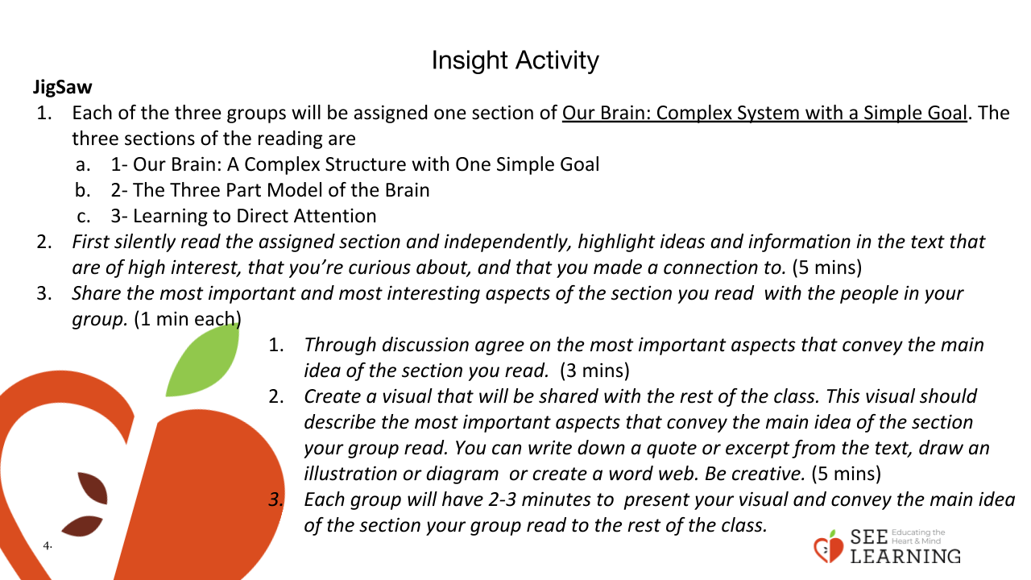 | Instructions and Guiding Language  JigSaw  - Split students up into groups of 3  - Assign one part of the reading Our Brain: Complex System with a Simple Goal to each group. The three sections of the reading are  - 1- Our Brain: A Complex Structure with One Simple Goal  - 2- The Three Part Model of the Brain  - 3- Learning to Direct Attention  - First silently read the assigned section and independently, highlight ideas and information in the text that are of high interest, that you’re curious about, and that you made a connection to. (5 mins)  - Share the most important and most interesting aspects of the section you read with the people in your group. (1 min each)  - Through discussion agree on the most important aspects that convey the main idea of the section you read. (3 mins)  - Create a visual that you can share with the rest of the class. This visual should describe the most important aspects that convey the main idea of the section your group read. You can write down a quote or excerpt from the text, draw an illustration or diagram or create a word web. Be creative. (5 mins)  - Each group will have 2-3 minutes to present your visual, conveying the main idea of the section your group read to the rest of the class.

Insight Activity ( 10 mins)
Slide 4: Insight Activity  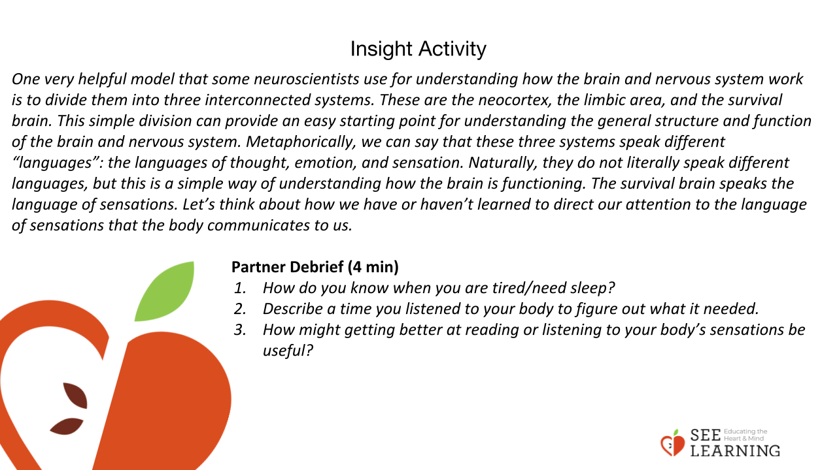 | Instructions and Guiding Language  Noticing Sensations: The Language of the Survival Brain  Explain (2 min)  One very helpful model that some neuroscientists have used for understanding how the brain and nervous system work is to divide them into three interconnected networks. These are the cortex, the limbic network, and the survival network. This simple division can provide an easy starting point for understanding the general structure and function of the brain and nervous system. Metaphorically, we can say that these three systems speak different “languages”: the languages of thought, emotion, and sensation. Naturally, they do not literally speak different languages, but this is a simple way of understanding how the brain is functioning. The survival network speaks the language of sensations. Let’s think about how we have or haven’t learned to direct our attention to the language of sensations that the body communicates to us.  Partner Debrief (4 min)  - How do you know when you are tired/need sleep?  - Describe a time you listened to your body to figure out what it needed.  - How might getting better at reading or listening to your body’s sensations be useful?  Close (1 min)  By learning to choose where we direct our attention, we can participate in the process of managing stress and creating positive neurocircuitry consciously, rather than just reactively. We can recognize when emotions and sensations are heightened and our bodies are in states of distress. We can learn to notice, name and intentionally return to operating from the cortex, the center of clear thinking, and choosing an action, instead of reacting to distressing emotions and physical discomfort. This happens through sustained practice. This process is called “tuning,” the positive experiences which can change the actual structure of the brain by increasing the number of connections between neurons (brain cells). Another process that is important for brain development is called “pruning,” the weakening and often removing of the neural connections that aren’t used—sometimes described as the “use it or lose it” principle. These processes show that the brain can change! Neuroplasticity in action.

