Compassion and Reciprocity

Purpose:
In this learning experience students will study scenarios and identify underlying motives for the actions each character took. Students will decide whether they were acts of true genuine compassion or apparent compassion/kindness. Through the use of mindful dialogue students will reflect on their own actions and motives and finally illustrate/write about a time when they gave or received compassion and kindness.
Learning Objectives:  Students will be able to:  - Define compassion in the context of outer actions, inner intentions and far reaching complex motivations  - Recognize the distinction between real (inner, genuine) kindness and apparent kindness by examining one’s personal motivation and intention | Primary Core Component  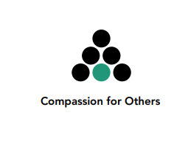  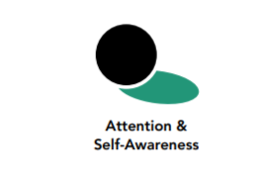
Length  45 Minutes | Materials Required  - SEE Learning journals or notebook; pens or pencils  - Scenarios Handout for each student

Check-In (5 mins)
Slide 2: Check-In   | Instructions and Guiding Language  - We’re going to take a moment to sit quietly together and rest our minds and bodies to help us be ready to focus and connect. [Pause.] Maybe you are tired or full of energy; maybe it’s been a challenging day so far, or an exciting one. Either way, it’s helpful to take this moment together.  - Let’s each see if we can think of any moments of kindness or compassion in our day so far. Maybe something happened at home or on your way to school or while you’ve been at school today. See what comes up for you, remembering a moment of kindness or compassion that you witnessed, or that you felt. [Pause.] Picture that moment, in your mind, and hold onto it. [Pause.] Don’t worry if you can’t think of a particular example right now. You can imagine a moment of kindness or compassion. [Pause.]  - Let’s sit with our moment of kindness or compassion for a little bit. Notice how you’re feeling... (Pauses can begin with 15 seconds and lengthen incrementally over time)  - We have time to hear from a few people—what thoughts came to mind for you?  - What did you notice about how it felt, while you were thinking about, or trying to remember a moment of kindness or compassion? (1-3 volunteers.)

Presentation/Discussion
Slide 3: Presentation/Discussion  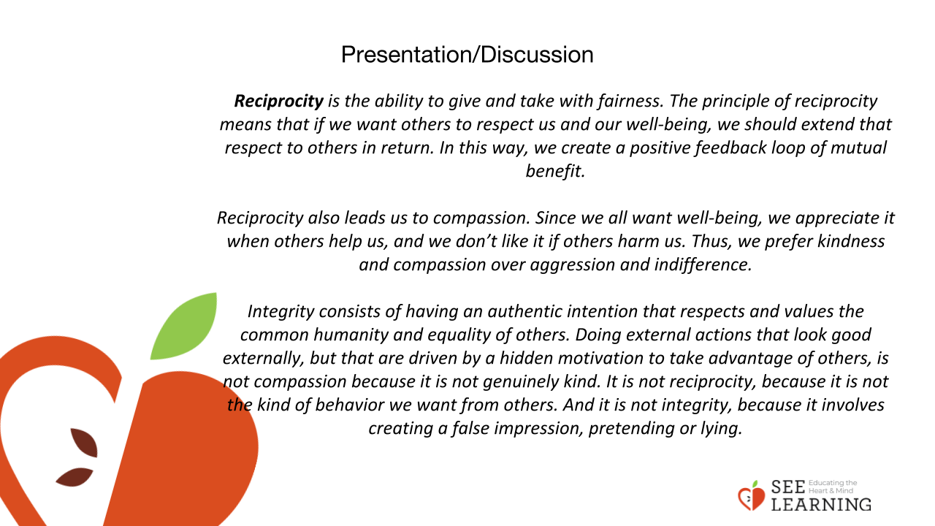 | Instructions and Guiding Language  Because we exist interdependently, human social life depends on reciprocity. Reciprocity is the ability to give and take with fairness. The principle of reciprocity means that if we want others to respect us and our well-being, we should extend that respect to others in return. In this way, we create a positive feedback loop of mutual benefit.  Reciprocity also leads us to compassion. Since we all want well-being, we appreciate it when others help us, and we don’t like it if others harm us. Thus, we prefer kindness and compassion over aggression and indifference.  Integrity consists of having an authentic intention that respects and values the common humanity and equality of others. Doing external actions that look good externally, but that are driven by a hidden motivation to take advantage of others, is not compassion because it is not genuinely kind. It is not reciprocity, because it is not the kind of behavior we want from others. And it is not integrity, because it involves creating a false impression, pretending or lying.

Insight Activity
Slide 4: Insight Activity  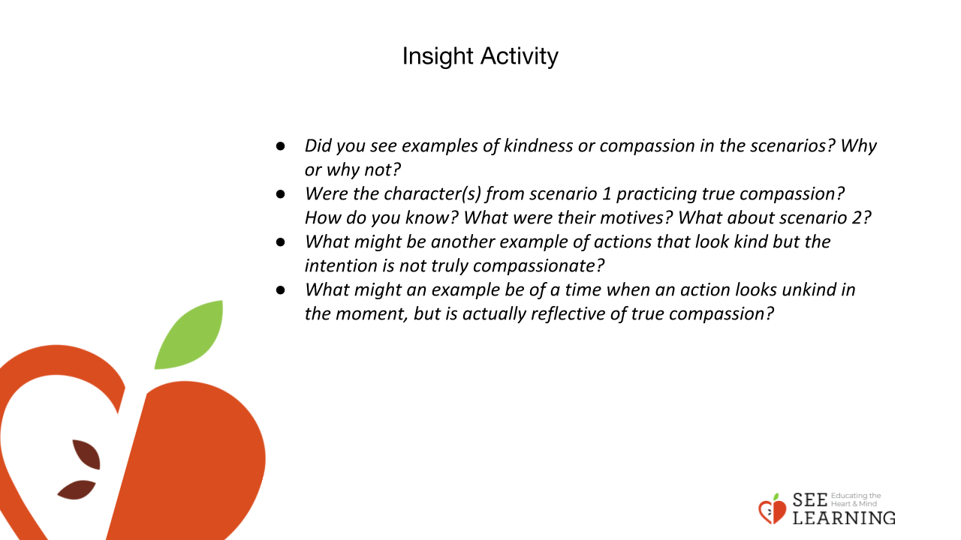 | Instructions and Guiding Language  Today we are going to think about how we can practice compassion and discuss what motivates a person to be kind and decide whether or not this is genuine or ingenuine kindness based on a persons motives and actions.  Step 1: Independently read through each scenario and think about the underlying motivations that may be behind each characters’ actions.  Step 2: A few volunteers will read/act them out while the rest of the class is thinking about the character’s motivation and whether or not they are practicing true compassion or if it is ingenuine by considering the motives of their actions.  Step 3: In pairs or as a whole class answer the following prompts to debrief the activity.  - Did you see examples of kindness or compassion in the scenarios? Why or why not?  - Were the character(s) from scenario 1 practicing true compassion? How do you know? What were their motives? What about scenario 2?  - What might be another example of actions that look kind but the intention is not truly compassionate?  - What might an example be of a time when an action looks unkind in the moment, but is actually reflective of true compassion?  Scenario 1  The Rich Person and the Charity  Narrator: A representative from a charity goes to a wealthy person to ask for a donation to assist people who are homeless.  Charity representative: “I know you’ve been very generous to charities in the past. Please, would you give us a donation? It would make a big difference to a lot of people who are in need.”  Potential Donor: “How will I be recognized if I make a donation? It’s important that people know that I made the donation, not someone else.”  Charity representative: “The homeless people you help will all be so grateful, and they will all be told that it was you who helped them.”  Potential Donor: “But I want other people to know too. Will it be in the news?”  Charity representative: “Oh yes. And if your donation is large enough, you will be specially honored at our annual party celebration with a trophy.”  Potential Donor: [smiling]: “In that case, I agree.”  End  Scenario 2  The Basketball Captain and the Recruit  Narrator: The captain of the basketball (or another sports) team sees potential in a new student and really wants them to join the team, thinking it will help win the championship that year.  Team Member 1: Hey, I wanted to give you this school t-shirt!  New Student: Thanks, but what for?  Team Member 2: Duh, because you’re super cool and your basketball skills are awesome!  New Student: Thanks! You really think so?  Team Member 1: Of course! Your form is great and I’ve never seen you miss a free throw. You’re a natural!  New Student: Gosh, thanks, you guys.  Team Member 2: Imagine just how much more fun you’d have if you joined our basketball team. I might even be able to get you more stuff if you did!  New Student: Hm, that seems cool, but I was planning on focusing more on my art this year.  Team Member 1: But think about it; you, us, our other teammates, and our captain. We would be unstoppable!  Team Member 2: Since you’re new here, this is a guaranteed way to be popular. People here really show up for our games. And they decorate our lockers! Plus, you shouldn’t let your talent go to waste. We could really use your skills.  New Student: Thanks, you guys but really, I’m okay with my decision. I’m going to put my energy into my artwork this year.  Team Member 1: Oh, come on! We’ve been pretty nice to you and we’re kind of friends now. You can’t let us down like that, especially with the championship game coming up.  Team Member 2: Yeah, just think about it; winning the championships! Imagine not being there with us, celebrating! Do you really think people are going to want to be your friend if they find out how you let the school down by not joining the team?

Reflective Practice (10 mins)
Slide 5 and 6: Reflective Practice  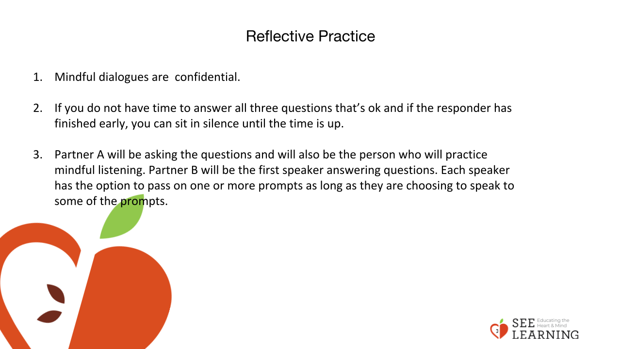  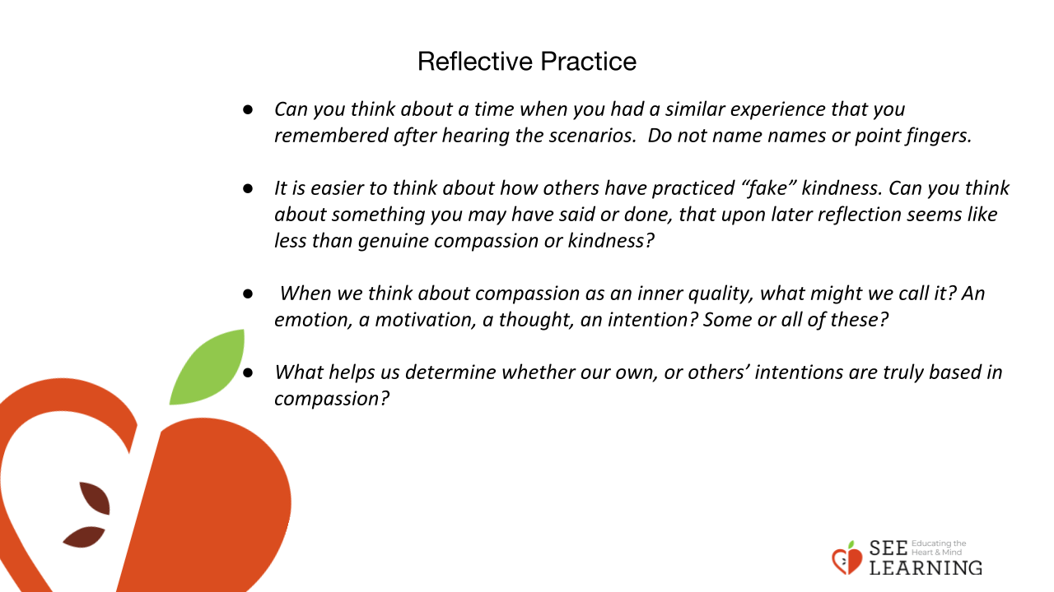  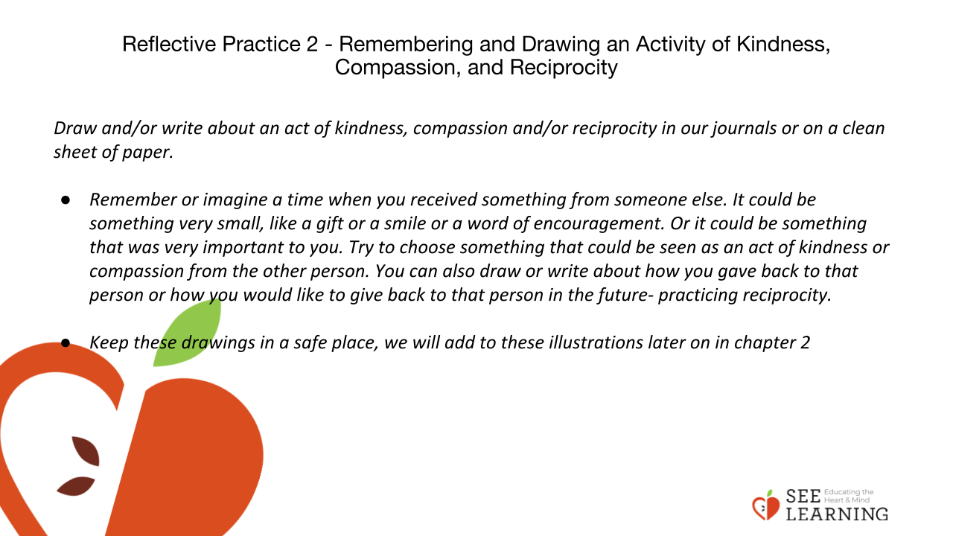 | Instructions and Guiding Language  For our next activity, we will engage in mindful listening. When practicing mindful listening we learn to listen with full attention and without judgment. We can learn a great deal about each other in a short amount of time. Being listened to can make us feel heard and seen and can strengthen relationships. Being able to express our thoughts and feelings can help us reflect more deeply and gain insight. It also supports us in our ability to attune to others and cultivate a compassionate response towards them.  Revisit guidelines for MINDFUL DIALOGUE (3 minutes)  - Mindful dialogues are confidential.  - If you do not have time to answer all three questions that’s ok and if the responder has finished early, you can sit in silence until the time is up.  - Partner A will be asking the questions and will also be the person who will practice mindful listening. Partner B will be the first speaker answering questions. Each speaker has the option to pass on one or more prompts as long as they are choosing to speak to some of the prompts.  In pairs answer the following prompts using the mindful listening protocol.  - Can you think about a time when you had a similar experience that you remembered after hearing the scenarios. Do not name names or point fingers.  - It is easier to think about how others have practiced “fake” kindness. Can you think about something you may have said or done, that upon later reflection seems like less than genuine compassion or kindness?  - When we think about compassion as an inner quality, what might we call it? An emotion, a motivation, a thought, an intention? Some or all of these? (Note that you are prompting thinking but not seeking a single “right” answer at this point, so welcome all thoughts.)  - What helps us determine whether our own, or others’ intentions are truly based in compassion?  REFLECTIVE PRACTICE 2  Remembering and Drawing an Act of Kindness, Compassion and Reciprocity  Introduce the journal/composition book that will be used during each of the SEE Learning Experiences. If you plan to have an on-going SEE journal, explain that the responses in the notebook/journal will be private and sometimes we will be asked to share about what was written or illustrated but will not need to show journal entries to anyone or hand it in to the teacher.  - Today we will draw and/or write about an act of kindness, compassion and/or reciprocity in our journals or on a clean sheet of paper.  - Remember or imagine a time when you received something from someone else. It could be something very small, like a gift or a smile or a word of encouragement. Or it could be something that was very important to you. Try to choose something that could be seen as an act of kindness or compassion from the other person. You can also draw or write about how you gave back to that person or how you would like to give back to that person in the future- practicing reciprocity.  - Keep these drawings in a safe place, we will add to these illustrations later on in chapter 2

