Identifying Thinking Traps

Purpose:
In this learning experience students will explore the concept of Thinking Traps. Through their inquiry they will relate them to well-being and the class agreements.
Learning Objectives:  Students will be able to:  - Experience examples of perceptual illusions  - Understand thinking traps by exploring examples of thinking traps and making connections between Thinking Traps and the principles of Self Compassion and Compassion for Others  - Discuss the significance of understanding Thinking Traps for keeping the class agreements | Primary Core Component  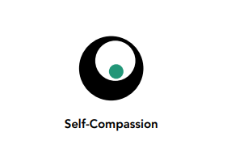  
Length | Materials Required  - Perceptual illusions examples on a handout if possible, or on the board  - A playing card or index card for each student  - Thinking Trap Handout

Check-In (5 mins)
Slide 2: Check-In   | Instructions and Guiding Language  - “We’re going to take a moment to sit quietly and rest our minds and bodies to help us be ready to focus and connect. [PAUSE] Maybe you are tired or full of energy; maybe it’s been a challenging day so far, or an exciting one. Either way, it’s helpful to take this moment together.  - Let’s each see if we can think of any moments of happiness in our day so far. Maybe something happened at home or on your way to school or while you’ve been at school today. See what comes up for you, remembering a moment of happiness that you witnessed, or that you felt. [PAUSE] Picture that happy moment, in your mind. [PAUSE] Don’t worry if you can’t think of a particular example right now. You can always imagine a moment of happiness instead. [PAUSE]  - Let’s sit with your moment of happiness for a little bit. (Timed by facilitator. Start with 15 seconds and lengthen incrementally in future Learning Experiences, as you notice most students are becoming comfortable with the existing amount of time.  - Please open your eyes if you closed them during the settling activity.  - We have time to hear from a few people—what thoughts came to mind? (2-4 volunteers.)  - What did you notice about how it felt, while you were thinking about, or trying to remember, a moment of happiness? (1-3 volunteers.)  - If the feelings and sensations that came up for you were pleasant ones, you can remind yourself back into them later today. Just thinking about the good feelings you were just experiencing can help you feel better at a completely different time.

Presentation/Discussion
Slide 3: Presentation/Discussion  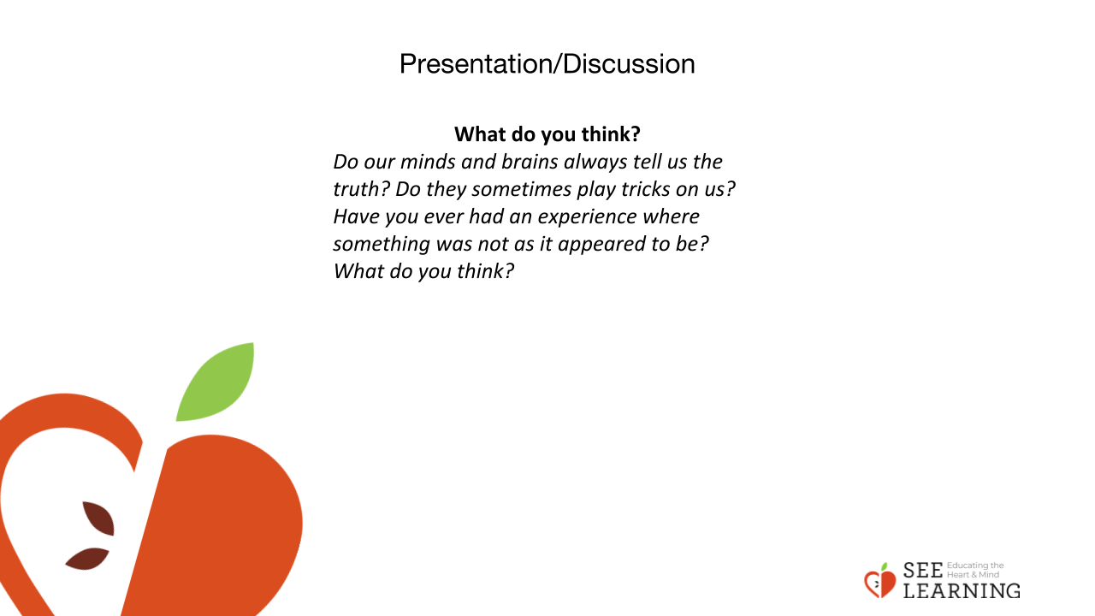 | Instructions and Guiding Language  Think Pair Share  Do our minds and brains always tell us the truth? Do they sometimes play tricks on us? Have you ever had an experience where something was not as it appeared to be? What do you think?  Guided Language  While our minds and brains are incredible things that allow us to perceive the world, think about it, and react to it, they sometimes play tricks on us and give us inaccurate information as well. Not everything is as it seems, and how things appear is not always how they actually are. If we react to appearances, instead of thinking critically, we can fall into “Thinking Traps.” These are cognitive and perceptual distortions.  For a long time now, psychologists and neuroscientists have found that our minds and brains can actually distort reality to make things appear to be different than they actually are. These can happen on the level of perception, (how we see, hear, or experience something through our physical senses) cognition (how we build knowledge and understanding based on our thoughts), or emotion (how what we are feeling impacts how we see or experience something).  Understanding Thinking Traps is a powerful tool to explore well-being and human behavior. It may help us to understand why people do not always follow the agreements they make, and why they do not always engage in behavior that is productive for themselves and others. If we understand Thinking Traps, we can have more compassion towards others (and ourselves) when they (and we) make mistakes. We can use our personal experiences and critical thinking abilities to more clearly understand the world around us. You may remember, several lessons ago, we were exploring the idea of happiness and recalling a time when we thought an object, event or achievement would bring us lasting happiness, but it didn't.

Insight Activity
Slide 4-6: Insight Activity  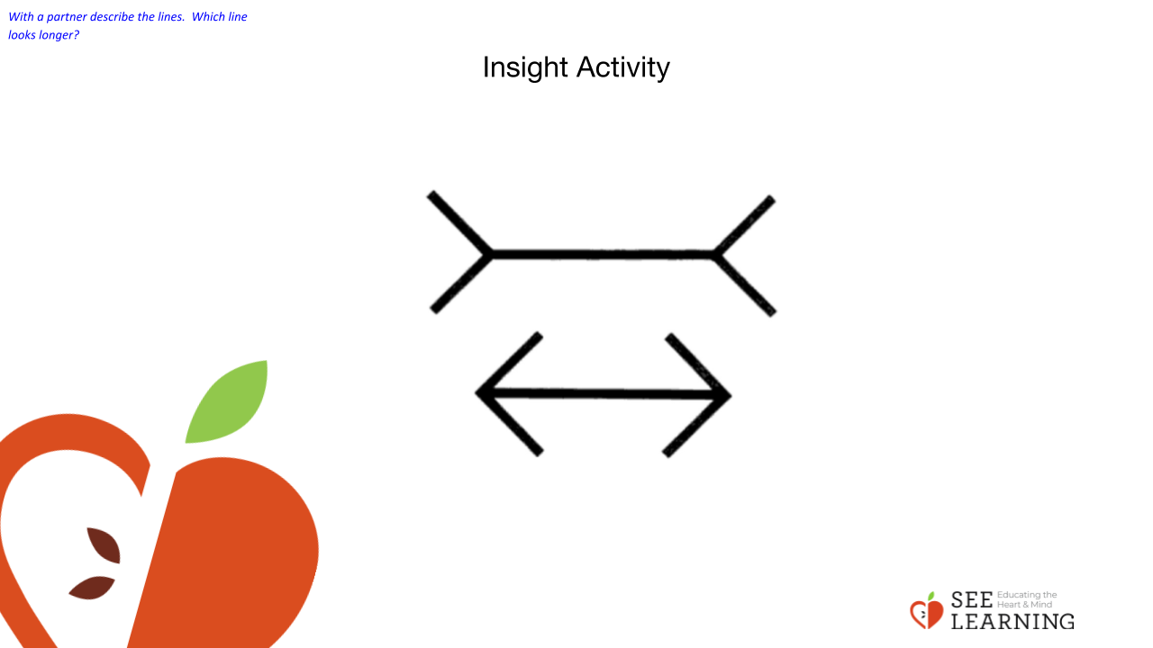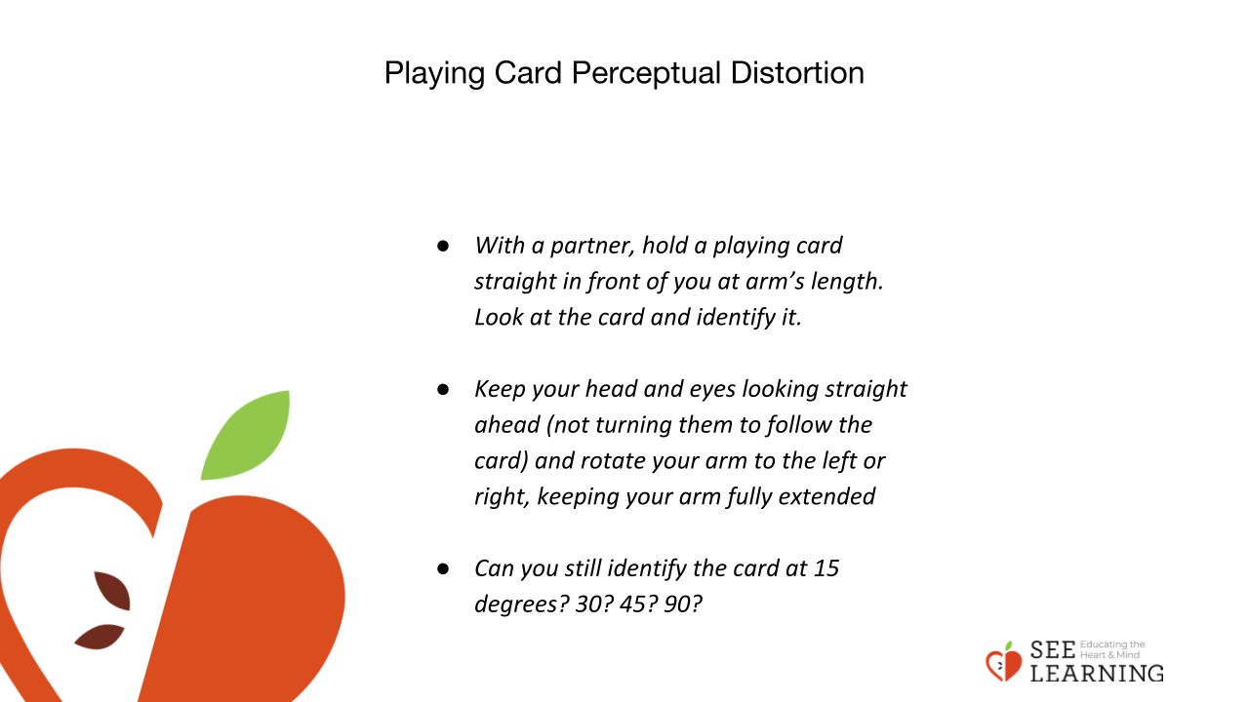  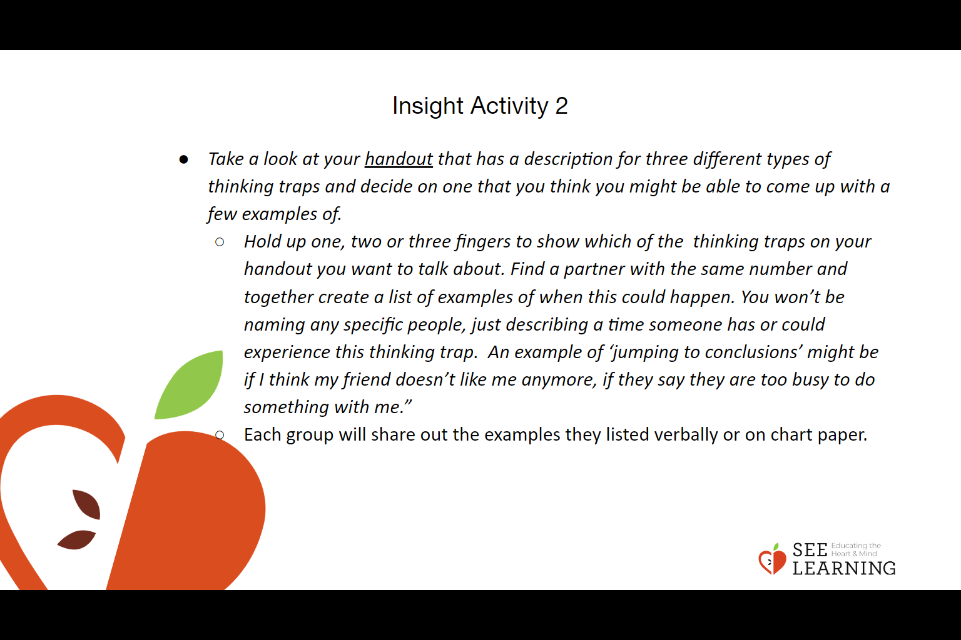  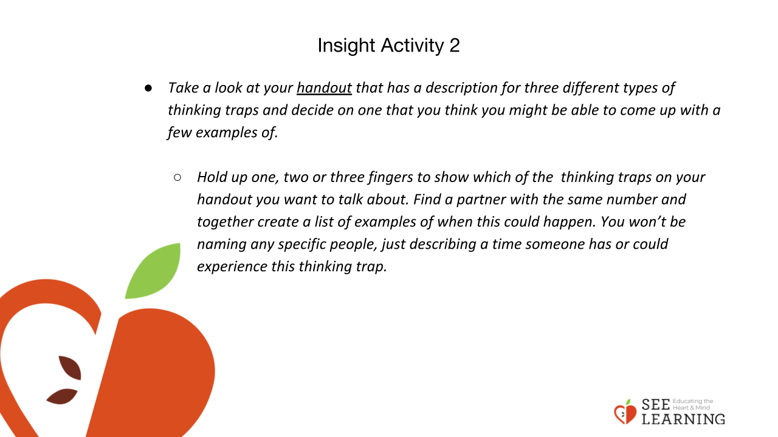 | Instructions and Guiding Language  Perceptual Distortion Visual  Take a look at these two lines.  - 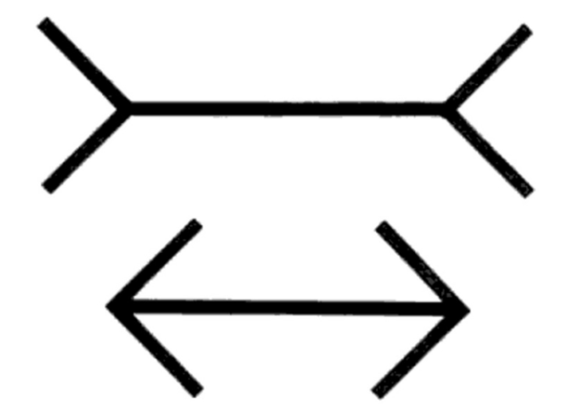  With a partner describe the lines. Which line looks longer?  To most people, the top line looks longer. But in reality, the two lines are the same length. Take a moment to measure the two lines with your partner.  An interesting thing is that even after we’ve measured the two lines ourselves, and know that they definitely are of equal length, this doesn’t change the fact that the top line will still appear longer to us. It’s a persistent perceptual distortion. Our brain and mind sticks with what we think we’re seeing, even when we know it’s not the case.  Playing Card Perceptual Distortion Visual  - With a partner, hold a playing card straight in front of you at arm’s length. Look at the card and identify it.  - Keep your head and eyes looking straight ahead (not turning them to follow the card) and rotate your arm to the left or right, keeping your arm fully extended  - Can you still identify the card at 15 degrees? 30? 45? 90?  What this experiment shows is that our eyes actually only see what they are looking at directly, and very little around them. Yet we don’t experience the world as if we were looking through pinholes. We feel like we see a whole range before us of somewhere between 90 and 180 degrees.  INSIGHT ACTIVITY 2  Thinking Traps  Guiding Language  In addition to perceptual illusions, we can also experience cognitive distortions. This is when our mind tells us that something we are thinking is true, but in reality, it isn’t true. Like perceptual distortions, cognitive distortions can be persistent. Cognitive distortions can be dangerous because if we fall for the cognitive distortion of thinking “I can never succeed at something,” like playing guitar or learning to solve a math equation, just because we couldn’t succeed at it right away, we might give up. By doing so, the opportunity to get good at that skill is lost. When it comes to cognitive distortions, however, we have more flexibility. We can not only learn to recognize cognitive distortions, but we can potentially change the way we react when they arise.  Once we recognize that our minds sometimes like to play tricks on us, we can catch thinking traps before they cause us too much trouble. We can learn to see, “Oh, this is just a thinking trap. This is just my mind playing tricks on me.” There’s no reason to judge ourselves negatively when this happens, because it’s a common human experience. We can offer ourselves self-compassion when we notice this happening. The question becomes, “How can I learn to recognize thinking traps and do something about it when they occur?”  - Take a look at your handout that has a description for three different types of thinking traps and decide on one that you think you might be able to come up with a few examples of.  - Hold up one, two or three fingers to show which of the thinking traps on your handout you want to talk about. Find a partner with the same number and together create a list of examples of when this could happen. You won’t be naming any specific people, just describing a time someone has or could experience this thinking trap. An example of ‘jumping to conclusions’ might be if I think my friend doesn’t like me anymore, if they say they are too busy to do something with me.”  - Each group will share out the examples they listed verbally or on chart paper.

Reflective Practice (10 mins)
Slide 7: Reflective Practice  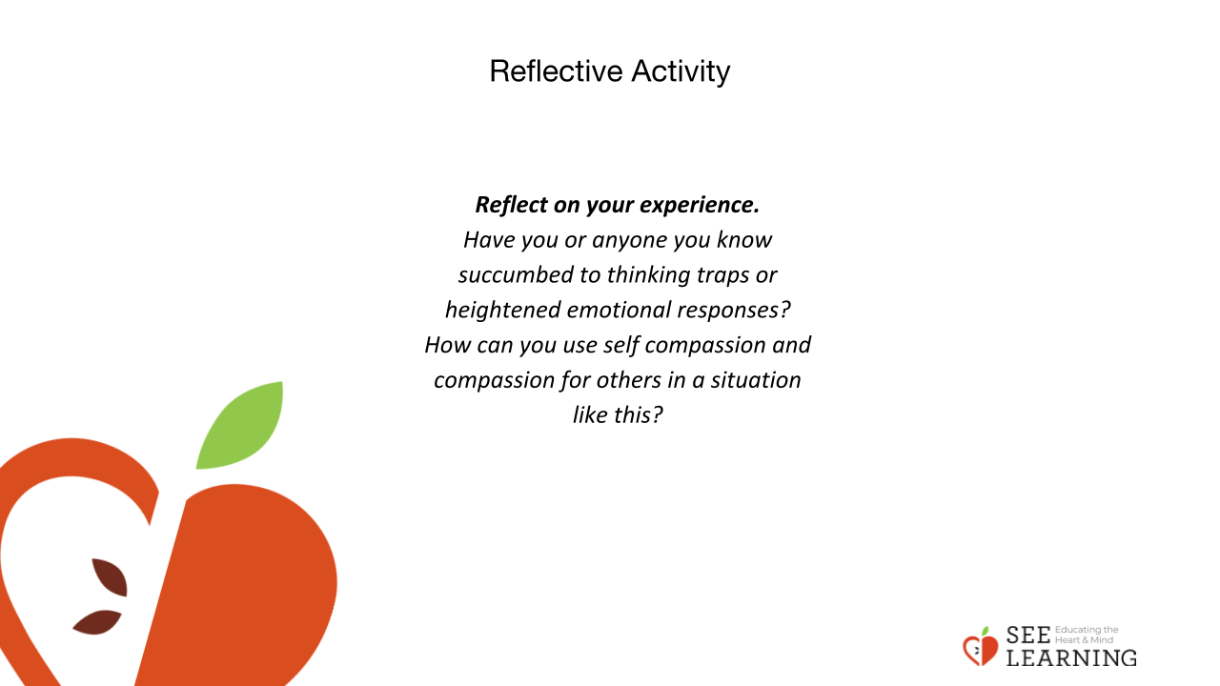 | Instructions and Guiding Language  - When we are not aware of cognitive distortions , (thinking traps), this can lead to a third category, called emotional distortions. Have you ever seen someone get angry or afraid of something because of a mistake?  - Allow time for students to share (again not naming names) and provide the example below.  - For example, perhaps a father can’t find his keys. He searches all around and gets anxious because he feels he is going to be late for an important appointment. His daughter comes into the room and he shouts, “Did you take my keys again? Why do you keep moving my things?”  - If he becomes really angry, then even if someone else points out that he’s made a mistake, he might not be able to hear it. He’s in what Paul Ekman calls the “refractory period” of intense emotion. During this period, people are less open to new information. When that happens, a person might do something or say something that they later regret. This can be a challenging but fruitful opportunity to hold compassion for that person, when they are experiencing an emotional distortion.  - Written Response/Verbal Share: Reflect on your experience. Have you or anyone you know succumbed to thinking traps or heightened emotional responses? How can you use self compassion and compassion for others in a situation like this?

