Co-creating Class Agreements

Purpose:
In this learning experience students will employ the lenses of interdependence and systems thinking, as well as common humanity, diversity, and inclusivity to shape brainstormed suggestions into a list of class agreements that can be used by the class for the remainder of the school year. Students will reflect on the short term and long term implications of upholding these agreements on both themselves and others.
Learning Objectives:  Students will be able to:  - Evaluate class agreements through the lenses of interdependence, common humanity, diversity, inclusion, and well-being.  - Collaboratively form agreements that serve as personal and collective commitments. | Primary Core Component  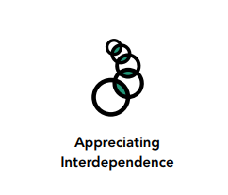  
Length  45 Minutes | Materials Required  - Small Group Charts from Part 1  - Sticky notes, index cards or slips of paper near each poster  - Chart paper for final draft of agreements  - Markers

Check-In (5 mins)
Slide 2: Check-In  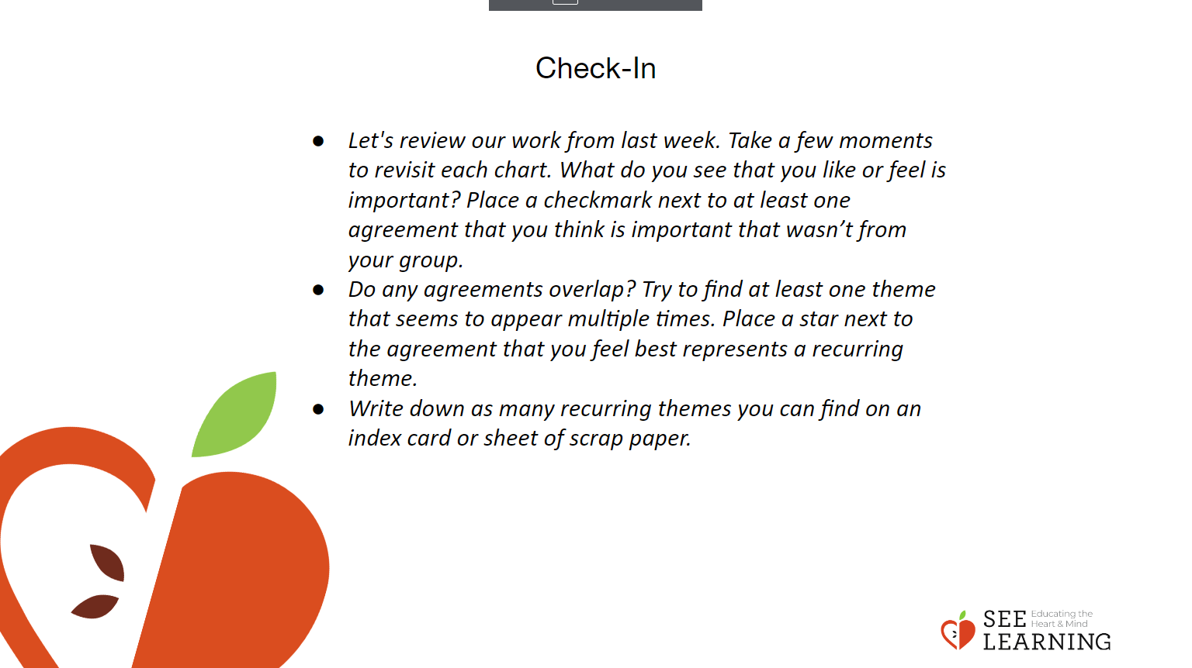 | Instructions and Guiding Language  - Display the charts from Classroom Agreements Part 1  - Let's review our work from last week. Take a few moments to revisit each chart. What do you see that you like or feel is important? Place a checkmark next to at least one agreement that you think is important that wasn’t from your group.  - Do any agreements overlap? Try to find at least one theme that seems to appear multiple times. Place a star next to the agreement that you feel best represents a recurring theme.  - Write down as many recurring themes you can find on an index card or sheet of scrap paper.

Insight Activity (15 mins)
Slide 3: Insight Activity  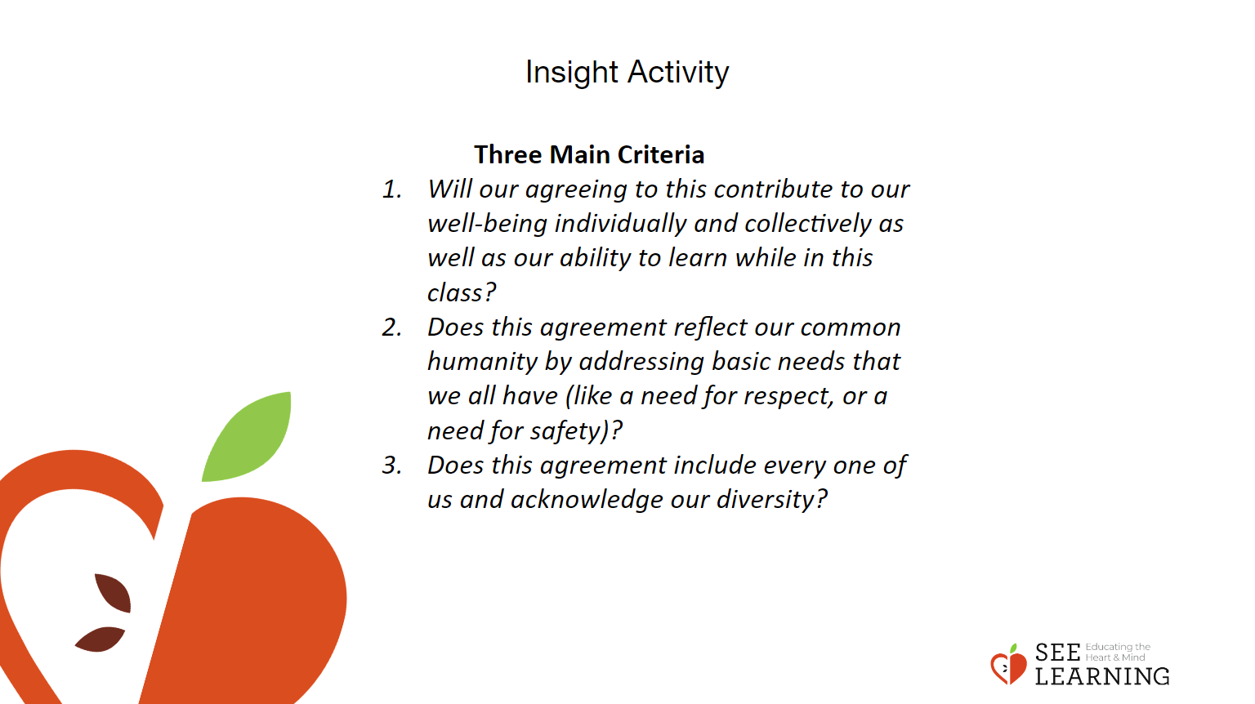 | Instructions and Guiding Language  Small Group Activity  Students will work in small groups to build a list of class agreements, drawn from the suggestions they previously brainstormed and recorded. They will use three prompts as a guide to help in assessing class agreements and in rewording them.  Step by Step Directions  Display or print out the directions for the groups to follow.  - One at a time, share the recurring themes that you identified in the check in activity. Notice any similarities and differences in the themes that were identified.  - Based on the themes your group identified and the information on the charts around the room, write 1 agreement that is most important to you and share it with your group.  - Together write 3-5 class agreements. Again using your group's ideas, the overlapping themes and the information on the charts around the room.  - Reflect on the following three questions and make changes to your agreements as needed.  - Will our agreeing to this contribute to our well-being individually and collectively as well as our ability to learn while in this class?  - Does this agreement reflect our common humanity by addressing basic needs that we all have (like a need for respect, or a need for safety)?  - Does this agreement include every one of us and acknowledge our diversity?  - Check again for any repetitive ideas and work to combine and refine your ideas.  - Finally, come up with three proposed agreements that you will share with the whole class from your group. Put them in the form of positive statements “We will…” instead of negative ones “We will not…”  - Write each agreement individually on an index card or sticky note.  Whole Class  As a whole class, we will share our 3 group agreements and combine agreements that are similar.  We will settle on up to 5 agreements that we will formally adopt. We want to have enough agreements that they cover the things we feel are important, but not too many so we can’t remember and keep track of them.  Each group will read out and present their three agreements. Please explain why you chose that agreement. Once you have presented, place your index card or sticky note on the table or board next to other agreements that have similar themes so that we can combine them.  Look at these proposed agreements and see which we can combine. (Invite discussion if necessary when combining proposed agreements.)  Now that we’ve condensed the proposed ideas, let’s evaluate them as a group. Let’s remember our three main criteria:  - Will our agreeing to this contribute to our well-being individually and collectively as well as our ability to learn while in this class?  - Does this agreement reflect our common humanity by addressing basic needs that we all have (like a need for respect, or a need for safety)?  - Does this agreement include every one of us and acknowledge our diversity?  Note  It is important to spend enough time discussing the agreements so that students feel that their voices are being heard. If you do not have enough time to reach a consensus, you may need to continue the discussion and adoption in the next session. However, if the discussion seems to be going on too long, remind students that the list of class agreements is a living document and that you will return to it as a class regularly. This means that it is not set in stone, and they can always change or revise the agreements later.  Review the list aloud. As you read each item, ask for a show of hands from the students to signal agreement. If students object, invite them to share their reasons and how they would reword or re-state the agreement.

Reflective Practice (10 mins)
Slide 4: Reflective Practice  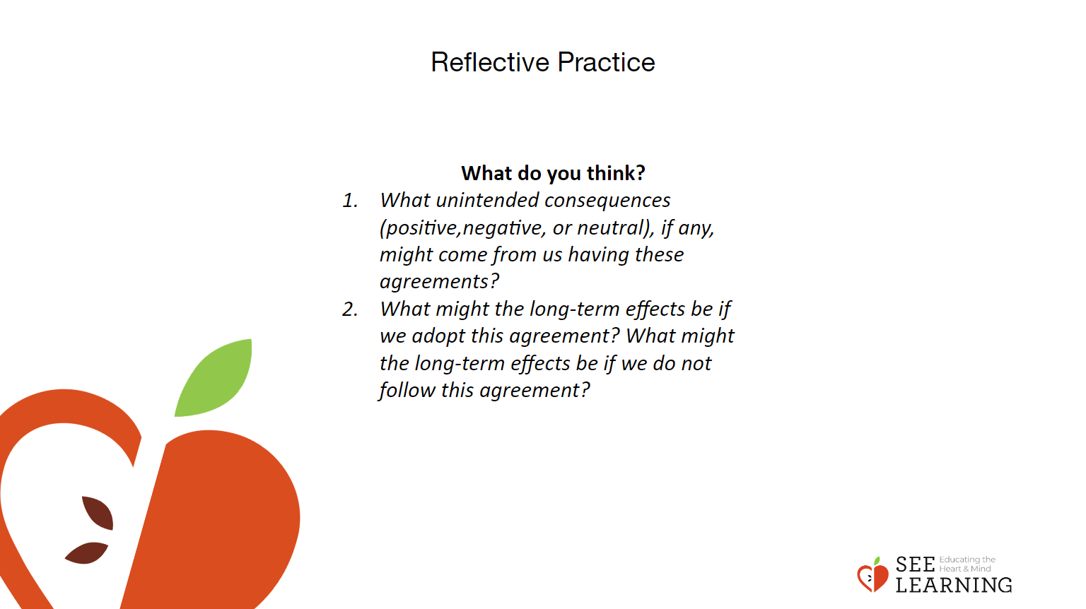 | Instructions and Guiding Language  Let’s look at our agreements through a systems thinking lens by reflecting on the following questions.  - What unintended consequences (positive,negative, or neutral), if any, might come from us having these agreements?  - What might the long-term effects be if we adopt this agreement? What might the long-term effects be if we do not follow this agreement?

Debrief (5 mins)
Slide 5: Debrief  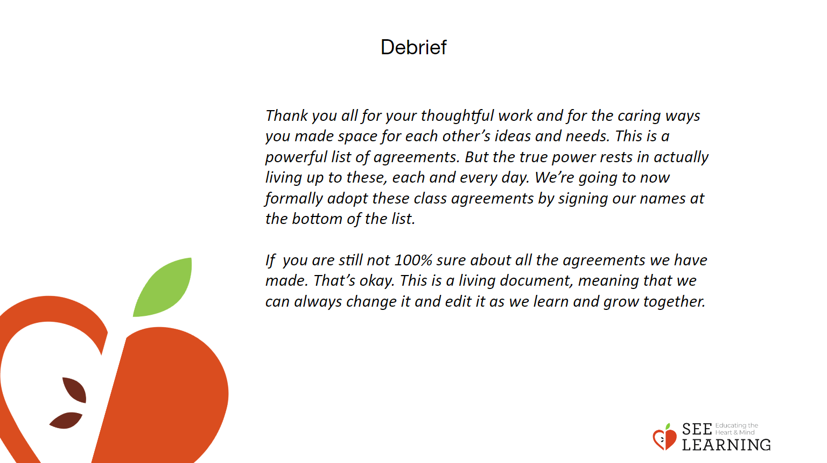 | Instructions and Guiding Language  Signing the Agreements (2 minutes)  Thank you all for your thoughtful work and for the caring ways you made space for each other’s ideas and needs. This is a powerful list of agreements. But the true power rests in actually living up to these, each and every day. We’re going to now formally adopt these class agreements by signing our names at the bottom of the list.  If you are still not 100% sure about all the agreements we have made. That’s okay. This is a living document, meaning that we can always change it and edit it as we learn and grow together.  Invite the students to sign the class agreements, then post it in a visible place in the classroom.

