Laying the Foundation for Class Agreements

Purpose:
In this learning experience students will see their classroom as an interdependent system. Primed with an understanding of common humanity, diversity, inclusivity, and interdependence students will work together to explore shared ways of interacting and relating to one another that promote shared happiness and wellbeing. Students will review a needs inventory list and an emotions inventory list to provide them with the languages they need to reflect on how they can interact with others and expect others to interact with them.
Learning Objectives:  Students will be able to:  - Determine the impacts of actions and attitudes on others and the learning environment  - Construct and agree upon guidelines for classroom engagement (class agreements)  - Examine how collective agreements can reflect an awareness of common humanity, diversity, inclusivity, and interdependence. | Primary Core Component  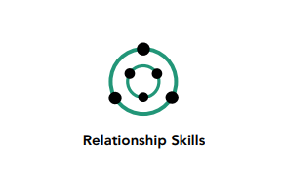  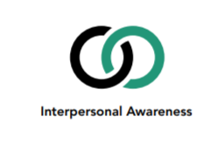
Length  45 Minutes | Materials Required  - Chart Paper  - Markers  - GalleryWalk Printouts for Stations

Check-in (8 mins)
Slide 2: Check-In  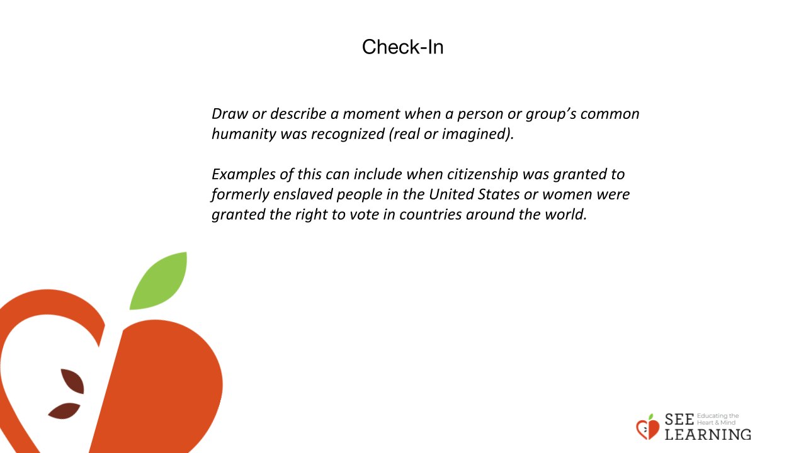 | Instructions and Guiding Language  Have the following prompt up on the board. “In groups of two or three, draw or describe a moment when a person or group’s common humanity was recognized (real or imagined).” Examples of this can include when citizenship was granted to formerly enslaved people in the United States or women were granted the right to vote in countries around the world.  Give students 5 minutes or so to discuss in groups and draw. Then ask each group to share their drawing in just two or three sentences. Conclude by inviting any student to share thoughts with “I notice, I like, I wonder.”  Guiding Language  So far we have started to ask a few key questions. What is well-being and what leads to it? What is our common humanity and what is diversity? And how are we interdependent? It’s okay if we haven’t fully answered these questions yet; in fact we’ve probably just scratched the surface. We will continue to explore them in the weeks and months to come.  Today we’ll be exploring our class as an interdependent system and how we’d like it to operate based on our understanding of common humanity and diversity.  So first let’s take a moment to think about what it means to show kindness to another person by acknowledging their common humanity.  Can you think of a time when someone recognized another person’s common humanity? It could be from your own life, or it could be something you saw on television, in a film, online, or in a book or comic book. Please get into groups of two or three. Think of an example from real life or something you’ve seen or something you’d like to imagine. Then draw it together on the board. Let’s take just a few minutes to do this.  When 5 minutes or so is up, invite each group to finish their drawings and then share briefly what they drew. Then invite students to share their thoughts with “I like, I notice, I wonder.”  Now let’s share what we’ve drawn. Those who are listening can then share something we notice, something we like, or something we wonder about. To do so, say “I notice… I like… or I wonder…”

Presentation (5 mins)
Slide 3: Presentation  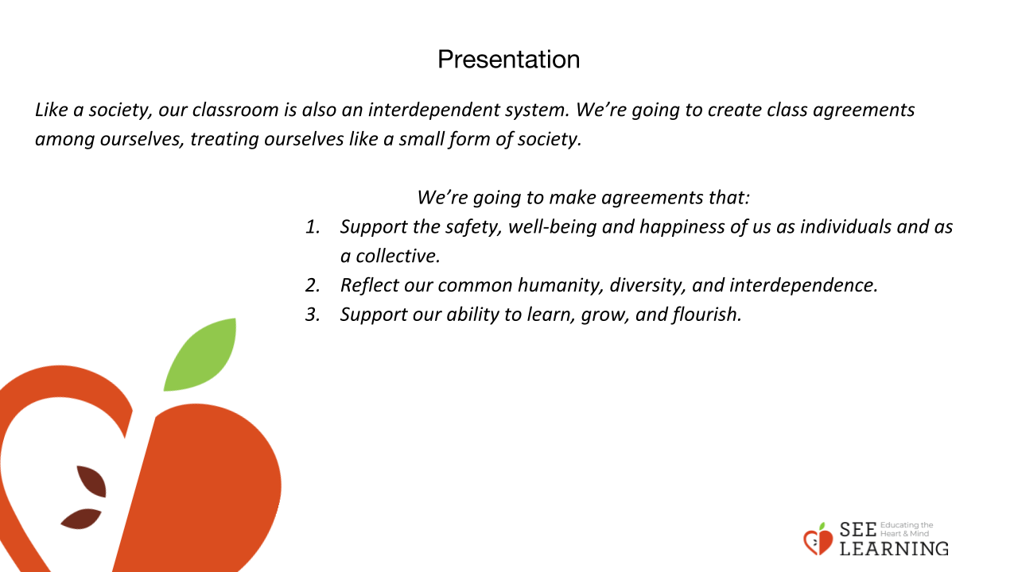 | Instructions and Guiding Language  Overview  Students will consider what could contribute to happiness and well-being when viewing their class as an interdependent system and when reflecting on their own common humanity and diversity.  Guiding Language (3 minutes)  Our classroom is an interdependent system, in which each person affects and is affected by the others.  Today we will begin to brainstorm shared agreements that outline how we will be together in this class. Collective agreements help support the well-being of individuals and groups, especially when made through an exploration of both the common humanity and diversity in the group. Through this process, we will each have a voice in how our classroom is experienced by us and others.  In the past, laws were often handed down by rulers and common people didn’t have any say in things. Now it is common for people to have a say in how they are governed. Most societies have common agreements in the form of laws, regulations, and policies. These agreements generally apply to all members of a society. Ideally, they serve to regulate conflict and to support the general well-being of the people in society. The agreements arise because we share a common wish for well-being, and because we are interdependent: our actions affect other people, and other people’s actions affect us. But although our agreements arise from and reflect our common humanity, it is rare for everyone to completely agree that the laws and policies of their society are all the best they can be or that they are perfectly fair. We also see that laws and policies vary across countries. This is a reflection of our diversity. The agreements within a society are thus a reflection of both this common humanity and this diversity.  Like a society, our classroom is also an interdependent system. We’re going to create class agreements among ourselves, treating ourselves like a small form of society.  We’re going to make agreements that:  - Support the safety, well-being and happiness of us as individuals and as a collective.  - Reflect our common humanity, diversity, and interdependence.  - Support our ability to learn, grow, and flourish.

Insight Activity (25 mins)
Slide 4: Insight Activity  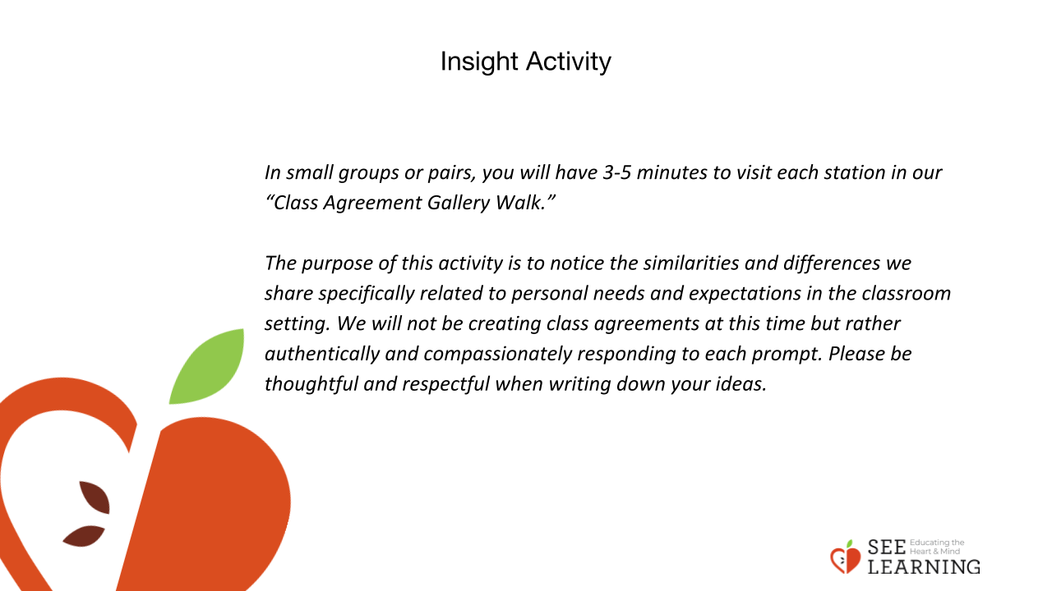 | Instructions and Guiding Language  Gallery Walk  Create stations around the room by printing out or writing out the prompts below. *Note: The print out should be taped or stapled on to the large chart paper so there is enough space for all students to write down their responses. Each large chart paper or station will have one prompt on it. Students will visit each station discussing and writing down ideas and thoughts on the chart paper provided.  Explain  In small groups or pairs, you will have 3-5 minutes to visit each station in our “Class Agreement Gallery Walk.” The purpose of this activity is to notice the similarities and differences we share specifically related to personal needs and expectations in the classroom setting. We will not be creating class agreements at this time but rather authentically and compassionately responding to each prompt. Please be thoughtful and respectful when writing down your ideas.  Gallery Walk Prompts  - How do we want to feel in our classroom?  - What do you need personally to be successful as a learner?  - How do we impact and affect one another? Intentionally (on purpose) or unintentionally (without knowing)? T-chart (positive, negative)  - How do we depend on each other in our classroom?  - Are my needs and assets the same as everyone else in my class? What might be a particular asset (useful or valuable quality), that I or some students might have, that not everyone in our class might have?  Once all groups have visited and contributed to each station, move into the reflective practice.

Reflective Practice
Slide 5: Reflective Practice  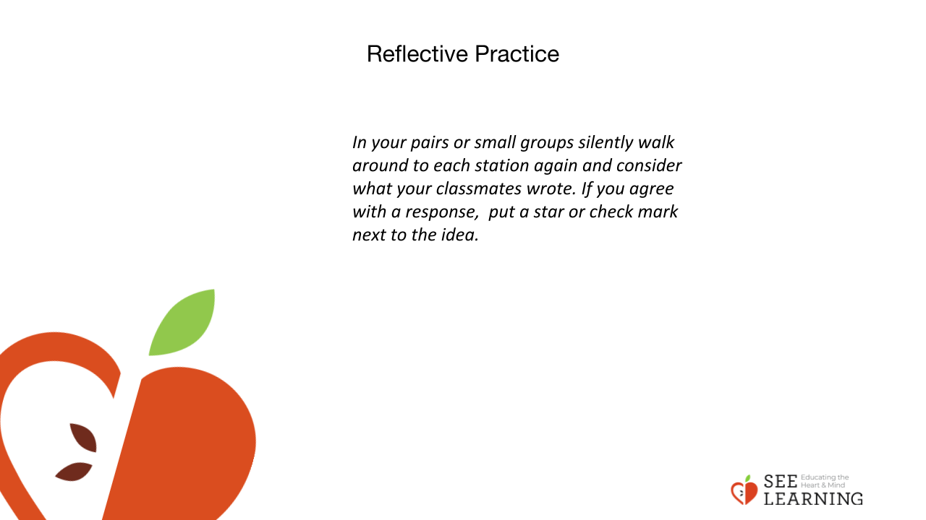 | Instructions and Guiding Language  Gallery Walk Reflection  In your pairs or small groups silently walk around to each station again and consider what your classmates wrote. If you agree with a response, put a star or check mark next to the idea.

Debrief (5 mins)
Slide 6: Debrief  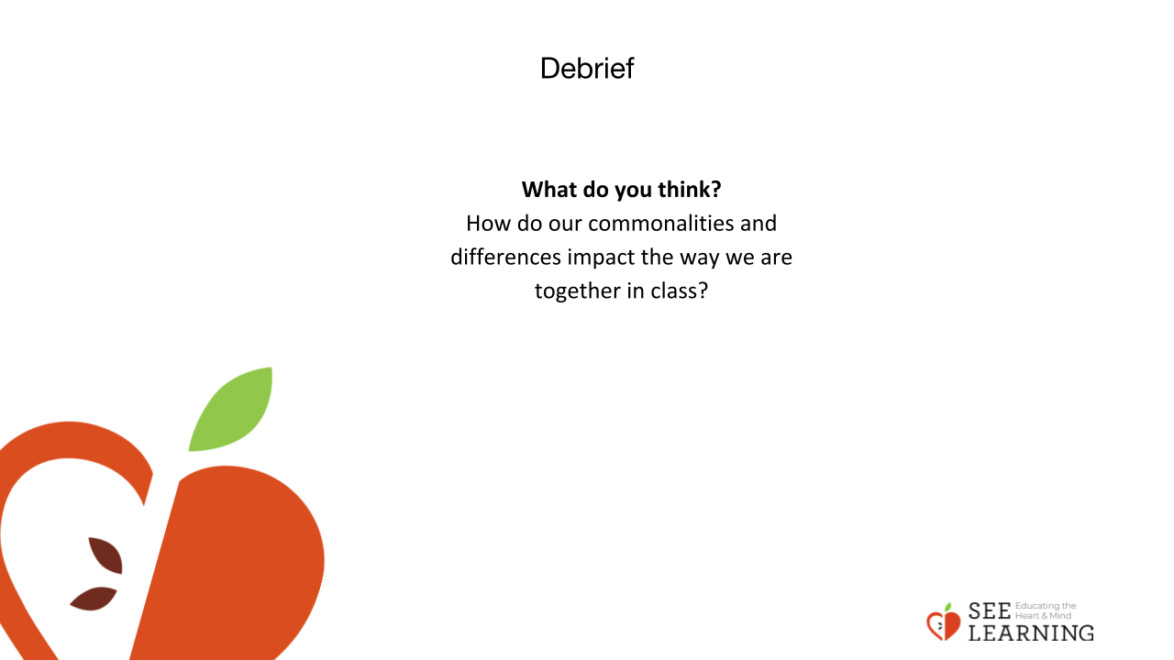 | Instructions and Guiding Language  Whole Class Discussion  How do our commonalities and differences impact the way we are together in class?

