Exploring Systems Thinking and Appreciating Interdependence

Purpose:
In this learning experience students will examine how interdependence affects their life. Through an examination of the concept of interdependence and through the application of systems thinking students will identify the interdependence that exists within a single event, object, or accomplishment. Students will reflect on how an awareness of interdependence can inform the daily decisions they make.
Learning Objectives:  Students will be able to:  - Investigate the interdependence of objects, people, and events as a feature of our shared reality by using the interdependence drawing.  - Examine how the things we need for our happiness and well-being depend on many other objects, events and people.  - Recognize interdependence as a foundational aspect of systems thinking.  - Reflect on the potential value of recognizing interdependence and cultivating systems thinking. | Primary Core Component  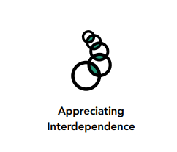
Length  45 Minutes | Materials Required  - Large sheets of paper  - Markers

Check-In (8 mins)
Slide 2: Check-In  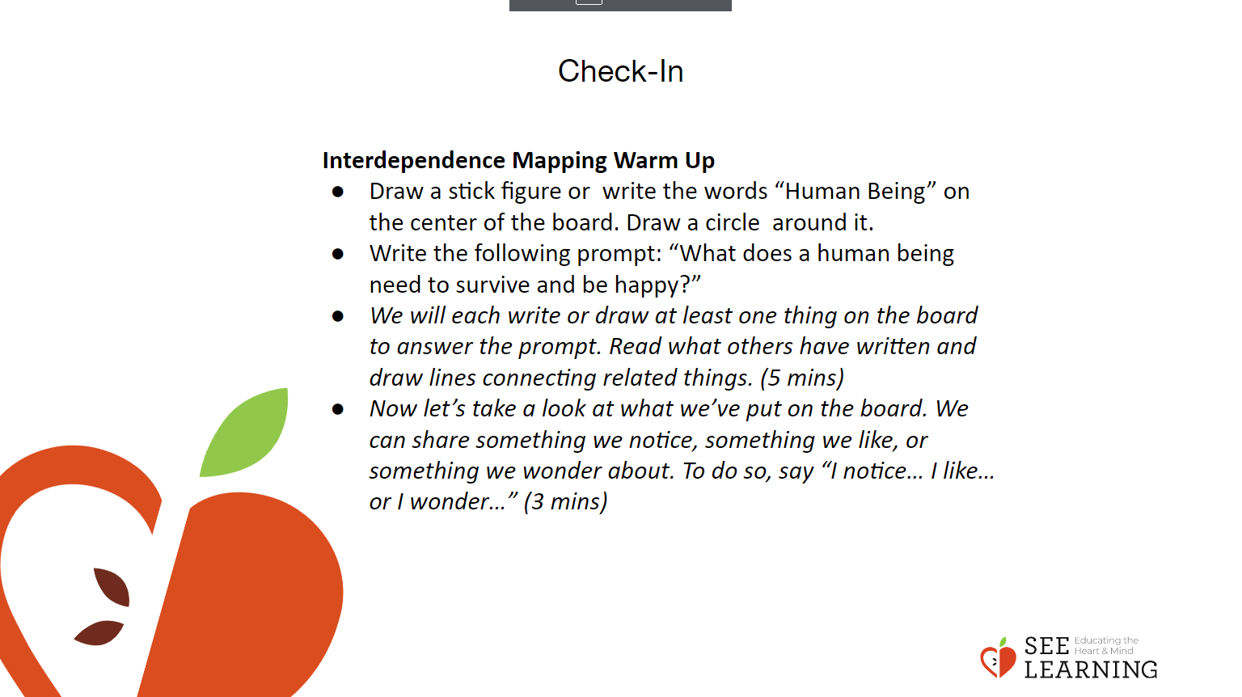 | Instructions and Guiding Language  Interdependence Mapping Warm Up  - Draw a stick figure or write the words “Human Being” on the center of the board. Draw a circle around it.  - Write the following prompt: “What does a human being need to survive and be happy?”  - We will each write or draw at least one thing on the board to answer the prompt. Read what others have written and draw lines connecting related things. (5 mins)  - Now let’s take a look at what we’ve put on the board. We can share something we notice, something we like, or something we wonder about. To do so, say “I notice… I like… or I wonder…” (3 mins)

Presentation (5 mins)
Slide 3: Presentation  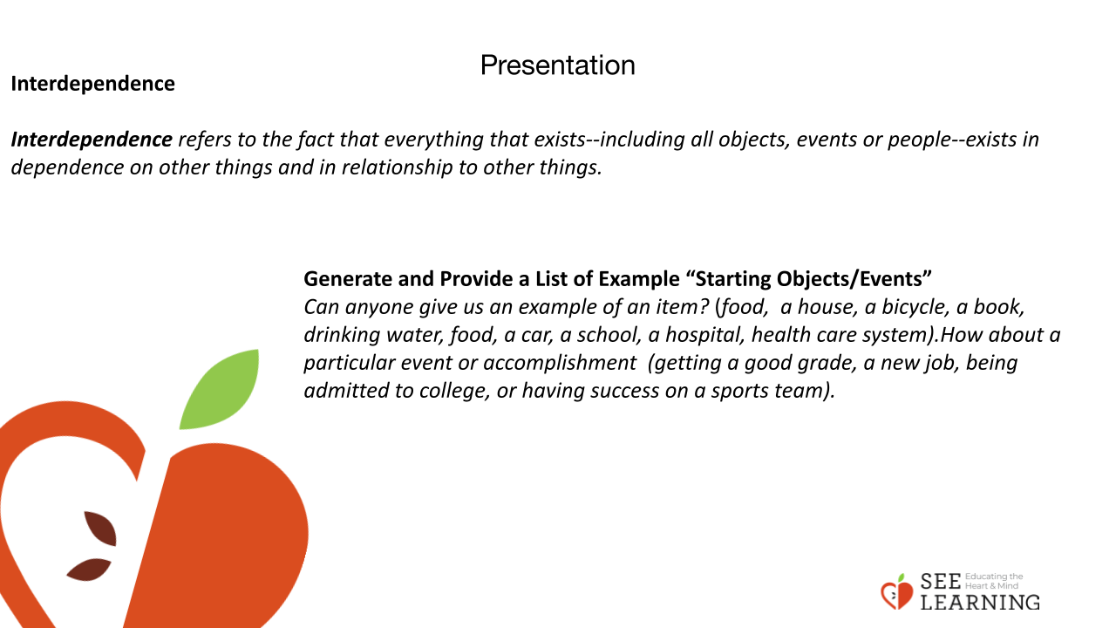 | Instructions and Guiding Language  Interdependence  Along with common humanity, another aspect of our shared human reality is interdependence. What is interdependence? Interdependence refers to the fact that everything that exists--including all objects, events or people--exists in dependence on other things and in relationship to other things. Exploring interdependence helps us appreciate complexity and is a key aspect of what is called “systems thinking.”  Why might it be important to explore interdependence? Exploring interdependence can be a powerful tool for recognizing how we depend on others and others depend on us; it can underscore the importance of reciprocity; it can serve as a foundation for gratitude and a feeling of connectedness to others. The ability to explore interdependence is also essential for systems thinking, since interdependence is a characteristic of all systems. This in turn supports an ecological and scientific understanding of the world and a holistic way of understanding and solving problems, whether they are individual or collective.  To explore the idea of interdependence, we’ll be working in small groups to create an interdependence drawing. Each group is going to identify an accomplishment, event, or object that you all agree can contribute to a person’s well-being and happiness. Each group will choose a specific and concrete thing or event. This will be called your “starting object/event.” Let’s list a few “starting objects” together before we begin our group work.  Generate and Provide a List of Example “Starting Objects/Events”  Can anyone give us an example of an item? (food, a house, a bicycle, a book, drinking water, food, a car, a school, a hospital, health care system).How about a particular event or accomplishment (getting a good grade, a new job, being admitted to college, or having success on a sports team). List the starting objects as examples for groups to choose from.

Insight Activity (20 mins)
Slide 4: Insight Activity  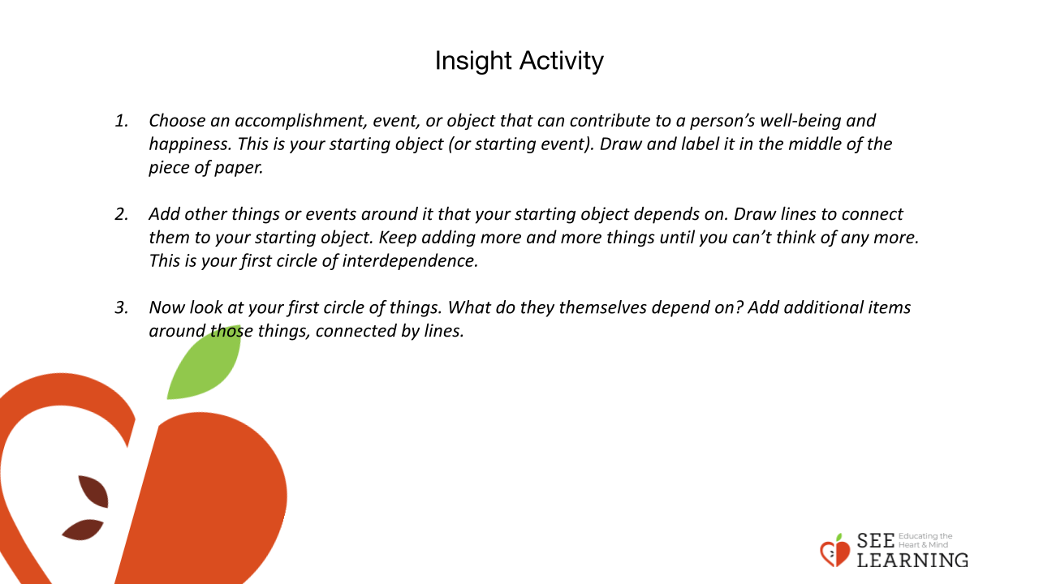  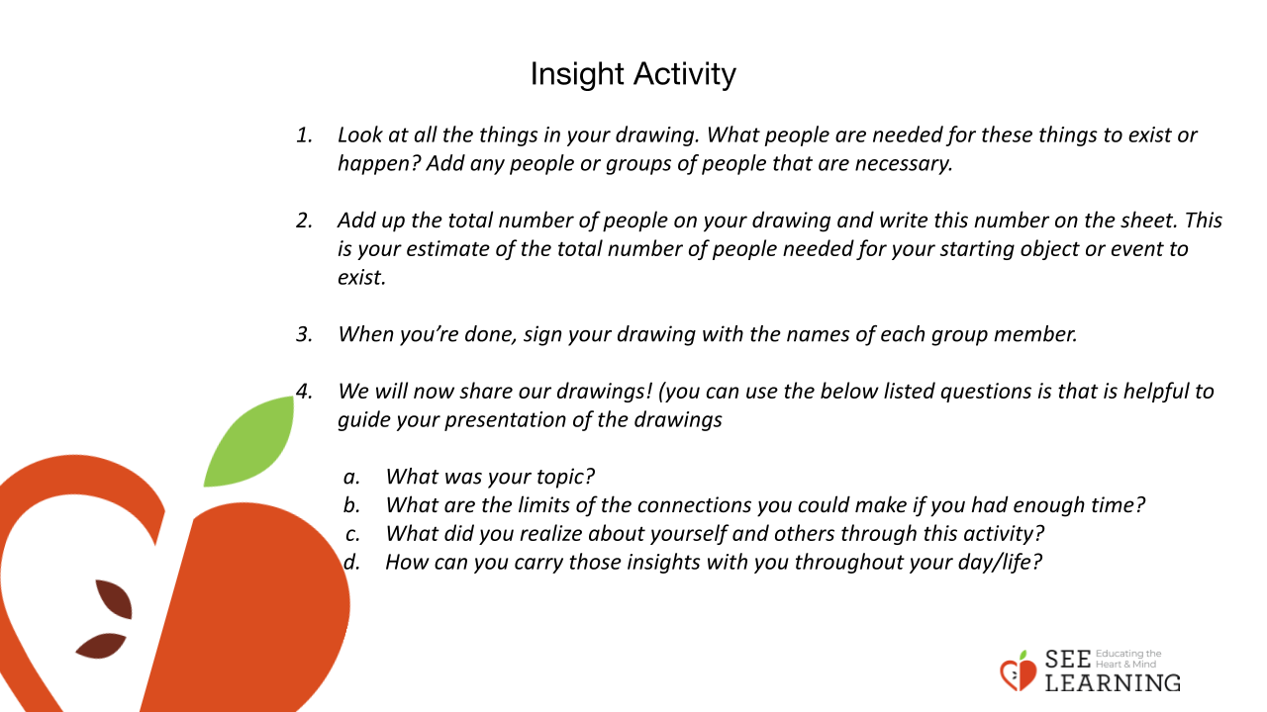 | Instructions and Guiding Language  Creating a Web of Interdependence  In small groups students will create a web of interdependence by choosing a single accomplishment, event, or object related to well-being or happiness. The web of interdependence can include drawings and/or words that illustrate all the things that their chosen accomplishment, event or object depends or depended on.  Display the instructions below.  - Choose an accomplishment, event, or object that can contribute to a person’s well-being and happiness. This is your starting object (or starting event). Draw and label it in the middle of the piece of paper. (1-2 minutes)  - Add other things or events around it that your starting object depends on. Draw lines to connect them to your starting object. Keep adding more and more things until you can’t think of any more. This is your first circle of interdependence. (4-5 minutes)  - Now look at your first circle of things. What do they themselves depend on? Add additional items around those things, connected by lines. (4-5 minutes)  - Look at all the things in your drawing. What people are needed for these things to exist or happen? Add any people or groups of people that are necessary. (3-4 minutes)  - Add up the total number of people on your drawing and write this number on the sheet. This is your estimate of the total number of people needed for your starting object or event to exist. (2 minutes)  - When you’re done, sign your drawing with the names of each group member.  - We will now share our drawings! (you can use the below listed questions is that is helpful to guide your presentation of the drawings (2 minutes per group)  - What was your topic?  - What are the limits of the connections you could make if you had enough time?  - What did you realize about yourself and others through this activity?  - How can you carry those insights with you throughout your day/life?  Monitor each group to provide guidance as necessary. You can prompt them to think further by asking questions like, “This item here, does it exist all by itself or does it need other people or things for it to exist?”

Reflective Practice
Slide 5: Reflective Practice  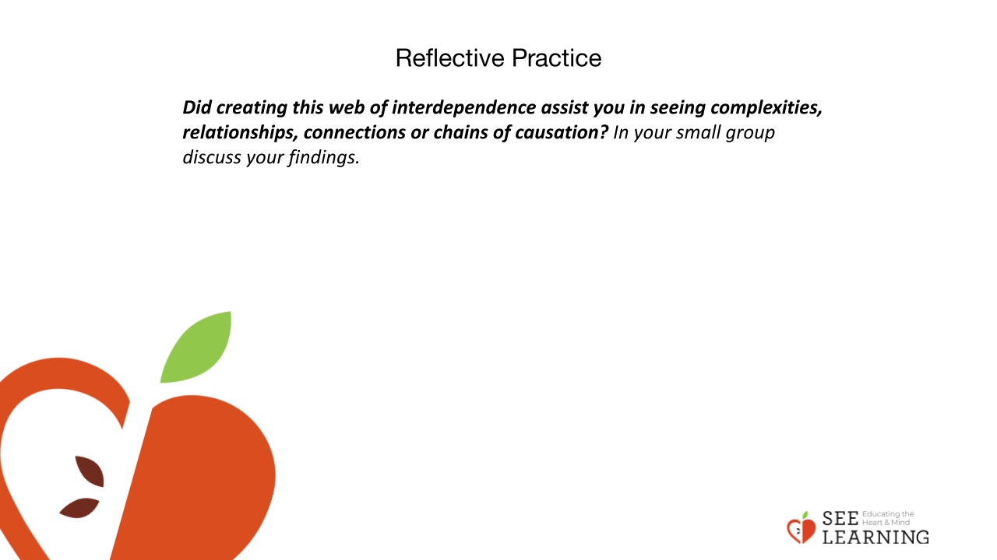  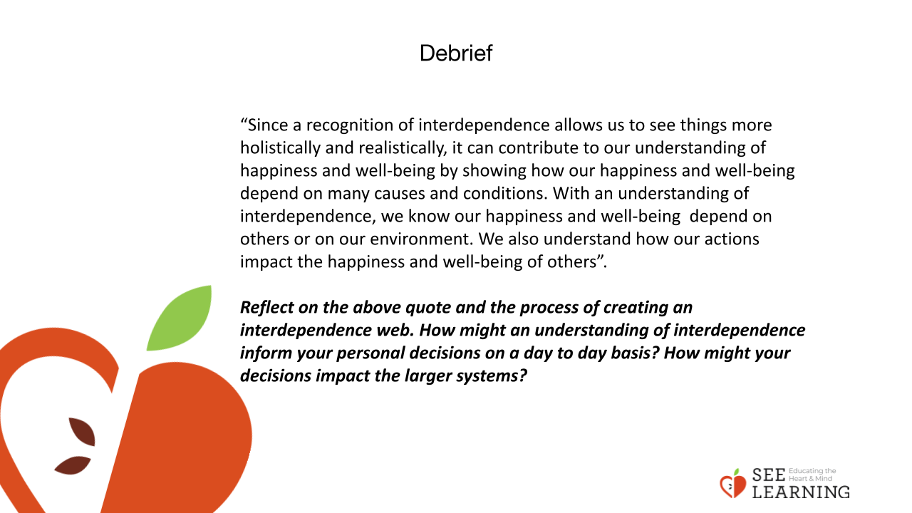 | Instructions and Guiding Language  The activity we just did can be used to investigate any event or object. Scientists have found that we have a tendency to think in very immediate terms. We can see what’s right in front of us, but it’s harder for us to see the connections between things, especially when they are distant in terms of time or space. We tend to think things just exist or happen by themselves. But in reality, everything happens through complex chains of causation. Exploring these chains and the entire system that makes up something, with all the relationships within that system, is called “systems thinking.” It’s a very crucial skill for us to develop, because it can help us see deeper into the nature of things. Did creating this web of interdependence assist you in seeing complexities, relationships, connections or chains of causation? In your small group discuss your findings.

