Exploring Common Humanity
Purpose:
In this learning experience students will examine the concept of common humanity. Through a series of activities students will determine how all people share a desire to be happy, well, and to experience both kindness and compassion. Students will reflect on how like them others want happiness and to avoid distress, worry, and suffering.
Learning Objectives:  Students will be able to:  - Demonstrate the relationship between common humanity, diversity, and inclusion  - Identify how awareness of common humanity supports the appreciation of diversity and the practice of inclusion | Primary Core Component  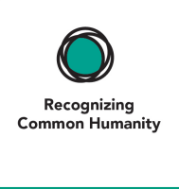  
Length  45 Minutes | Materials Required  - Vocabulary Posters with definitions of core concepts from LE 1 (clearly visible)  - Blank index cards  - SEE Learning journal or writing/drawing paper for each student  - Pens, pencils, colored pencils, markers

Check-In ( mins)
Slide 2: Check-In  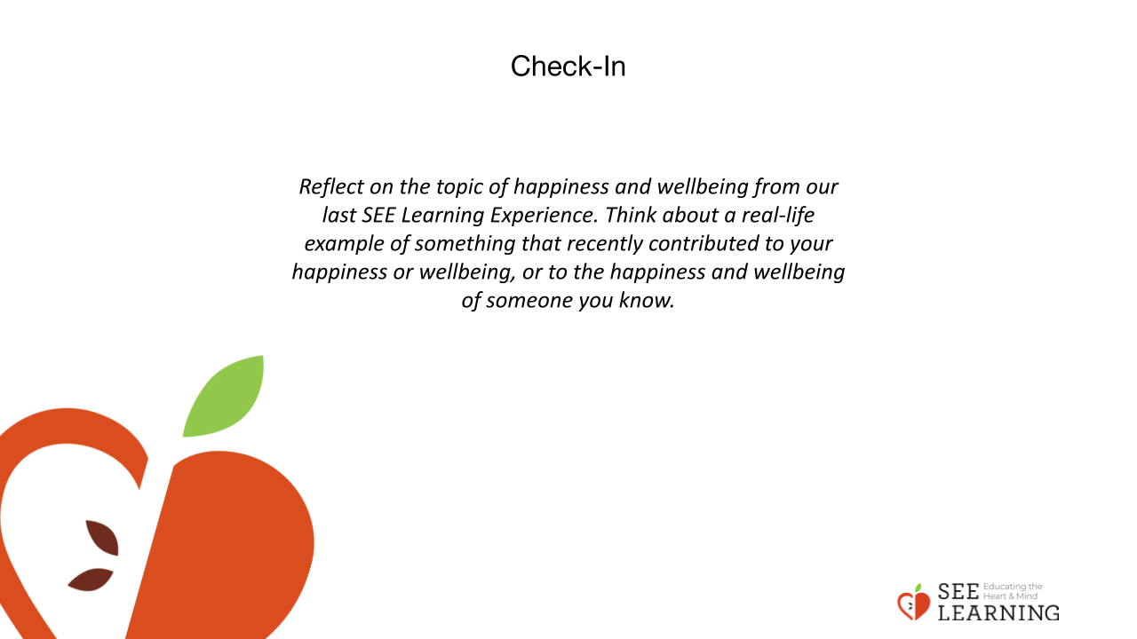 | Instructions and Guiding Language  Whole Group Verbal Share with the Option to PASS  Reflect on the topic of happiness and wellbeing from our last SEE Learning Experience. Think about a real-life example of something that recently contributed to your happiness or wellbeing, or to the happiness and wellbeing of someone you know.

Presentation (10 mins)
Slide 3: Presentation  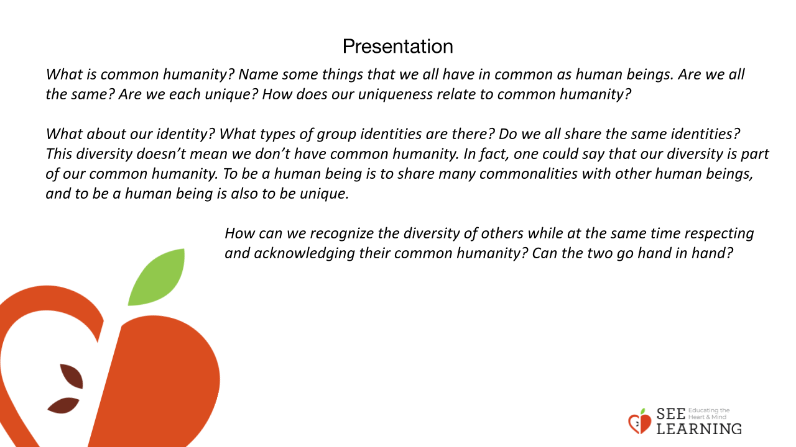 | Instructions and Guided Language  Use the questions and prompts below to engage the class in a discussion around common humanity and diversity.  Today we are going to look more deeply at the concept of common humanity. What is common humanity? Name some things that we all have in common as human beings. (We’re all born, we all age. We all need food and water. We all have bodies, we all live, grow and eventually die; we are all vulnerable to physical, emotional and environmental harm; we all need nourishment and safety; we all depend on others for survival, especially when we are young; and we all depend on this planet for our survival, we prefer wellbeing, happiness and health). Are we all the same? Are we each unique? How does our uniqueness relate to common humanity?  What about our identity? What types of group identities are there? (Gender identity, our cultural identity, racial identity, our national identities) Do we all share the same identities? This diversity doesn’t mean we don’t have common humanity. In fact, one could say that our diversity is part of our common humanity. To be a human being is to share many commonalities with other human beings, and to be a human being is also to be unique.  Throughout history, there have been many times when one group tried to deny the common humanity of another group by focusing on the differences others had and not acknowledging their basic humanity. For long periods of human history, girls and women weren’t valued the same way boys and men were, just because they were different. The same has happened to many ethnic and racial groups, people with disabilities, and many others groups that were stigmatized or discriminated against just for being different.  Since we are exploring wellbeing, we want to investigate this question: How can we recognize the diversity of others while at the same time respecting and acknowledging their common humanity? Can the two go hand in hand? Give students a moment to reflect and ask a few volunteers to share their thoughts.
Insight Activity (15 mins)
Slide 4: Insight Activity  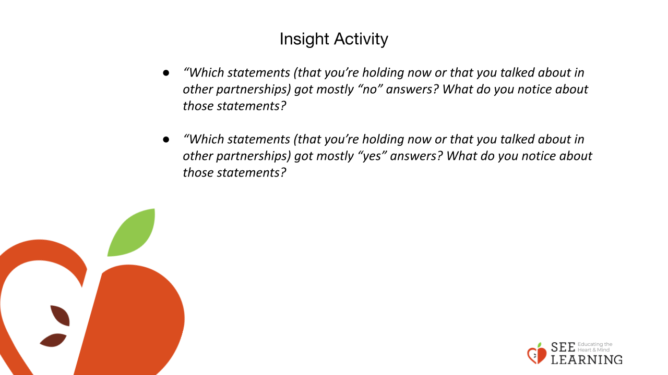 | Instructions and Guided Language  All People/Not All People  Directions  - You will each receive 2 index cards. Label one card with the words “All People” and label the second card “Not All People”  - Write down 2-3 examples on each index card. Under the heading “All People” write down examples of common humanity. Under the heading “Not All People” write down examples of diversity (something that is true for some people but not all people).  - Please use appropriate examples that will not be harmful to anyone in the group as we will be sharing our examples with everyone else in the class.  - After completing the statements on the cards, all the cards will be shuffled together and you will receive two random cards that were written by another classmate. .  - Next you will pair up and take turns reading the statement(s) on the card. Your partner will respond yes (agree) or no (disagree), giving some evidence or an example that supports their answer. And then you will switch roles.  - After each of you has read and responded to the statements on the cards, Thank your partner, trade cards, and find another partner by holding your cards up.  - Repeat until time is up.  Debrief the activity in the last four minutes. Ask each current pair to join up with another pair, forming groups of four. Pose several questions, one at a time, for them to discuss in their group of four. This will be followed by a whole group share.  - “Which statements (that you’re holding now or that you talked about in other partnerships) got mostly “no” answers? What do you notice about those statements?  - “Which statements (that you’re holding now or that you talked about in other partnerships) got mostly “yes” answers? What do you notice about those statements?  Whole group debrief:  - What did you notice from doing this activity? Did anything surprise you?  - Is it possible to appreciate common humanity and diversity at the same time? If so, how?

Debrief (5 mins)
Slide 5: Debrief  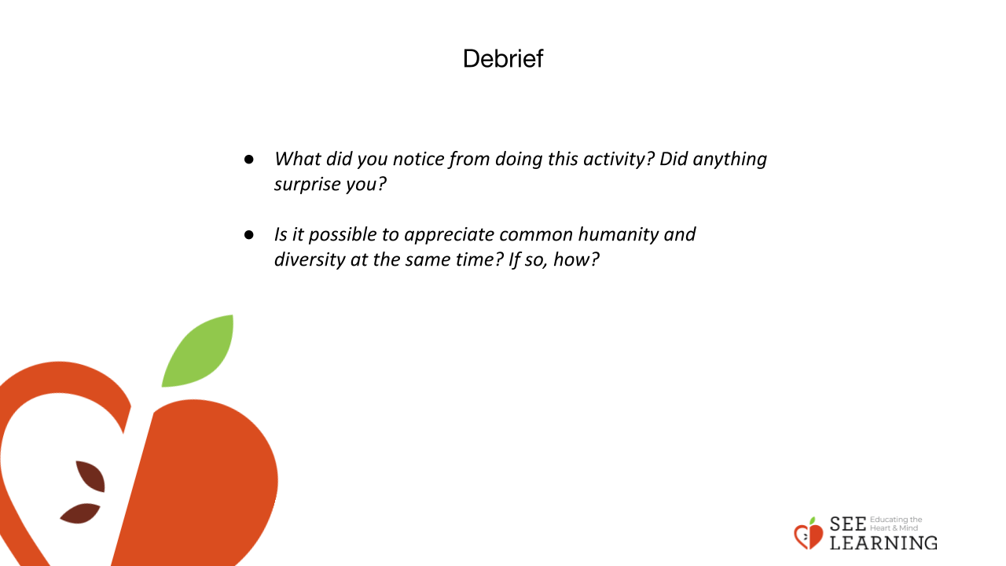 | Instructions and Guided Language  Small Group Debrief  - Which statements (that you’re holding now or that you talked about in other partnerships) got mostly “no” answers? What do you notice about those statements?  - “Which statements (that you’re holding now or that you talked about in other partnerships) got mostly “yes” answers? What do you notice about those statements?  Whole Group Debrief  - What did you notice from doing this activity? Did anything surprise you?  - Is it possible to appreciate common humanity and diversity at the same time? If so, how?

Reflective Practice (10 mins)
Slide 6: Reflective Practice  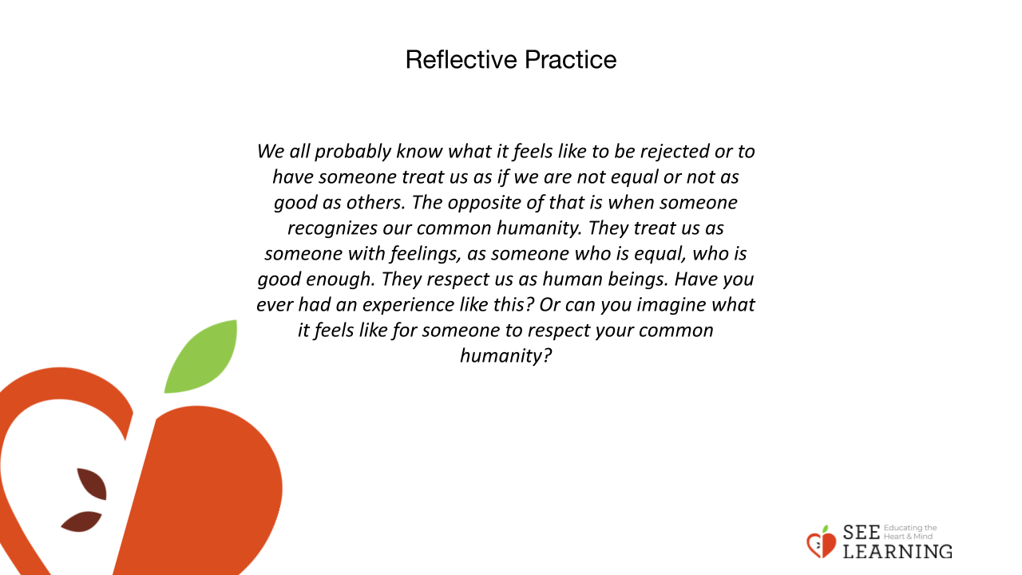 | Instructions and Guided Language  Silent Reflection/Writing Prompt  We all probably know what it feels like to be rejected or to have someone treat us as if we are not equal or not as good as others. The opposite of that is when someone recognizes our common humanity. They treat us as someone with feelings, as someone who is equal, who is good enough. They respect us as human beings. Have you ever had an experience like this? Or can you imagine what it feels like for someone to respect your common humanity?

