Exploring Happiness and Wellbeing

Purpose:
In this learning experience students will explore interpersonal awareness and common humanity through the lens of happiness and wellbeing. Students will be asked to identify how happiness can be cultivated through the development of ethics, the recognition of common humanity, ethics, and wellbeing.
Learning Objectives:  Students will be able to:  - Identify how the orientation to happiness and wellbeing is an area of common humanity  - Determine how the orientation to happiness can help to explain many human activities, motivations, and emotions.  - Describe the relationship between happiness and the four key concepts that will be developed throughout SEE Learning: ethics, common humanity, wellbeing, and interdependence. | Primary Core Component  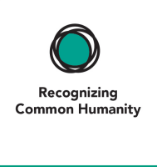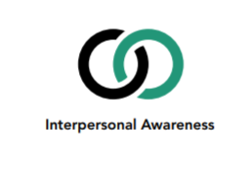
Length  45 Minutes | Materials Required  - Chart paper  - Large “Yes” and “No” signs that are placed either end of a continuum line  - Folders or journals  - Markers and writing utensils  - “Happiness” handout (One for each student.)
Check-In (5 min)
Slide 2: Check-In  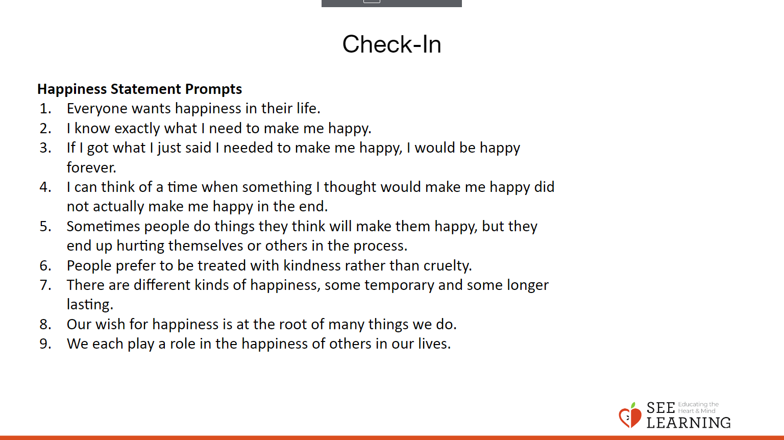 | Instructions and Guiding Language  Display the prompts “What is happiness?” and “What leads to happiness?” Briefly reflect on the prompts, discuss these questions in small groups or with a partner and write or draw an example that illustrates your response.

Insight Activity - Where I Stand (10 min)
Overview
Students will be given prompts that encourage them to think about the personal and universal wish for happiness, the internal and external causes for feeling happy, and the role this plays in their own motivations and actions. They will reflect on prompts, agree or disagree with those statements, and then explain their thinking to others.
Slide 3: Insight Activity - Where I Stand and Slide 4:Debrief  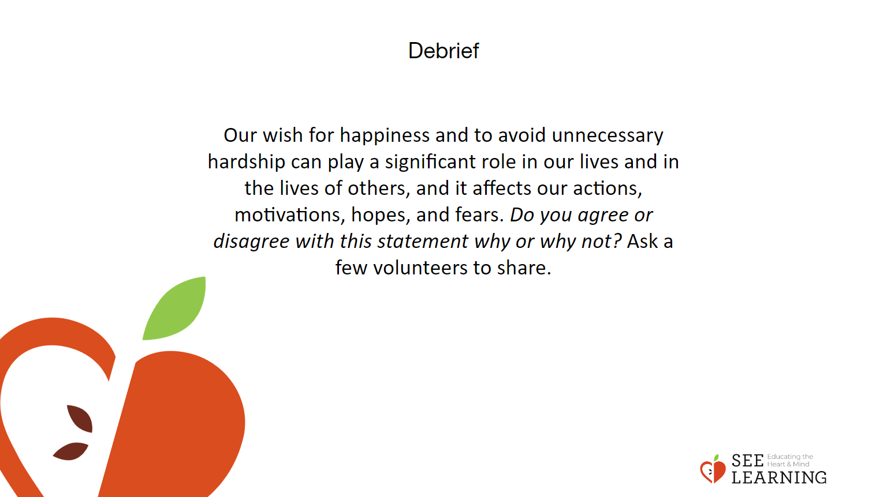  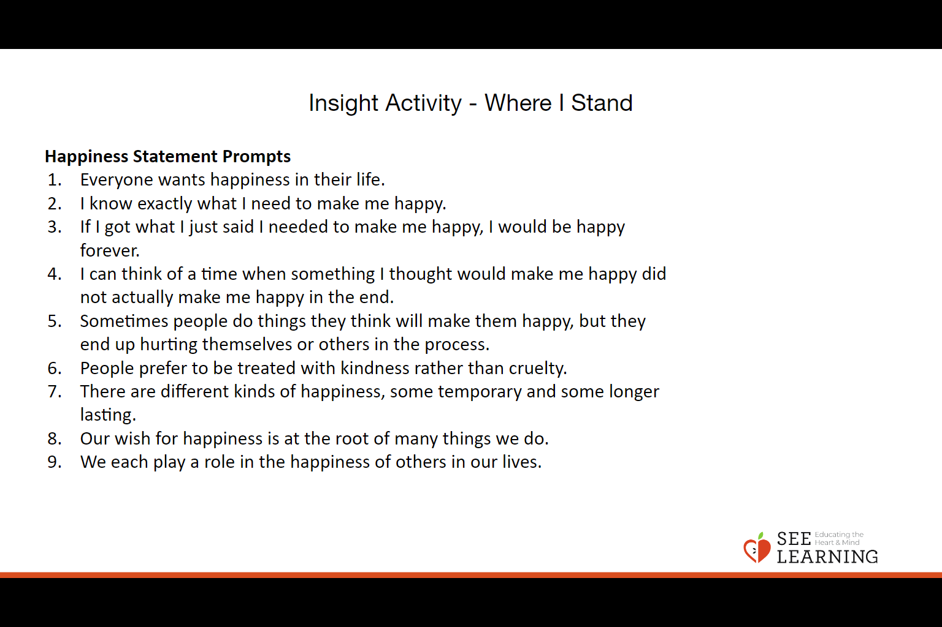 | Instructions and Guiding Language  Directions  - Set up a continuum line in the classroom by placing two large signs reading “Yes” and “No,” on either end of a line. The line can be imaginary or can be created with string or colored tape on the floor.  - Read the provided prompts aloud to the students, provide time for students to ponder the prompt and then choose their position along the continuum.  - Ask for volunteers to explain to the whole group why they chose their position.  Guiding Language  I’m going to read some statements and we will each stand along this continuum line, showing how close to ‘definitely yes’ or ‘definitely no’ each of us feels about the statement. We’ll have some time to think about where we’d like to stand, then we’ll each pick a place to stand and we will have the opportunity to share our thoughts with each other on why we are standing where we are. You may find that you are unsure about where you’d like to stand, and this is ok too. Also, at any time if you change your mind or hear something that makes you feel differently, you can move to a different place.  Happiness Statement Prompts  - Everyone wants happiness in their life.  - I know exactly what I need to make me happy.  - If I got what I just said I needed to make me happy, I would be happy forever.  - I can think of a time when something I thought would make me happy did not actually make me happy in the end.  - Sometimes people do things they think will make them happy, but they end up hurting themselves or others in the process.  - People prefer to be treated with kindness rather than cruelty.  - There are different kinds of happiness, some temporary and some longer lasting.  - Our wish for happiness is at the root of many things we do.  - We each play a role in the happiness of others in our lives.  Debrief  Display the statement below.  Our wish for happiness and to avoid unnecessary hardship can play a significant role in our lives and in the lives of others, and it affects our actions, motivations, hopes, and fears. Do you agree or disagree with this statement why or why not? Ask a few volunteers to share.
Insight Activity - Brief Introduction to SEE Learning
Overview
This year we are going to explore and discuss topics like how we navigate life and its challenges, how we take care of ourselves emotionally, how we support one another, and how we create communities that promote the wellbeing of all and welcome all as valued members. Why might these topics be important to explore?
Slide 5: Insight Activity - Brief Introduction to SEE Learning  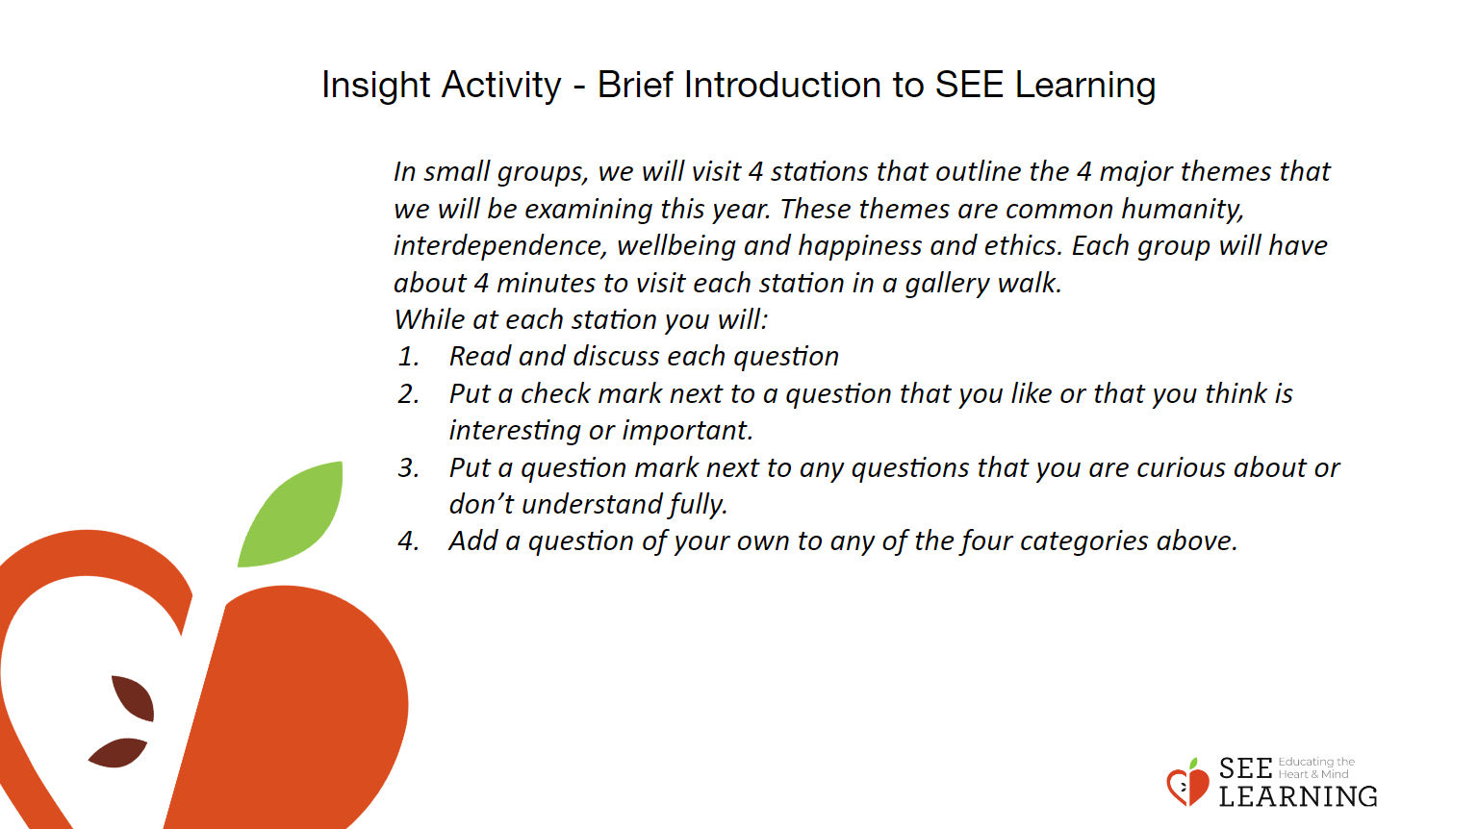 | Instructions and Guiding Language  Gallery Walk  In small groups, we will visit 4 stations that outline the 4 major themes that we will be examining this year. These themes are common humanity, interdependence, wellbeing and happiness and ethics. Each group will have about 4 minutes to visit each station in a gallery walk.  While at each station you will:  - Read and discuss each question  - Put a check mark next to a question that you like or that you think is interesting or important.  - Put a question mark next to any questions that you are curious about or don’t understand fully.  - Add a question of your own to any of the four categories above.  Create 4 charts using the language below, hang them up around the room so students can move from station to station in a gallery walk.  - Common humanity. What do we all have in common as human beings? In what ways are we different as individuals or groups? What might we gain from exploring our shared humanity and our diversity?  - Interdependence. Do things exist by themselves? Do they depend on other things? How do systems work? Is our physical and social reality static (unchanging) or dynamic (changing)? What might we gain from exploring interdependence and dynamic systems?  - Wellbeing and Happiness. What is wellbeing? What is happiness? Do we all want them? What leads to wellbeing and happiness? What undermines them? Are they individual, collective, or both?  - Ethics. How do we want to lead our lives? What leads to having purpose and meaning in life? What responsibilities, if any, do we have to ourselves and others? How do we want to engage collectively in groups or in society such that these groups have collective wellbeing and less suffering? Can we come up with a common set of ethical values, despite our individual, religious or cultural differences? Is ethical discernment or ethical intelligence something that can be cultivated, and if so does it have any benefits?

Reflective Practice (5-10 mins)
Slide 6: Reflective Practice  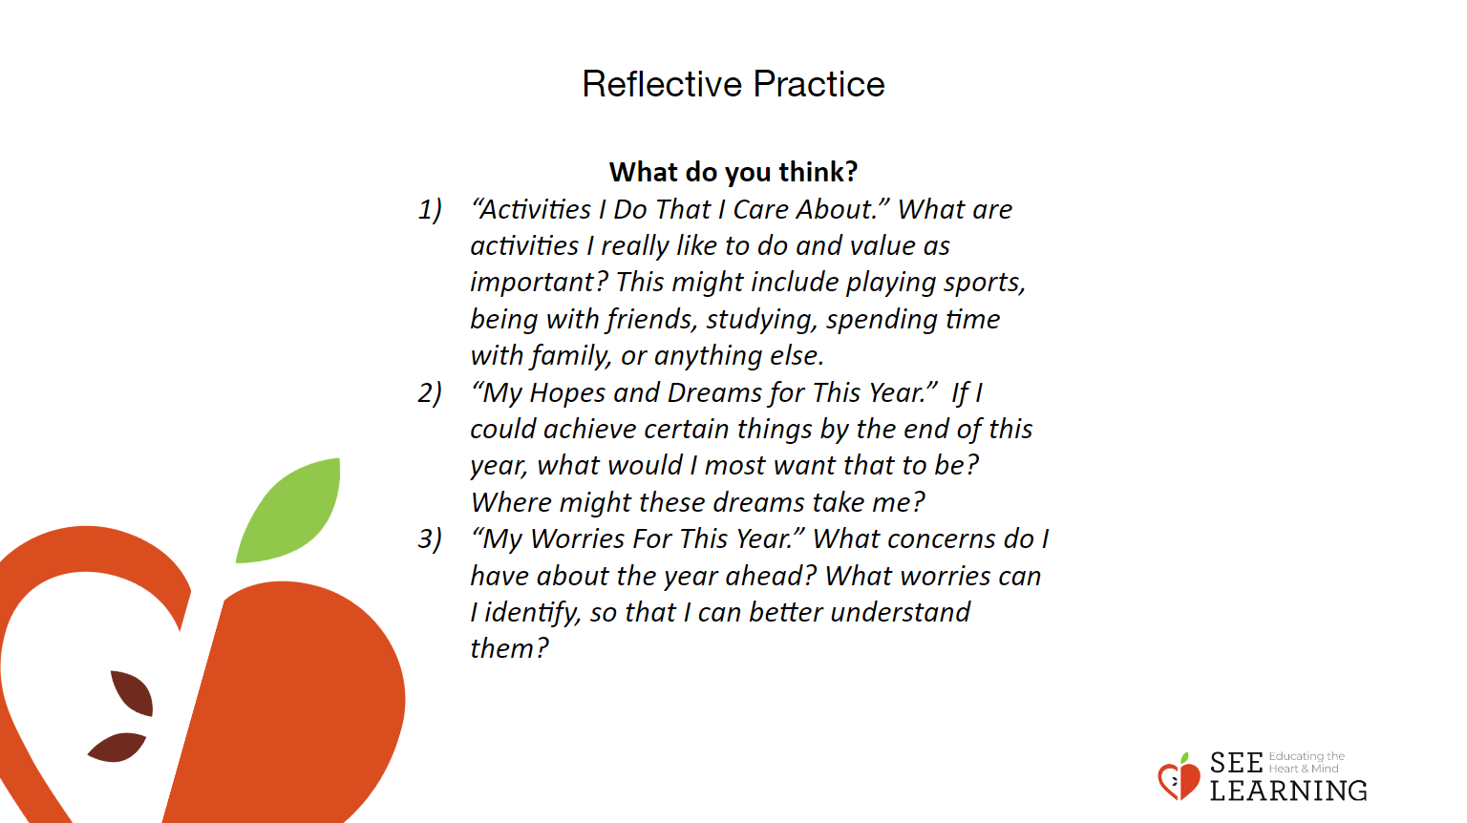 | Instructions and Guiding Language  Display the reflection questions and ask students to silently read and reflect on each one and then choose one to write about.  - “Activities I Do That I Care About.” What are activities I really like to do and value as important? This might include playing sports, being with friends, studying, spending time with family, or anything else.  - “My Hopes and Dreams for This Year.” If I could achieve certain things by the end of this year, what would I most want that to be? Where might these dreams take me?  - “My Worries For This Year.” What concerns do I have about the year ahead? What worries can I identify, so that I can better understand them?

Debrief (5 mins)
Slide 7: Debrief  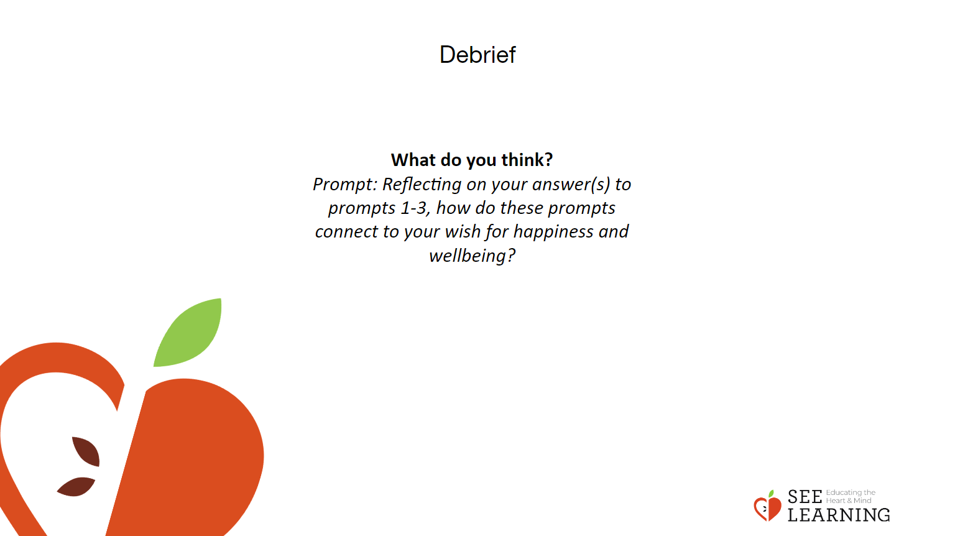 | Instructions and Guiding Language  As a whole class ask students to respond to the prompt below and verbally share with the rest of the class. If students do not wish to share they can choose to “pass.”  Prompt: Reflecting on your answer(s) to prompts 1-3, how do these prompts connect to your wish for happiness and wellbeing?

