Emotion Families

Purpose:
In this learning experience, students will identify how some emotions are related to others and can be grouped into ‘emotion families.’ Students will determine that emotion vocabularies can be expanded by creating charts of “emotion families” and recognizing how emotion terms can help describe how emotions vary in specific ways, such as intensity.
Learning Objectives:  Students will be able to:  - Construct charts of “emotion families” around six common emotion terms (happiness, sadness, compassion, fear, anger, and jealousy)  - Describe different ways that emotion terms are related to one another and contribute to their wellbeing | Primary Core Component  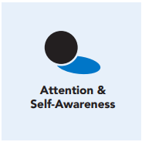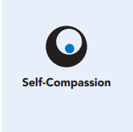
Length  45 Minutes | Materials Required  - Whiteboard or chart paper with markers  - Emotion Words resource in Chapter 2, Learning Experience 2  - Six pieces of chart paper each headed with one of the emotion words listed below:  - Happiness  - Sadness  - Compassion  - Fear  - Anger  - Jealousy  - Markers or pens for each group

Check-In (5 min)
Slide 2: Check-In  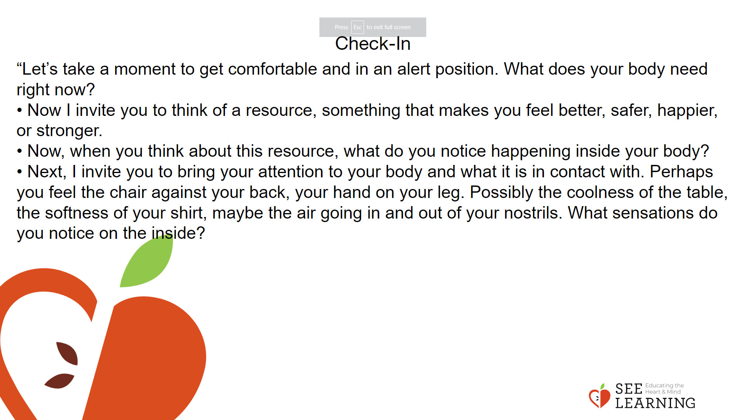 | Instructions and Guided Language  [PAUSE]s can be up to 10 seconds each  Settling Activity  • “Let’s take a moment to get comfortable and in an alert position. What does your body need right now? [PAUSE]  • For you it may be settling into your chair, or if you feel like it, leaning against a wall, sitting or lying on the floor. Please take a moment to make yourself comfortable in an alert position. Feel free to move if you need to. [PAUSE]  • Now I invite you to think of a resource, something that makes you feel better, safer, happier, or stronger.  • It could be a person, place, thing, something about yourself, or a memory of a kindness you experienced. It can be real or imaginary. Notice the details of this resource and any sensations associated with it. [PAUSE]  • Now, when you think about this resource, what do you notice happening inside your body? Notice the sensations. [PAUSE]  • Next, I invite you to bring your attention to your body and what it is in contact with. Perhaps you feel the chair against your back, your hand on your leg. Possibly the coolness of the table, the softness of your shirt, maybe the air going in and out of your nostrils. What sensations do you notice on the inside? [PAUSE]  • Scan your body for a pleasant or neutral sensation and just pay attention to that and observe it. See if it changes or stays the same. [PAUSE]  • You can always shift your body and your focus to another place that feels better. You can always focus on your resource. [PAUSE]  • If you get distracted, remember that you are human and it’s okay to get distracted. Just acknowledge you’re distracted and try to bring your attention back to your resource or a pleasant or neutral sensation in your body. [LONGER PAUSE]  • As we do this, we’re learning more about our bodies and how to calm them and make them feel better.  • Now we’ll conclude the practice. If you closed your eyes, I now invite you to open them. Thank you.”

Insight Activity-Creating Emotion Families (20-30 min)
Activity Overview
Learners will create Emotion Family posters for one of the 6 emotions (Happiness, Fear, Sadness, Anger, Compassion, and Jealousy) by contributing emotion words content and observations to other posters.
• “Today we’re going to explore Emotion Families. Emotion Families are emotions that are related or similar to each other in some way. When we group emotions together it helps make it easier to understand what impacts they may have.
• Emotion words that are related to each other often describe variations of how strongly the base emotion is being experienced.
• Today we’re going to use this list of common emotions to brainstorm Emotion Families.” [Reference the six emotions you wrote on a chart or board.]

Slide 3: Insight Activity  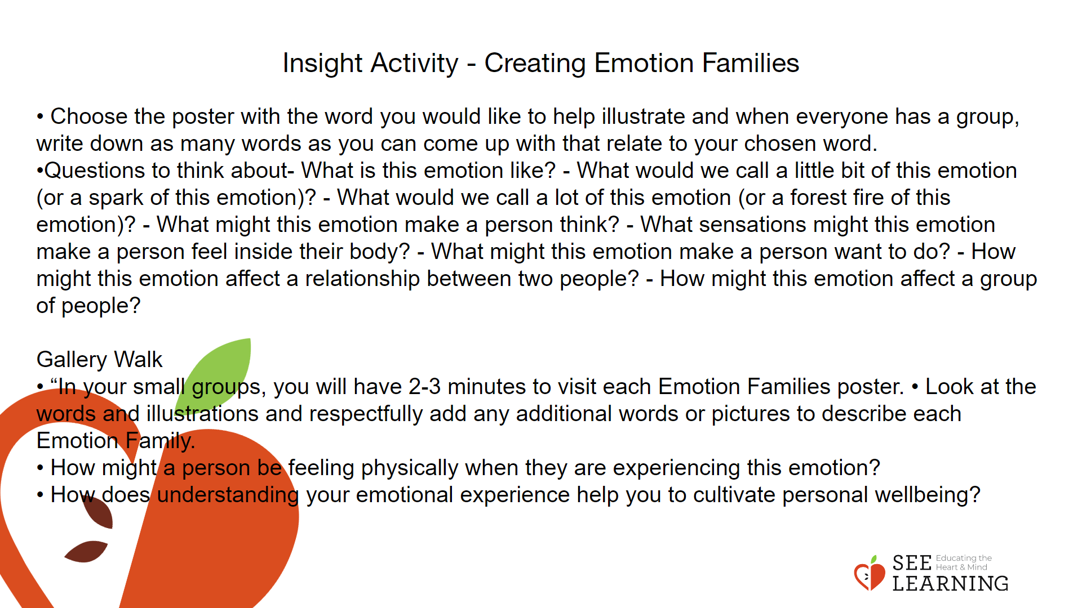 | Instructions and Guided Language  Group Example  • Before we split up into groups we will do one together as an example. We will look at fear and answer the following prompts.  - What are other emotion words that are similar to FEAR or that describe a feeling related to FEAR?  - What might we call it if some felt a tiny bit fearful? Extremely fearful? Think of some circumstances in between those two and some words that might describe those feelings.”  Small groups co-create their Emotion Families posters. (10 minutes)  • “In small groups, you will create an Emotion Family poster for one of these six emotion words.  • Choose the poster with the word you would like to help illustrate and when everyone has a group, write down as many words as you can come up with that relate to your chosen word.  • You can make a list, use drawings, facial expressions, emojis and representational art that connect to the emotion word.  • As you are creating your Emotion Family poster, you may want to ask each other questions like:  - What is this emotion like?  - What would we call a little bit of this emotion (or a spark of this emotion)?  - What would we call a lot of this emotion (or a forest fire of this emotion)?  - What might this emotion make a person think?  - What sensations might this emotion make a person feel inside their body?  - What might this emotion make a person want to do?  - How might this emotion affect a relationship between two people?  - How might this emotion affect a group of people?”  Gallery Walk  • “In your small groups, you will have 2-3 minutes to visit each Emotion Families poster.  • Look at the words and illustrations and respectfully add any additional words or pictures to describe each Emotion Family.  Think about body sensations that may be connected to this Emotion Family. How might a person be feeling physically when they are experiencing this emotion?  • How does understanding your emotional experience help you to cultivate personal wellbeing?”  Examples  If students are struggling to come up with emotion words connected to the word family of their choice, use the examples below to help students generate ideas. Happiness:  Joy, Excitement, Relieved, Peaceful, Excited, Satisfied, Feeling Good  Sadness:  Sorrow, Discouraged, Disappointed, Lonely, Helpless, Hopeless, Feeling Low, Grief  Compassion:  Love, Kindness, Liking, Affection, Endearment, Friendship, Trust, Feeling Close, Feeling Connected  Fear:  Anxiety, Worry, Nervousness, Horror, Shock, Desperate, Panicked, Dread, Feeling Small Anger: Frustration, Annoyed, Bitterness, Rage, Exasperated, Furious  Jealousy:  Envy, Resentment, Begrudging, Feeling Rivalry, Feeling Competitive

Reflective Practice (10 mins)

Teaching Tips
• If students share that they experienced disturbing thoughts, sensations, or emotions, remind them of the skills they have already learned to help regulate themselves: Help Now! Strategies, grounding, resourcing, or shifting attention to a neutral or pleasant sensation in the body.
• If you have internet access in your classroom, your students can compare the charts they created to the “Emotion Families” available on Paul and Eve Ekman’s website “Atlas of Emotions,” available at www. atlasofemotions.org. As of 2020, this website is only available in English and Spanish.

Slide 4 and 5: Reflective Practice  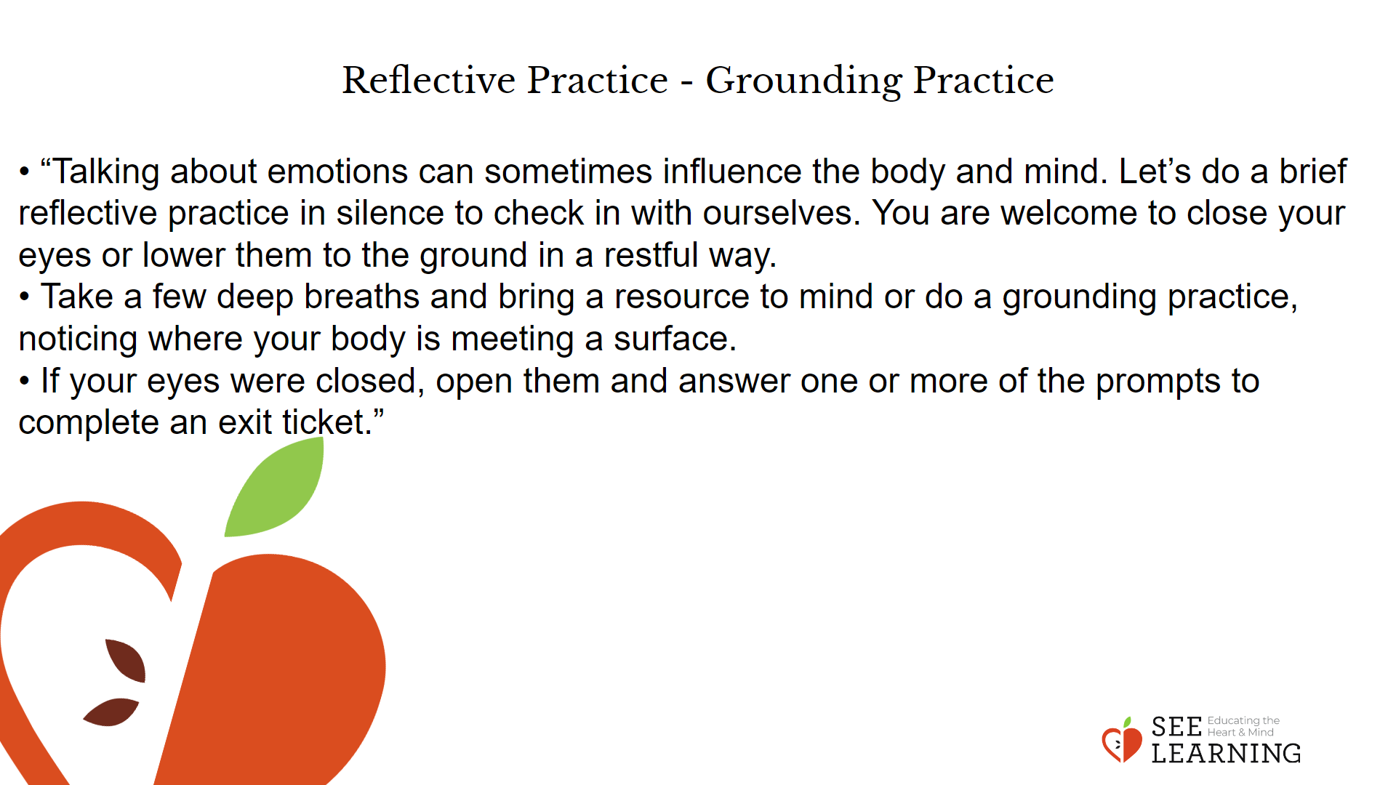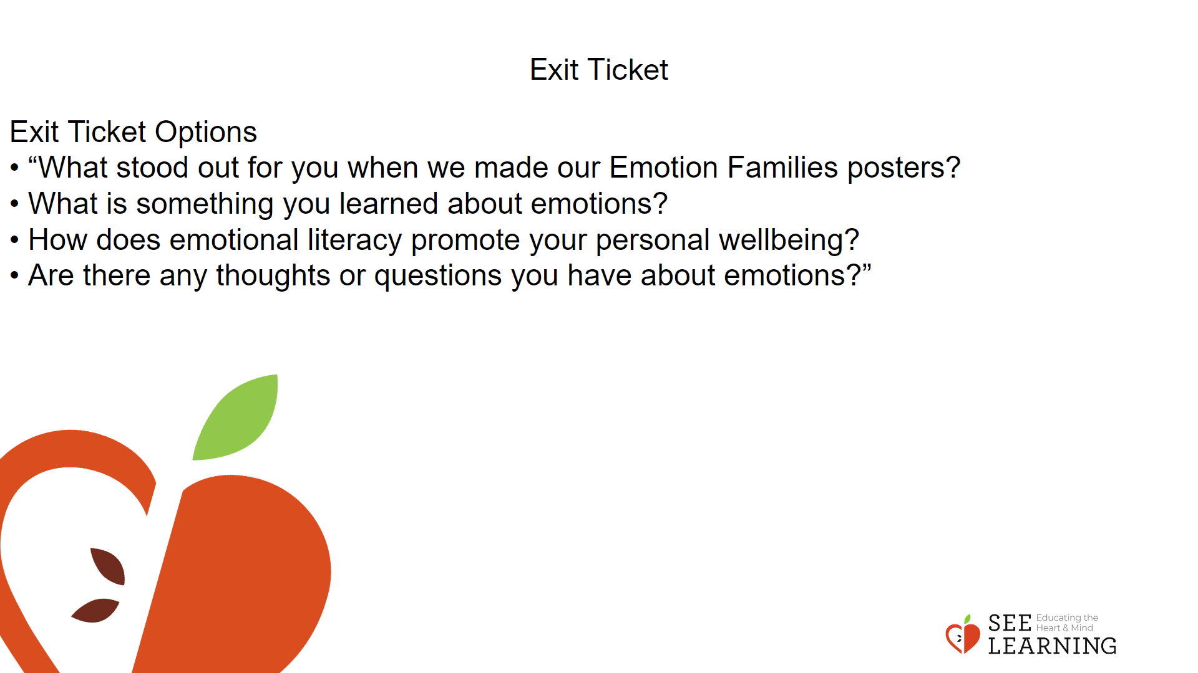 | Instructions and Guided Language  Grounding Practice  Instructions and Guiding Language  • “Talking about emotions can sometimes influence the body and mind. Let’s do a brief reflective practice in silence to check in with ourselves. You are welcome to close your eyes or lower them to the ground in a restful way.  • Take a few deep breaths and bring a resource to mind or do a grounding practice, noticing where your body is meeting a surface. (PAUSE for 30 seconds)  • If your eyes were closed, open them and answer one or more of the prompts to complete an exit ticket.” Exit Ticket Options  • “What stood out for you when we made our Emotion Families posters?  • What is something you learned about emotions?  • How does emotional literacy promote your personal wellbeing? • Are there any thoughts or questions you have about emotions?”

